GNSS Impact Study

Final Report

10.11.2021

Initial Version

SI03 - V1.0

Prepared by | FDC  Aurélien FOURNET, FDC  César EL-BEZ, FDC  Franck MANGIN, FDC
Approved by © | Franck MANGIN, FDC

Table of Contents
1 Introduction 7
2 Report Presentation 8
2.1 Study Context and Objective 8
2.1.1 What is GNSS 8
2.1.2 GNSS Use 15
2.1.3 Study Objectives 17
2.2 Study Characteristics and Limits 17
3 Impact Analysis 19
3.1 Identification of GNSS Potential Alterations 19
3.1.1 Ground and Space Segments 21
3.1.2 Signal (User Segment) 23
3.1.3 Receiver (User Segment) 25
3.2 Identification of Attacker Profiles 26
3.3 GNSS Threats Characterisation 26
3.3.1 Common Scales Definition 27
3.3.2 Threats Characterisation 29
3.4 Impact Assessment for Timing and Synchronisation 32
3.4.1 Energy 32
3.4.2 Water Management 38
3.4.3 Finance 41
3.4.4 Civilian State Activities 43
3.4.5 Electronic, Audiovisual and Information Communication 45
3.4.6 Rail Communications 55
3.4.7 Maritime AIS 58
3.4.8 Air Traffic Control 60
3.4.9 Space 65
3.4.10 Industry 66
3.5 Impact Assessment for Geolocation 69
3.5.1 Civil Transport 69
3.5.2 Civilian State Activities 99
3.5.3 Space 111
4 Conclusion 113
Table of Annexes
Annex 1 Timing and Synchronisation Standards 114
Annex 2 Abbreviations and Acronyms 123
Annex 3 Change Records 130
List of Figures
Figure 1: GNSS Segments 8
Figure 2: Triangulation applied to GNSS 9
Figure 3: Cross-correlation between the satellite-generated code and the receiver generated code 10
Figure 4: Service areas of the different SBAS systems (source: EUSPA) 15
Figure 5: Classification of GNSS threats and vulnerabilities 20
Figure 6: High level smart grid, production and dispatching architecture 33
Figure 7: Reference architecture "Smart Grid"-1 (Source: CEN-CENELEC-ETSI smart Grid Coordination Group) 34
Figure 8: Synchronisation needs distributed on the SGAM model 35
Figure 9: Indice de dégradation de la conversation en fonction de la latence sur le réseau IP (source: ITU-T) 47
Figure 10: Simplified architecture of the GSM-R network 56
Figure 11: Illustration of GNSS use for AIS time synchronisation 59
Figure 12: Topologies of synchronisation methods for multilateration systems 62
Figure 13: Architecture of a distributed clock multilateration system via autonomous GNSS 63
Figure 14: Architecture of a distributed clock multilateration system via the GNSS “Common View” algorithm 64
Figure 15: Time Sensitive Network (TSN) GNSS use 68
Figure 16: High level architecture of GNSS use in air navigation 70
Figure 17: High-level architecture of GNSS use in ADS-B system 72
Figure 18: High-level architecture of GNSS use in maritime navigation 77
Figure 19: High-level architecture of GNSS use in autonomous maritime navigation 80
Figure 20: Illustration of GNSS use in kinetic tide 83
Figure 21: Illustration of GNSS use by radar tide gauges 84
Figure 22: Maritime vertical references (source: Shom) 85
Figure 23: High level architecture of automobile navigation application 88
Figure 24: High level architecture of the digital tachograph application 89
Figure 25: Illustration of GNSS use by autonomous vehicles 90
Figure 26: High level architecture of the use of GNSS in Pay-As-You-Drive application 91
Figure 27: ERTMS level 1 (source: THALES) 94
Figure 28: ERTMS level 2 (source: THALES) 94
Figure 29: Virtual beacon concept 95
Figure 30: High level architecture of GNSS use in ERTMS level 2 96
Figure 31: ERTMS level 3 (source: THALES) 97
Figure 32: High level architecture of GNSS use in ERTMS level 3 97
Figure 33: REGINA network and E6 Galileo acquisition capacity (source CNES) 102
Figure 34: MAYG station coordinates evolution over time (source: IGN) 103
Figure 35: Observation of the Mayotte island deformations – Estimation of these deformation origins (source: REVOSIMA) 104
Figure 36: REGINA configurations for constellation and signal acquisition (source: CNES-2020) 105
Figure 37: GRC-MS, members of the consortium (source CNES) 105
Figure 38: Illustration of the GNSS use for aerial mapping 108
Figure 39: One-way synchronisation method using GNSS 114
Figure 40: Example of an NTP synchronisation architecture 115
Figure 41: PTP architecture 115
Figure 42: SyncE architecture 117
Figure 43: Architecture White Rabbit (WR) 118
Figure 44: GNSS Common-View method (source: NIST) 120
Figure 45: Typical installation in measurement laboratories (source: Ublox ITSF 2019) 120
Figure 46: TWSTFT illustration (Source: BIPM) 121
Figure 47: Map of the REFIMEVE network in France 122

List of Tables
Table 1: Example of sensitivity values depending on the sector considered 12
Table 2: Global GNSS constellations characteristics 13
Table 3: Likely sources of unintentional interferences 24
Table 4: Scale of severity levels for a GNSS receiver 27
Table 5: Scale of areas sizes affected by the threat 27
Table 6: Scale of threat duration 28
Table 7: Scale of threat Likelihood of occurrence 28
Table 8: Synthesis and characterization of threats to GNSS 29
Table 9: Energy applications impact assessment main outcomes 38
Table 10: Water management applications impact assessment main outcomes 40
Table 11: Finance applications impact assessment main outcomes 42
Table 12: Civilian state activities applications impact assessment main outcomes 45
Table 13: Time and frequency requirements for a synchronous network 46
Table 14: Timing and synchronisation requirements for Mobile telecommunication 48
Table 15: Electronic, audio-visual and information communication applications impact assessment main outcomes 54
Table 16: GSM-R synchronisation needs 57
Table 17: GSM-R impact assessment main outcomes 57
Table 18: AIS impact assessment main outcomes 59
Table 19: Air Traffic Control applications impact assessment main outcomes 64
Table 20: Space applications impact assessment main outcomes 66
Table 21: Industry applications impact assessment main outcomes 68
Table 22: GNSS positioning requirements for air navigation in civil aviation (source: Annex 10 - Aeronautical Telecommunications - Volume I - Radio Navigational Aids) 71
Table 23: GNSS requirements for ADS-B 72
Table 24: GNSS requirements for drone operations 73
Table 25: Air transport applications impact assessment main outcomes 73
Table 26: IMO performance requirements 75
Table 27: Localisation required performances for maritime navigation 76
Table 28: Localisation required performances for AIS 77
Table 29: Localisation required performances for maritime asset management 78
Table 30: Localisation required performances for autonomous navigation 79
Table 31: Localisation required for bathymetry survey 81
Table 32: Maritime and waterway transport applications impact assessment main outcomes 86
Table 33: Road transport applications impact assessment main outcomes 92
Table 34: Rail transport applications impact assessment main outcomes 99
Table 35: Application characteristics (source: IGN) 100
Table 36: Static positioning characteristics (Source: EUSPA, IGN) 101
Table 37 : Geographic information applications impact assessment main outcomes 108
Table 38: AMDAR data positioning requirements 110
Table 39: Meteorology applications impact assessment main outcomes 111
Table 40: Space applications impact assessment main outcomes 112

Introduction
Many entities use Global Navigation Satellite System (GNSS), such as GPS, Galileo or Glonass, for PNT (Positioning, Navigation, Timing) applications. Those systems broadcast signals on dedicated frequencies from satellites located more than 20,000 km from Earth. The use of such system for timing synchronisation or positioning applications extended to many sectors of activity thanks to the deployment of new constellations and services, the increase of their performance as well as the reduction of the implementation cost.
The large expansion of GNSS use can be associated with a specific technological dependence associated with the use of these systems. This induces a potential risk for critical national sectors of activity. The occurrence of incidents, failures or degradations, intentional or not, affecting the reception or the integrity of information transmitted by GNSS could have major security and socio-economic impacts.
In this context, the FDC company has been mandated by the FIRST-TF Research Federation (a French national network of time and frequency metrology stakeholders) in collaboration with the French Ministry of Ecological and Solidarity Transition, to conduct an impact study to improve the understanding of the effects of an alteration or an unavailability of GNSS information on the functioning of systems used by some Critical Infrastructures (CI) of civil society. This study especially covers the following sectors: Transports (road, railway, air, maritime, waterway), Energy, Water management, Finance, State Civil activities (Metrology, Meteorology, Geographic information), Electronic communications, audio-visual and information, Space and Industry.
To achieve this objective, an initial analysis based on the results of previous studies has been supplemented by targeted bibliographic search and the organisation of interviews with major stakeholders in several CIs.
This document constitutes the public version of the study final report.

Report Presentation

Study Context and Objective

What is GNSS

Functioning Principle

GNSS System Components
GNSS is composed of three segments as illustrated in the Figure 1 below.

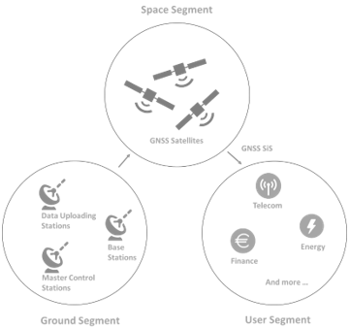
Figure 1: GNSS Segments

- The space segment refers to the satellite constellations which continuously transmit the Signals in Sapce (SiS) used to measure distances.
- The ground segment, which consists of stations spread across the world, is in charge of satellites tracking as well as regular transfer of information to satellites (positions, corrections to their atomic clocks, etc.). The satellite positioning information are time-stamped and transmitted to users in the form of "navigation messages".
- The user segment refers to the receivers which use the signals transmitted by the satellites (SiS) to calculate Position, Velocity and Time (PVT) data.

Principe of GNSS Positioning
GNSS positioning is based on the triangulation principle. The distances between a receiver and each of the visible satellites are computed based on the travelling time of a satellite signal, from its emission to its reception by the receiver, considering that it propagates at the speed of light. Hence, the user must also be aware of the GNSS time used by the satellites to compute its position.
A GNSS measurement therefore consists of calculating four variables: the three receiver position variables plus the time difference between the receiver's time reference and the satellite's onboard clock. A minimum of four satellites are therefore required to perform a GNSS measurement.
The figure below illustrates the principle of triangulation applied to GNSS.
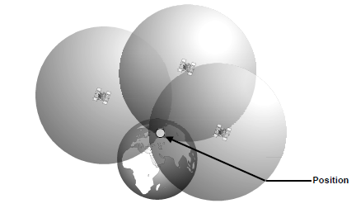
Figure 2: Triangulation applied to GNSS
The satellites transmit two types of data: PRN codes (Pseudorandom Noise) and navigation messages. PRN codes are used to compute receiver-satellite distances and to identify the satellites. A same receiver is thus able to receive signals from different satellites. The navigation messages contain various information such as the position of the transmitting satellite, its status, atmospheric data and time and clock corrections. Among other things, this information is used to correct some errors affecting the calculation of the geometric distance between a satellite and the receiver.
The position of the satellites must be continuously monitored to ensure the accuracy of the GNSS measurement. Hence, the satellites' orbits are continuously controlled by the ground segment and each satellite receives frequent corrections to its estimated position. These corrections are integrated into the navigation message.
The accurate measurement of the signal travel time is also essential. As the signal propagation speed is close to that of light, the slightest error in this measurement leads to a significant uncertainty in the receiver-satellite distance computation. For instance, a one microsecond error in the travel time measurement results in a 300 m error in the travel distance computation.
To ensure an adequate accuracy of the distance measurements, the receiver first generates the codes transmitted by the satellites being tracked. These binary codes are predefined and specific to each satellite. The receiver determines the time of arrival of the signal in its frame of reference using the cross-correlation between the generated and received codes. The time difference between the two epochs can then be calculated. Once corrected for many sources of error, this time difference is used to measure the time difference between the receiver time refence and the satellite clock or the constellation time scale.
Thus, the accuracy of the GNSS measurement also depends on the quality of the correlation between the codes transmitted by the receiver and the corresponding codes transmitted by the satellites.
The following figure illustrates the cross-correlation principle.
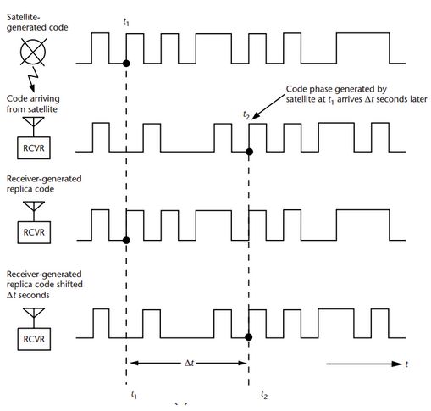
Figure 3: Cross-correlation between the satellite-generated code and the receiver generated code

GNSS Performance Measurement
In order to evaluate the appropriate conditions of use of GNSS, the following performance parameters have been defined:
- Uncertainty of the GNSS measurement: Non-negative parameter that characterises the dispersion of the values attributed to the true value of the quantity (position or time) that we want to measure with the GNSS receiver. It can be the standard deviation of the measurements (or one of its multiples).
- Accuracy: Refers to the difference between the true user position and the user position computed by the GNSS receiver. Accuracy requirements are dependent on the application concerned. It is expressed as the value within which a specified proportion of samples would fall if measured. Accuracy is either used to characterise horizontal positioning information, vertical positioning information or GNSS time information. These different types of accuracies are defined below:
- Horizontal position accuracy: Refers to the statistical measure of the horizontal position error (usually 95th percentiles of the cumulative error distribution), being this error the difference between the true horizontal position and the horizontal position estimated by the GNSS receiver at a given time.
- Vertical position accuracy: Refers to the statistical measure of the vertical position error (usually 95th percentiles of the cumulative error distribution), being this error the difference between the true vertical position and the vertical position estimated by the GNSS receiver at a given time. This feature applies when vertical guidance is required, for instance in some aircraft approaches.
- Integrity: Refers to the measure of trust that can be placed in the position or time estimated by the GNSS receiver. This is usually expressed as the probability of a measurement error being larger than a predefined alert limits without warning the user. The way integrity is ensured and assessed, and the means of delivering integrity related information to the user are highly dependent on the application safety level. Indeed, the more critical the application, the more integrity tends to be defined by monitoring a large set of measurable parameters.
- Protection level: Refers to the statistical error bounding the data computed by the GNSS receiver
- Alert limit: Refers to the maximum error tolerance beyond which an alert will be issued by the system
- Time To Alert (TTA): Refer to the maximum allowable time elapsed from the onset of the failure until the user is warned
- Integrity Risk: Refers to the probability of the data error computed by the GNSS receiver to be outside the defined maximum error tolerance (i.e. alert limit) but still considered available by the system. Hence, no alert is issued by the system before the end of the Time To Alert time. For critical systems, the integrity risk can be defined as a tolerable risk probability that is derived from a specific risk analysis.
- Availability: Refers to the percentage of time the GNSS information can be computed by the user. Requirements vary greatly according to the application concerned, they are typically ranged between 95% and 99.9%. There are two classes of availability:
- System availability which is the percentage of time the system allows the user to compute the required data
- Overall availability which takes in addition into account the receiver performance and the user’s environment
- Continuity: Refers to the ability to provide the required performance during an operation without interruption once this operation has started. Continuity is usually expressed as the risk of a discontinuity
- GNSS sensitivity: Refers to the minimum GNSS signal strength at the antenna, detectable by the receiver (dBW or dBm). GNSS sensitivity depends on the sector of activity considered. The following table provides some sensitivity values:
Table 1: Example of sensitivity values depending on the sector considered
 | Aviation | Maritime | Automobile
Sensitivity (usual) | -135 dBm (acquisition)  -140 dBm (tracking) | -130 dBm (acquisition)  -135 dBm (tracking) | -147 dBm (acquisition)  -162 dBm (tracking)

- Robustness: Robustness to spoofing and jamming is a qualitative parameter characterising the type of attack or interference a receiver can mitigate. It can include authentication information to ensure users that the signal comes from a valid source (enabling sensitive applications). The notion of robustness includes the following sub-parameters:
- Position authenticity: Gives a level of assurance that the data provided by a positioning system has been derived from real signals. Radio frequency spoofing may affect the positioning system resulting in false position data as output of the system itself.
- Robustness to interference: Designates the ability of the positioning system to operate under interference conditions and to maintain the applicable positioning service level requirements.
- Traceability to UTC: National metrology institutes provide "metrological traceability" to UTC of their UTC(k) time scale in the sense of ISO 17025-2017. Traceability in the sense of ISO 17025-2017 is not provided by GNSS services. GNSS measurements are therefore not able to provide validated traceability to UTC. In the context of this study, the traceability requirements at the UTC will not necessarily imply traceability in the sense of ISO 17025-2017.

Main Existing Systems
GNSS signals can be delivered by multiple systems, including global or regional constellations and Satellite-Based Augmentation System (SBAS) broadcasting corrections via geostationary satellites.
The current global constellations are as follows:
- GPS: The first GNSS is fully operational since 1995. It is managed by the US Department of Defense. It is currently being modernized with the deployment of new GPS III satellites;
- GLONASS: The Russian GNSS is fully operational since 2011. It is managed by the Russian aerospace defence forces. The latest generation of satellites (GLONASS-K) entered service in February 2016;
- Galileo: This is the European GNSS system currently being deployed. In addition to the provision of a high-quality Open Service (OS) based on signals transmitted on the E1 and E5 bands, Galileo is also the first GNSS constellation to provide a return link for distress beacons’ users. Galileo also offers other unique capabilities such as an Open Service Navigation Message Authentication (OSNMA) as well as a Commercial Authentication Service (CAS) complementing the OS, with the provision of controlled access and signals authentication function. OSNMA and CAS represent the first anti-spoofing protections available to civilian GNSS users. Finally, Galileo also includes a regulated service, the PRS (Public Regulated Service), restricted to government-authorised authorized for sensitive applications requiring a high level of service continuity;
- BeiDou (Phase 3) or BDS-3: Chinese GNSS is currently being deployed with the aim of replacing the current regional system. BeiDou is managed by the Chinese Bureau of Navigation Satellites. With the regional positioning system, BeiDou represents today the largest constellation of satellites.
The table below details the main characteristics of each system constellation:
Table 2: Global GNSS constellations characteristics
Parameter |  | GPS | GLONASS | Galileo | BeiDou
Orbital period |  | 11h58m | 11h15m | 14h04m | 12h37m
Orbital height |  | 20 200 km | 19 100 km | 23 222 km | 21 150 km
Inclination |  | 55° | 64.8° | 56° | 55°
Number of orbital planes |  | 6 | 3 | 3 | 6
Number of Satellites |  | 24 operational and 6 spare | 21 operational and 3 spare | 24 operational and 6 spare | 27 MEOs + 5 GEOs + 3 IGSOs
Coordinate Reference System |  | WGS-84 | PZ90 | GTRF | CGCS2000
Reference time |  | GPS Time  (GPST) | GLONASS Time (GLONASST) | Galileo System Time (GST) | BeiDou Time  (BDT)
Performance level | Average horizontal accuracy (95%) | < 9 m | 5 m | < 4m (Galileo Open Service) | 10m
 | Average vertical accuracy (95%) | < 15 m³ | 10m⁴ | < 8m (Galileo Open Service)⁵ | 10m⁶
 | Average time accuracy | 40 ns³ | Not provided | 30 ns (Galileo Open Service) | 50 ns

In addition to these global constellations, there are several augmentation systems allowing to increase some performances of the GNSS information. Among these systems, SBAS (Satellite Based Augmentation Systems) deliver real-time corrections to increase the accuracy of GNSS measurements while ensuring their integrity. Originally developed in the 1990s for civil aviation, their use is now spreading to many other sectors such as rail. There are currently four operational SBASs (WAAS in the United States, MASA in Japan, GAGAN in India and EGNOS in Europe) and five additional SBASs under development (SDCM in Russia, BDSAS in China, A-SBAS for ASECNA, KASS in South Korea and SPAN in Australia and New Zealand). The following figure represents these different systems and their service area:
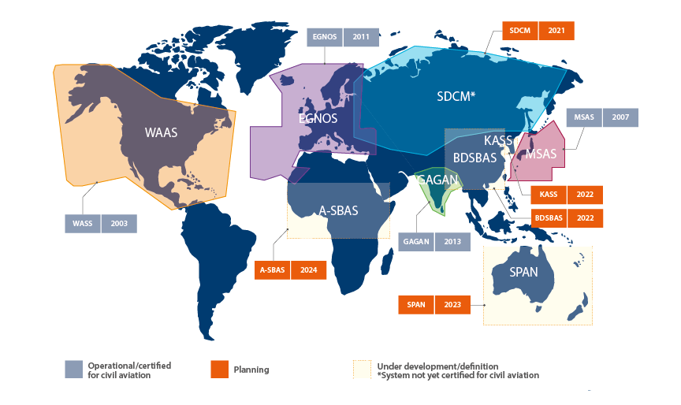
Figure 4: Service areas of the different SBAS systems (source: EUSPA)

GNSS Use

Time Synchronisation
The use of satellite systems (GNSS) for time synchronization applications has become essential in many industries, for instance to:
- Synchronize the clocks of the different elements of the same telecommunication network in order to transmit data flow (voice, video, etc.) in an optimal manner;
- Synchronize the clocks of measurement elements in order to synchronize the corresponding measurements;
- Date security certificates and check their validity;
- Synchronize the dating of information received by data servers on the same computer network;
- Synchronize security systems, in particular in the field of transport;
- Carry out scientific experiments.
GNSS synchronization function has therefore a central role in many applications and industries.

Their use to provide a common time reference for equipment on the same network can simultaneously allow:
- Savings: it is no longer necessary to distribute a time reference through physical channels (e.g. with fibre optics, coaxial cables) which can be very expensive to install and to maintain for the operator;
- An easy set up: GNSS receivers operate independently. Installing GNSS receivers within a network can, for operators, appear simpler than setting up a synchronization network;
- Access to satisfactory performance compatible with the accuracy requirements of the most demanding applications and services.
More generally, in addition to being an essential element for the proper functioning of a single network, time synchronization is also used to interface networks with each other. The loss of time synchronization can therefore not only have an impact within the network which implements it, but also cause malfunctions within the connected networks. GNSS signals have indeed become an essential, comprehensive and standardized means of broadcasting a common time source for network operators.
All of these factors have driven the adoption of GNSS by network operators for time synchronization, to such an extent that GNSS has become for some applications a single point of failure.
Due to its central role in many applications and industries, the loss of time synchronization by GNSS could have significant social and economic impacts, for example by disrupting the operation of certain telecom, financial or electricity networks.

Positioning
With the decreasing of their size and cost, GNSS receivers use in the transport sector continues to expand and diversify. GNSS is used in particular in the following areas:
- Road transport: positioning by GNSS is used in the field of road transport for many applications such as navigation, fleet management, regulatory applications (tachograph, etc.), road safety, monitoring of dangerous products or road tolling;
- Intelligent and autonomous vehicles: personal vehicles are becoming more and more intelligent and autonomous, and the corresponding new functions may require the use of GNSS positioning systems. These functions include communication and data exchange between vehicles/infrastructures/pedestrians (V2V, V2I, V2X), autonomous navigation, sending of messages and emergency calls (eCall) or "Pay-As-You-Drive" systems;
- Railways: rail traffic management methods are evolving and GNSS is an integral part of these evolutions. Indeed, Europe is studying GNSS positioning solutions to improve rail signalling and train management;
- Maritime: the maritime transport sector increasingly relies on GNSS for navigation at sea, near coasts as well as in inland waterways. The ship Automatic Identification System (AIS) relies on the GNSS positioning of the vessel and GNSS is also used for synchronization of the AIS system itself;
- Aviation: GNSS is used for both landing and take-off (e.g. LPV200 approaches) and in-flight navigation. The SESAR research program, pillar of the single European sky, as well as the ICAO roadmap promote the use of GNSS for future air traffic control systems. GNSS could be used to enable continuous descents and climbs, reduction of spacing between aircraft as well as optimization of the route network.
In addition to these five main areas, new applications based on the use of drones are on the way or have already entered the world of transport. These applications include delivery drones (already used for the delivery of packages or medicines) and taxi drones (currently under test). Whether it is to transport a package or a person, a drone depends today heavily on GNSS to determine its position and follow its flight plan. In addition, a set of services entitled U-Space Blueprint is being studied by SESAR in order to allow safe integration of drones into airspace, in particular by setting up a drone traffic control system. The use of GNSS is particularly considered for such systems.
Due to its variety of applications, the loss of GNSS positioning in the transport sector could have very diverse social and economic impacts such as, for example, an increase in road traffic congestion, an increase in the number of accidents (road, air, sea, rail), unbalanced competition (for example by non-compliance with cabotage regulations), or the immobilization of an aircraft on the ground. The environmental impact, for example through increased pollution, will often go hand in hand.
In order to avoid these negative impacts, ensuring the accuracy, integrity, continuity and availability of the GNSS positioning service has become a major issue in the transport sector.

Study Objectives
The objective of the present study is to provide a better understanding of the effects of an alteration or an unavailability of GNSS information on the functioning of systems implemented in some Critical Infrastructures of civil society.
Critical elements ranging from the safety of people and goods, to the impact on environment and economy are considered, projecting as far as possible over the next ten years.

Study Characteristics and Limits
Methodology of the study:
The methodology applied to this study is based on the risk evaluation method “EBIOS 2010” developed by the ANSSI (The French National Cybersecurity Agency) in 2010 and now replaced by the EBIOS Risk Manager method. However, unlike the EBIOS method, this study is limited to an impact analysis and does not cover risk assessment.
As a first step, threats to GNSS have been characterised through the identification of alteration sources on GNSS information and of profile of potential attackers

For each considered sector, the following steps have been covered:
- Description of the use of GNSS for the different applications considered;
- Identification of the vulnerabilities linked to a degradation of GNSS information;
- Identification and characterisation of feared events that could occur as a result of a failure of GNSS information;
- Evaluation of the impact of each feared event on safety and security of people and assets, economy and environment. These criteria lead to the definition, for each feared event, of an overall gravity level on a 4-level scale (Minor, Significant, Serious and Critical).

Classification of the report:
The public status of this report, necessary for its wide distribution, has led to remove some details and information included in its national classified version. In particular, the outcomes of the activities dedicated to the identification and characterisation of the vulnerabilities, feared events as well as the corresponding detailed levels of impacts are not reported in the present document.

Impact Analysis

Identification of GNSS Potential Alterations
The GNSS must be protected against numerous alterations that may be intentional, non-intentional or natural as illustrated within the figure hereunder.
The three GNSS segments are concerned by these alterations. The objective of this paragraph is to describe each alteration.

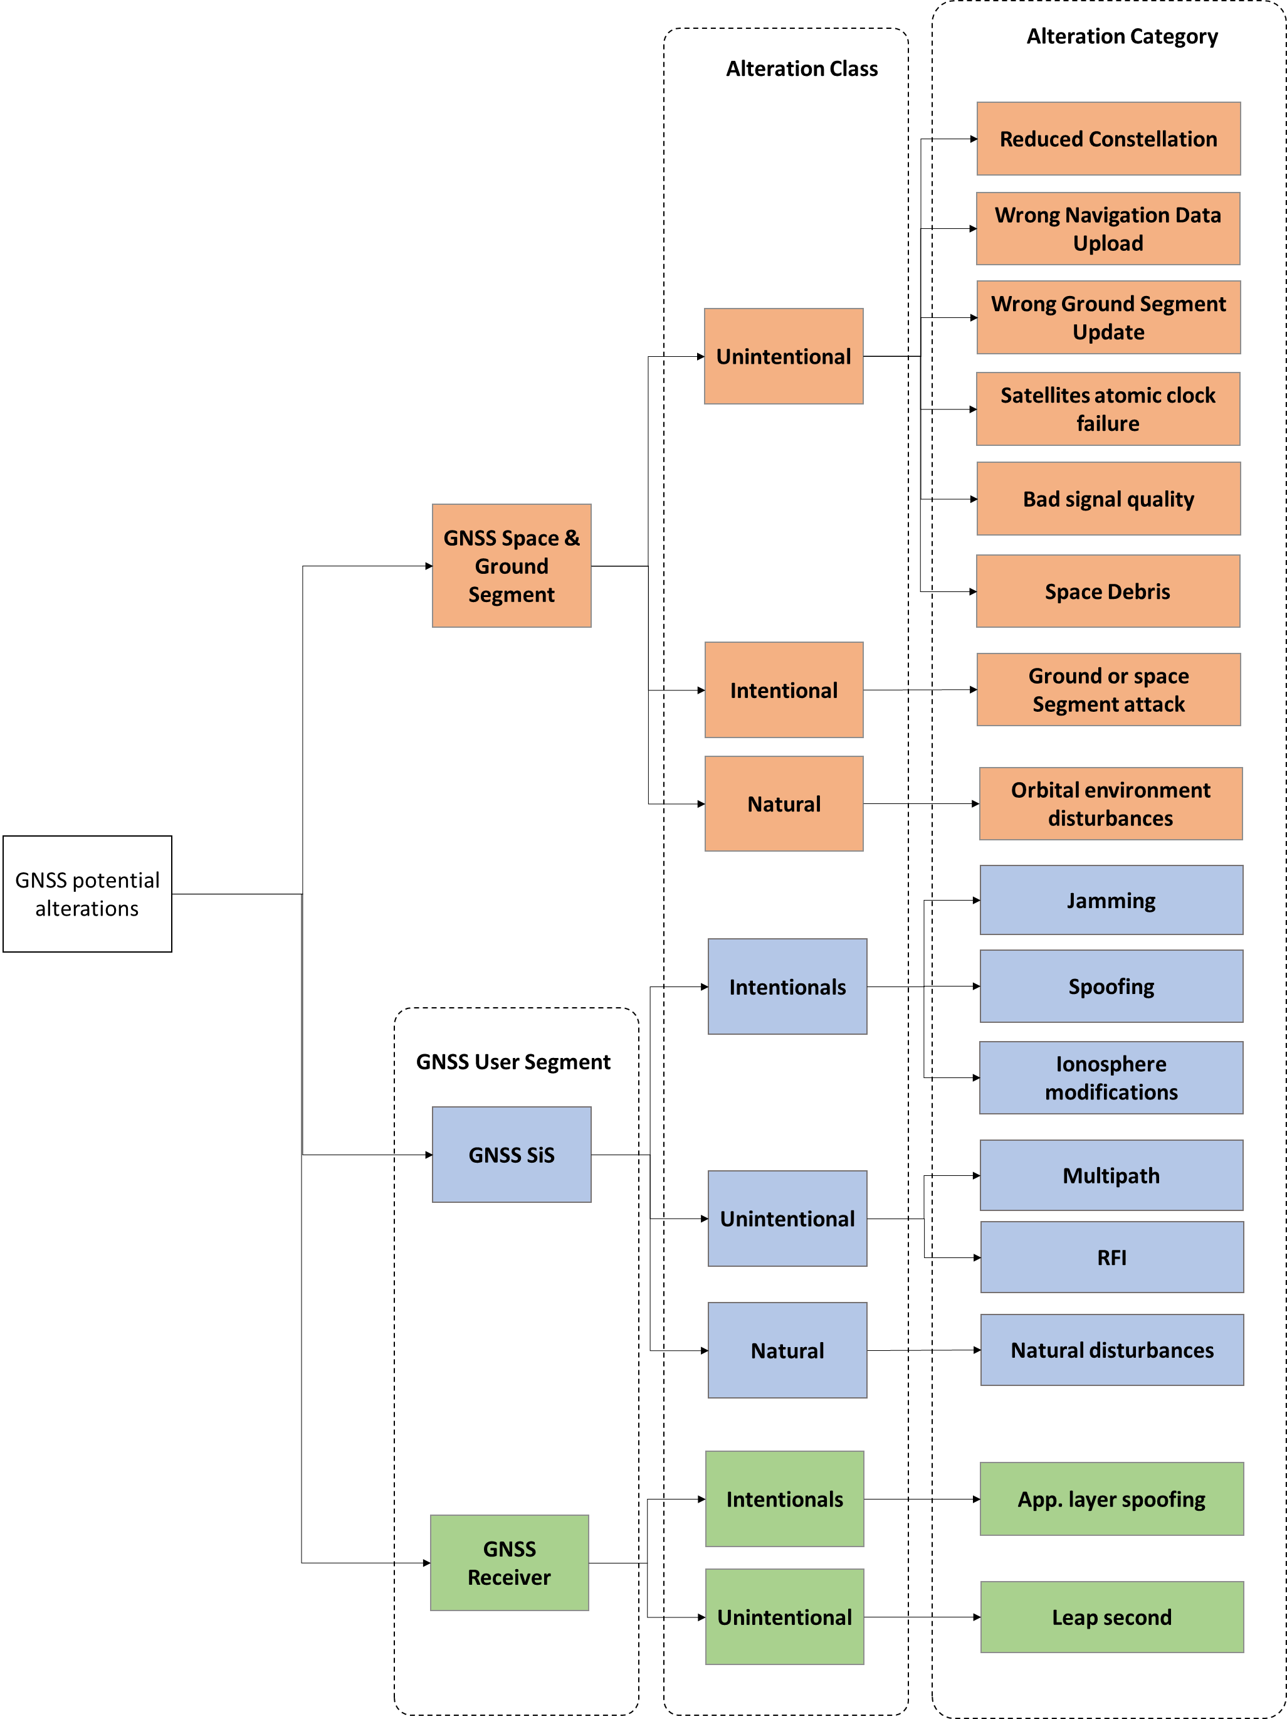
Figure 5: Classification of GNSS threats and vulnerabilities

Ground and Space Segments

Unintentional
Among unintentional threats and vulnerabilities of the GNSS Space and Ground segments; the following have been identified:
- Reduced constellation: this is a long-term threat which mainly consists in satellites shortage from a same constellation due to potential simultaneous old spacecraft end of life and late delivery of next generation satellites (this happened to GLONASS in the early 2000’s);
- Wrong navigation data upload: when wrong navigation data are uploaded and then broadcasted by GNSS satellites, the user segment receivers have an erroneous clock and position knowledge of the GNSS satellites and provide false position and time information.
- Wrong Ground Segment update: One wrong ground segment upload may lead to some ground segment IT systems crash which may, in the worst case, lead to the unavailability of the whole GNSS constellation until the problem is identified and solved;
- Satellites atomic clock failure (clocks Jump/drift): The proper functioning of GNSS depends on the accuracy of the atomic clocks installed on board the satellites (measured over 48 hours). These clocks can in fact, as they age, exhibit failure modes such as frequency jumps generating linear phase drifts. A frequency hopping can result in a sudden change in the signal transmitted without prior notification with phase drifts that can be difficult to detect and correct from the ground because they are very weak and sometimes close to the effects of a relative movement between satellites and GNSS receiver. An example of a clock failure is that of PRN 23 on January 1, 2004 which introduced errors up to kilometre;
- Bad signal quality: there can be a fault in the signal modulation or generation process by a satellite, a wrong signal envelope can be broadcasted causing unpredictable behaviour in receivers at user segment level.
- Space Debris: More than 500,000 pieces of debris, or “space junk,” are tracked as they orbit the Earth. They all travel at speeds up to 28 000 km/h, fast enough for a relatively small piece of orbital debris to damage a satellite or a spacecraft. The rising population of space debris increases the potential danger to the launched or orbiting satellites.

Intentional
The ground segment of GNSS is designed to withstand military-type attacks, however it may have residual vulnerabilities in the face of certain terrorist actions or cyberattacks. Indeed, the resistance of GNSS systems to the military-type attacks is essentially ensured by redundancy. However, these measures do not protect these GNSS against terrorist actions or coordinated cyberattacks.
The space segment of GNSS also presents vulnerabilities to intentional attacks that could be conducted from the ground or from space. These attacks correspond to particular types of weaponry which can be classified into several categories:
- Kinetic energy weapons
- Directed energy weapons (lasers, radio frequency)
- Particle beam weapons
Intentional threats on the ground and space segments are not addressed in more detail within the scope of this study.

Natural
Concerning the orbital environment disturbances, the Earth is subject to extreme solar events and these have the potential to disrupt the satellites themselves. Such disruption may be temporary or irreversible. The following orbital environment disturbances can be listed:
- Solar flare: A flare is defined as a sudden, rapid, and intense variation in brightness. A solar flare occurs when magnetic energy that has built up in the solar atmosphere is suddenly released. Radiation is emitted across virtually the entire electromagnetic spectrum.
- Radiation Storms: Solar radiation storms occur when a large-scale magnetic eruption, often causing a coronal mass ejection and associated solar flare, accelerates charged particles in the solar atmosphere to very high velocities. When they reach Earth, the fast-moving protons penetrate the magnetosphere that shields Earth from lower energy charged particles. Once inside the magnetosphere, the particles are guided down the magnetic field lines and penetrate into the atmosphere near the north and south poles.
- Geomagnetic storm (Carrington class coronal mass ejection): A geomagnetic storm is a major disturbance of Earth's magnetosphere that occurs when there is a very efficient exchange of energy from the solar wind into the space environment surrounding Earth. The largest storms that result from these conditions are associated with solar coronal mass ejections (CMEs) where a billion tons or so of plasma from the sun, with its embedded magnetic field, arrives at Earth. On July 23, 2012, a massive, potentially damaging, solar storm (solar flare, coronal mass ejection and electromagnetic radiation) barely missed the Earth. An extreme solar storm event is unpredictable but would be likely occur 1 time each 100-200 years.

Signal (User Segment)

Intentional
Among intentional threats, three categories of threats can be distinguished: Jamming, spoofing and the modification of the ionosphere.
- Jamming: It can be defined as an attack carried out by the emission of noise-type signals on the frequencies used by GNSS systems. Jamming is most often generated by ill-intentioned or ill-informed civilians whose motivation is to protect their privacy or avoid paying the fees for using a service, but it can also be implemented by criminals using it to commit their misdeeds, in particular for the theft of goods protected by GNSS trackers (luxury cars, cargoes, etc.). Illegal jamming aims to prevent access to GNSS services by disrupting the reception and tracking of signals, and therefore the delivery of time and position data by GNSS receivers. Although the sale and use of even low-powered GNSS jammers is illegal in most countries, they can be found for sale on the internet. These jammers (also called Privacy Protection Devices) sold on the Internet, produce various types of signals implementing different modulation techniques (e.g. swept signal, pulsed signal), on different frequency bands (single frequency, narrow ban, wide band) and powers. These jammers can simultaneously interfere with multiple GNSS frequency bands. In addition, depending on its power, and with a possible difference in the horizontal and vertical planes, a jammer may jam an area ranging from a few meters to several kilometres or even hundreds of kilometres;
- Spoofing: This consists of the transmission of fake GNSS signals intended to deceive the position, speed or time data provided to users by the receivers. The signals thus transmitted can either be forged or derived from a recorded GNSS signal. The simplest spoofing attack consists of receiving GNSS signals and retransmitting them without any modification, this technique is called "meaconing". A method of intermediate complexity consists in recording a GNSS signal, in modifying it and in retransmitting the spoofing signal thus generated. Finally, the most sophisticated attacks consist in generating the GNSS signal. These signals can be transmitted with or without synchronization of the simulated and actual signal. However, the more precisely the generated GNSS signal is synchronized with that of the target satellite, the more effective the spoofing attack will be;
- The modification of the ionosphere can be originated by nuclear explosions. Indeed, the energy released by a nuclear explosion creates highly ionised arcs in the atmosphere which are able to significantly impact radars, telecommunications and GNSS signals. GNSS operations may be affected for weeks due to propagation anomalies.
Particular forms of jamming and spoofing characterized by "Nation" type attackers with security or geopolitical issues have been implemented in recent years with a certain regularity (e.g. unavailability of the GPS signal in the area affected by the Balkan war, GPS jamming by North Korea, GNSS attacks in Russia and Syria, or signal jamming in Ukraine). These operations aiming to prevent or disrupt access to the GNSS service may have different motivations and be based on different concepts of operation. For example, these may be selective military-type attacks (targeting only open GNSS services) or non-discriminatory attacks, carried out over a defined geographical area. It should be noted that this particular form of jamming / spoofing also covers measures taken to disrupt the reception of GNSS signals in the context of the protection of political VIPs.

Unintentional
As regard to the GNSS SiS, two unintentional threats exist: Multipath effects and Radio Frequency Interferences (RFI).
- Multipath: It is the phenomenon whereby a signal arrives at a receiver via multiple paths attributable to reflection and refraction. Multipath represents one of the dominant error sources in satellite-based timing and positioning systems. The main cause of multipath is the receiver antenna closeness to a reflecting infrastructure combined with low elevation GNSS SiS. It affects the phase measurements as well as the code measurements, but the effects vary with the received frequencies
- Radio Frequency Interference (RFI): They can be defined as the unintentional transmission of an interfering signal toward a communication or GNSS system disrupting or preventing signal transmission. Such unintentional transmissions can be originated by spurious adjacent band or harmonic radiations due to one badly designed or installed commercial high-power transmitter. A typical RFI may last several days as it lasts until the RFI origin is located and the defective system is replaced.
Several likely sources of unintentional interferences can be identified. The Table 3 hereunder identifies some potential sources.
Table 3: Likely sources of unintentional interferences
Signal | Freq. range | Power | Location | Affected Band
TV (UHF) | 500-860M | Strong | World-wide | E5/L5, L2, E6, E1/L1
CT2/+ | 864-948M | Weak | North Europe | E1/L1
DAB | 1452-1492M | Strong | Europe, Canada, potentially world-wide | E1/L1, E6
GSM | 824-960M /  1710-1990M | Mid | World-wide, mainly Europe and North America | E1/L1
TDMA, IS-54 | 854-894M /  1850-1990M | Mid | North America and Centre America, Russia | E1/L1
CDMA, IS-95 | 824-894M /  1850-1990M | Mid | Mainly North America, Far East, Australia | E1/L1
DECT | 1880-1900M | Weak | Europe, Australia, Russia, Centre/South America | E1/L1
PHS | 1895-1918M | Weak | North America, Far East | E1/L1
UMTS /  WCDMA | 1900-2170M | Mid | World-wide | E1/L1
Bluetooth | 2402-2495M | Weak | World-wide (Higher f. in France, Spain, Japan) | E1/L1
WLAN (IEEE802.11b) | 2410-2483M | Mid | World-wide | E1/L1
UWB | 1000-3000M | Weak | World-wide | E1/L1, L2, E6, E1/L1
4G LTE | 1500-1700 M | Strong | North America | E1/L1
CT2/+ | 864-948M | Weak | North Europe | E1/L1

Natural
GNSS threats can have natural origins such as ionospheric scintillation or solar burst.
Among natural disturbances, ionospheric scintillation effects are the most important, these effects vary with many factors such as time, season and geomagnetic position. It degrades the GNSS positioning accuracy and causes loss of signal tracking during severe scintillation activities, especially in the low latitude regions.

Receiver (User Segment)

Intentional
Spoofing the GNSS SiS using signal simulators is not the only (and easiest) way to intentionally spoof a GNSS application. Methods involving the application layer of receivers also exist.

Unintentional
GNSS satellites navigation messages include a parameter needed to related GPS time to UTC (Coordinated Universal Time). That relationship is maintained through leap second implementation transitions. For leap second transition, user equipment must utilize the notice regarding a scheduled future delta time due to leap seconds (AtLSF), together with the week number (WNLSF) and the day number (DN), at the end of which the leap second becomes effective.
GNSS receiver can be badly affected or even disrupted by a leap second transition. Even if a leap second update occurrence is scheduled by the GNSS systems operators, this event is considered as an alteration by most of the GNSS receivers’ users and manufacturers. Dealing with a leap second (basically one minute that doesn’t last 60 seconds) is technically challenging and strategies have to be implemented to avoid PNT applications failures.

Identification of Attacker Profiles
The GNSS attacker profiles identified in this study are described below. The attacks considered here can also be of unintentional types.
- Nations: States employing people who collect information in a professional manner and commit attacks on GNSS for their government;
- Terrorist groups: Terrorists are politically motivated and have their own political agenda which they use to select targets. This attacker profile may want to jam GNSS over a large area;
- Organized crime groups: Organized crime targets information or assets that are of value to them and that can be converted into money. These assets can be luxury cars, valuable cargoes, etc., protected by GNSS "trackers" which the criminals want to disrupt;
- Pirates (amateur or professional): professional and amateur pirates generally have the same interests as organized crime but operate in a more individual logic;
- Employees (dissatisfied or malicious): employees can attack the entities or infrastructures in which they work for various reasons (e.g. for money, professional disappointment etc.);
- Individuals (malicious and/or unaware of the consequences of their actions): individuals are using GNSS receivers that they may want to disrupt, for example in the case of commercial relations with service providers, in order to protect their privacy or to conceal undeclared salaried activity. The protection of their privacy can also lead them to use anti-drone jammers (case of VIPs in the sports / entertainment world). When using jammers intended to interfere with their own GNSS receivers, these citizens will also affect nearby GNSS receivers;
- Owners of radio and electronic equipment: Certain radio and electronic equipment can cause emissions that unintentionally disrupt the reception of GNSS signals. They can be classified into several categories:
- Equipment in default;
- Non-compliant equipment;
- Equipment used improperly;
- Equipment emitting interference in the GNSS band.

GNSS Threats Characterisation
The objective of this paragraph is to characterize all the threats to GNSS. The threats considered will be those likely to be generated by attacker profiles identified above, supplemented by threats of a natural type.

Common Scales Definition
In order to characterize, as homogeneously as possible, the various possible threats for GNSS, four common level scales have been defined for the following parameters:
- Severity at the GNSS receiver
- Size of the impacted area
- Duration of the threat
- Likelihood of occurrence

Table 4: Scale of severity levels for a GNSS receiver
Severity | Description
Critical | Impossibility for the GNSS receiver to provide position or time information for a long time  or provision of incorrect time and position information without possibility of detection for the user
Serious | Impossibility for the GNSS receiver to give position or time information for a limited period of time  or significant degradation of the performance of the GNSS receiver (horizontal or vertical accuracy greater than 300 meters / uncertainty of the order of a millisecond) for a long period
Significant | Significant degradation of GNSS receiver performance (horizontal or vertical accuracy less than 300 meters / microsecond uncertainty) over a long period of time
Minor | Minor degradation in GNSS receiver performance (horizontal or vertical accuracy less than 30 meters / nanosecond uncertainty). The GNSS receiver is still able to provide a relatively accurate position or time source

Table 5: Scale of areas sizes affected by the threat
Area size | Description
Large | The considered threat can impact an area with a diameter greater than a few thousand kilometres
Extended | The considered threat can impact an area with a diameter of a few hundred kilometres
Limited | The considered threat can impact an area with a diameter of a few tens of kilometres
Restricted | The considered threat can impact an area with a diameter of a few tens of meters

Table 6: Scale of threat duration
Duration | Description
Long | The considered threat can have an effect over several days
Limited | The considered threat can have an effect over several hours or even more than a day
Short | The considered threat can have an effect over several tens of minutes or even over an hour

Table 7: Scale of threat Likelihood of occurrence
Likelihood | Description
Frequent | The considered threat can appear several times in the same day
Likely | The considered threat can appear several times in the same month
Occasional | The considered threat may appear several times in the same year
With Low likelihood | The considered threat can appear several times over several years
Unlikely | The considered threat has not been observed for decades

Threats Characterisation
The table below provides a characterisation of the identified threats.

Table 8: Synthesis and characterization of threats to GNSS
Threat ID | Threat Name | Severity for the GNSS receiver | Area Size | Duration | Likelihood of occurrence | Responsible
1 | Major satellite failure | Significant | Large | Limited | Occasional | N/A
2 | Minor satellite failure | Minor | Large | Long | Occasional | N/A
3 | Constellation failure | Serious | Large | Limited | Low likelihood | N/A
4 | Extreme solar events | Critical | Large | Long | Low likelihood | N/A
5 | Fixed jamming for privacy protection or illegal actions | Serious | Limited/  Extended | Limited/ Long | Frequent | VIP (in the sports / Entertainment world) / Organized crime groups / Terrorist groups
6 | On-board jamming for privacy protection or illegal actions | Serious | Restricted | Short/ Limited | Frequent | Individuals (malicious and/or unaware) / Employees / Organized crime groups
7 | On-board jamming for non-payment of service fees | Serious | Restricted | Limited/ Long | Likely | Individuals (malicious and/or unaware)
8 | Jamming for military purposes | Critical | Extended | Long | Low likelihood | Nations
9 | Spoofing targeting non-critical equipment | Critical | Restricted | Short | Occasional | Pirates
10 | Spoofing targeting critical equipment | Critical | Limited | Short/ Long | Low likelihood | Terrorist groups / Pirates
11 | Spoofing for military purposes | Critical | Extended | Long | Low likelihood | Nations
12 | Spoofing for political VIPs protection | Critical | Limited | Long | Low likelihood | Nations
13 | Nuclear tests in space | Critical | Large | Long | Unlikely | Nations
14 | Spoofing caused by malfunction or incorrect configuration of equipment | Critical | Restricted | Short/ Long | Occasional | Owners of radio and electronic equipment
15.a | Jamming caused by equipment malfunction | Critical | Restricted/ Limited | Short/ Long | Occasional | Owners of radio and electronic equipment
15.b | Jamming caused by non-compliance of equipment | Critical | Restricted/ Limited | Short/ Long | Occasional | Owners of radio and electronic equipment
15.c | Jamming caused by improper use of equipment | Critical | Restricted/ Limited | Short/ Long | Occasional | Owners of radio and electronic equipment
15.d | Jamming caused by electromagnetic interference of radio equipment | Critical | Restricted/ Limited | Short/ Long | Occasional | Owners of radio and electronic equipment
15.e | Interference caused by the testing of industrial equipment | Critical | Restricted/ Limited | Short/ Long | Occasional | Owners of radio and electronic equipment
16 | Recurring scintillation phenomena | Significant | Large | Limited | Likely | N/A
17 | Application layer spoofing | Critical | Restricted/ Large | Long | Occasional | Pirates
18 | Wrong leap seconds implementation | Critical | Large | Limited | Occasional | N/A

Impact Assessment for Timing and Synchronisation

Energy

Overall Description and GNSS Use
Time information is crucial in the energy sector which relies on both timing (timestamp, etc.) and frequency synchronisation (signal tuning, etc.) in order to provide an optimal service. Time is mainly used to synchronise measurements timestamps along the production and distribution networks but it can also be used to synchronise data storage and collection means.
Operators in charge of power production and distribution must be able to access these data in real time in order to monitor and control the energy smart grid. They also must be able to access the history of received data in order to analyse and potentially anticipate future problems on the network.
The energy sector has been divided in three sub-sectors: Electricity, Oil and Gas.

Electricity
In this field, time seems to be mainly used to synchronise measurements performed during the generation process of electricity but also along the transmission network and, more recently, along the distribution network.
Collected data are gathered and analysed by the electricity dispatching centres (national or regional). These centres rely on time synchronisation functions to support their data storage, collection and analysis mediums. Operators in charge of managing energy production and dispatching must be able to access to:
- These data in real time in order to control the network
- The received data history in order to analyse and potentially anticipate future problems on the network.
In recent decades, French electricity distribution network had to evolve in order to face the development of the uses, the increasing adoption of renewable energies and the growing electricity demand. These evolutions, aiming at maintaining the reliability and the quality of electricity supply to the clients, have been possible thanks to a real time monitoring of the whole network, from the high-voltage network to the public distribution network sub-stations.
Smart grid is the convergence of two worlds: telecommunications and traditional power grids. The monitoring and control of these networks are provided by smart devices located on them. These smart devices essentially consist of protection relays, measuring devices (frequency, voltage, energy, power, temperature), telecontrol equipment (Remote Terminal Unit/Programmable Logic Controller (RTU/PLC)) and defaults & events recorder as shown in the following figure.

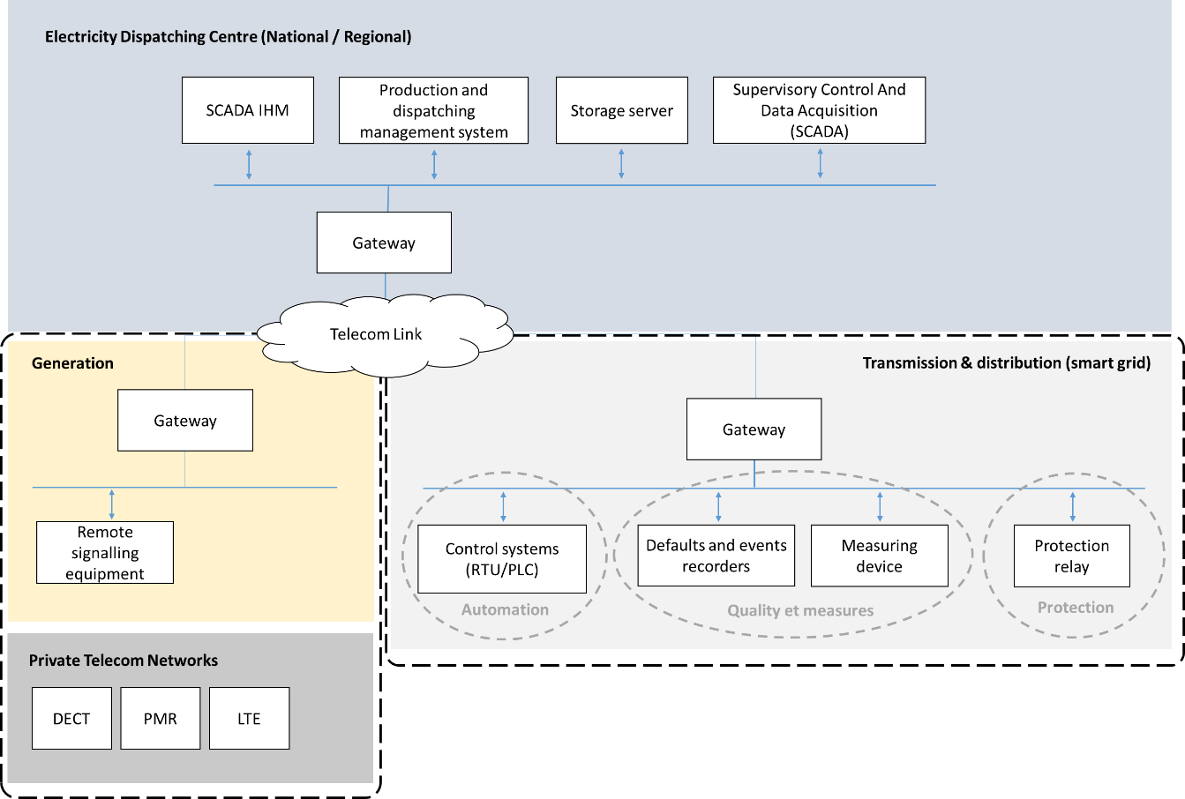
Figure 6: High level smart grid, production and dispatching architecture
Among measuring devices, Phasor Measurement Units (PMUs) need GNSS for time synchronisation in order to take reliable measures on the network and timestamp their measures. Control systems allow to control remotely the power grid that may require a good time synchronisation in order to perform their tasks in a coordinated way and ensure a coherent timestamp.
At the generation level (nuclear power station for instance), RTE provides the secondary adjustments of voltage and frequency-power. Generation control is handled by the dispatcher on the basis of data sent by the remote signalling equipment but also by telephone exchanges with operators from the production facility. The remote signalling equipment needs time synchronisation to be able to timestamp on the same time base the data transmitted to the distribution centres.
Employees of production facilities use on a daily basis private telecommunication networks such as:
- Digital Enhanced Cordless Telecommunications (DECT): used within production facilities for preventive and curative maintenance operations;
- Professional Mobile Radio (PMR): used outside the facilities in order to ensure the protection of sensitive areas and isolated workers;
- PMR LTE: intended to gradually replace current PMR and DECT means of communications in order to meet new business needs in mobility (voice, data, images, IoT).
These private means of telecommunication need time and frequency synchronisation to be able to work correctly.
Supervisory Control and Data Acquisition (SCADA) are in charge of the collection and the understanding of the data they receive. They are also in charge of transmitting order given by the operator via his interface (HMI) to the smart devices of the sub-stations or power stations. The data collected by SCADA servers are stocked on dedicated servers and analysed by management systems of electricity production and distribution.
Needs in synchronisation vary mainly with the Smart Grid applications that are synchronised. Except for the use of PMUs in WAMPACS systems, there are no standards defining with precision the needs of synchronisation of the different applications of energy.
In this study, it is proposed to use the SGAM (Smart Grid Architecture Model) developed by the coordination group Smart Grid CEN CENELEC-ETSI in order to illustrate in a holistic and simplified way the architecture of typical power grids.
The SGAM methodology proposes to sub-divide the typical architecture of a power grid in two parts:
- Domains: this is global value chain, from the production to the final user;
- Zones: this is the hierarchy of energy management systems, from the sensors positioned on the field to the electricity market.
Such division is illustrated in the figure below.
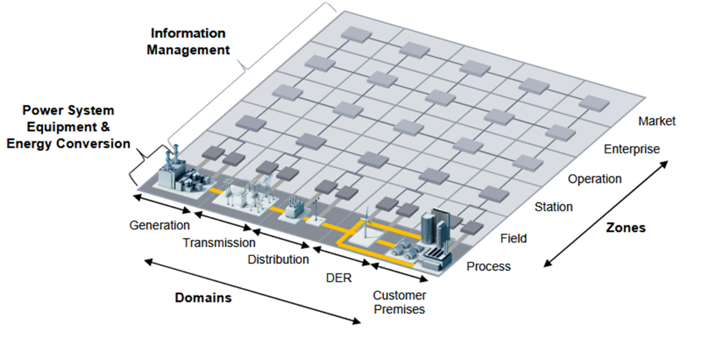
Figure 7: Reference architecture "Smart Grid"-1 (Source: CEN-CENELEC-ETSI smart Grid Coordination Group)
This document covers the first four domains which are Generation, Transport, Distribution, and Distributed Energy Resources (DER). Even if the customer premises domain is still in the middle of technological evolution with the introduction of new LINKY meters, it does not depend on GNSS synchronisation for its good functioning.
The needs in time synchronisation can be distributed on the SGAM model.

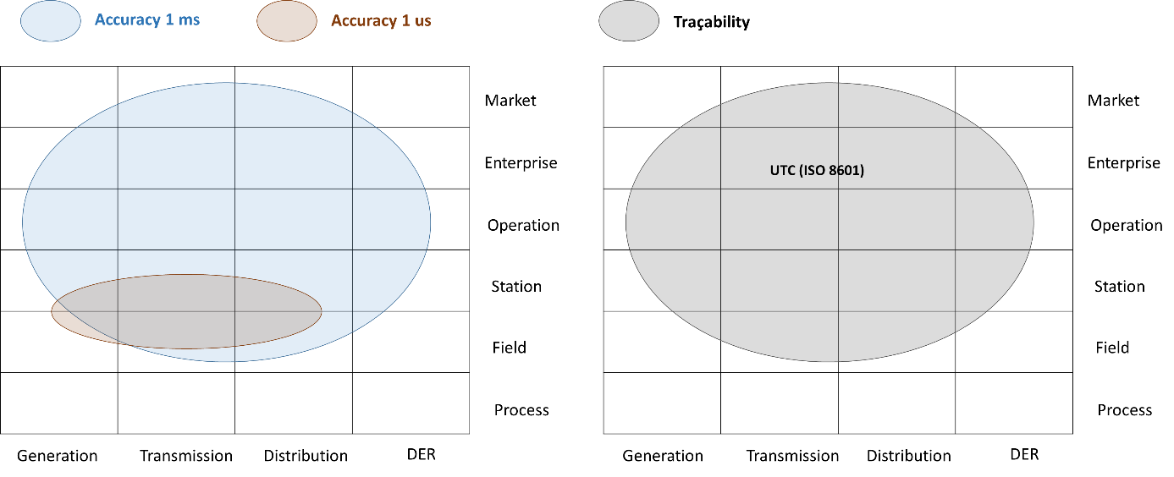
Figure 8: Synchronisation needs distributed on the SGAM model
Within electricity smart distribution network, GNSS is mainly used as a time source at the electrical stations composing the transmission and distribution networks but also within power stations.
Initially IRIG B was the most used mean of time dissemination within the electrical stations. Practically, the master equipment providing the IRIG B code was often equipped with a GNSS receiver. With the introduction of Ethernet and the appearance of new equipment relying on the use of a more precise time source, operators started to use NTP/SNTP protocols to synchronise their networks. NTP/SNTP time servers using GNSS as a UTC time source have emerged and can now be used by some equipment from the electrical stations like RTUs for remote monitoring and remote control of the electrical transmission and distribution network.
In addition, IEEE C37.238.1 standard pushes the use of PTP (IEEE 1588) to synchronise measurements coming from the PMU. PMU are generally located at the junction of transmission lines as well as on some nodes of the distribution network lines. They are often integrated within protection relays. PTP relies on the use of a Primary Reference Time Clock (PRTC) providing a reference time and frequency to PTP equipment. This reference clock can be synchronised with the help of GNSS receiver (UTC). However, some PMUs can also be directly connected to a GNSS time receiver without having to rely on the use of PTP.
Furthermore, PMU are not the only equipment needing a more precise synchronisation. For instance, online fault location methods can rely on the use of PTP. Indeed, there are synchronised location methods which suppose that voltage and current measurements between two terminals of the network are synchronised on a common time reference. Synchronised measures between two terminals of the power grid enable to make precise comparisons between, time of arrival of a progressive wave at the first terminal, and time of arrival of the same wave at the second terminal in order to locate with precision a potential default on the line.

Gas
The rise of decentralised green gases has shaken traditional operational models of gas network management. New opportunities are brought up by new information and communication technologies like smart objects, enabling a finer real time supervision of gas network even from difficult to access technical stations. Sensors can be deployed on the transport and distribution network and new tools are available for the operators in order to improve industrial management (predictive and preventive maintenance, assets management, etc.).
At the transportation network, SCADA tools are used to monitor and control pipelines networks sending high pressure natural gas. These tools have been designed with the following purposes:
- Connection and monitoring in real time of gas pipelines;
- Prevention and management of leaks and breakdowns in real time;
- Centralisation of the data from the gas compression stations;
- Inventory of gas stock.
At the distribution network, the concept of “Smart Gas Grid” (SGG) is more recent than the electric “Smart Grid” as it appeared officially in 2011 in a report from the European Commission on Smart Grid. SGG defines a modernised gas distribution network which integrates functionalities relying on the implementation of communicating elements. SGG have been designed to carry out the following functionalities:
- Increasing integration of green gas in energy consumptions;
- Optimisation of the performance and the security of gas supply;
- Use of more effective technologies, notably at the client level;
- Creation of gateway with other electricity, gas and water networks.
Gas network supervision is carried out with the help of various measurement equipment like temperature probes, chromatograph, spectrometer, intermediate meter and pressure sensors.
Unlike PMUs and power lines’ fault location systems, measurement equipment constituting the smart gas grid do not seem to need a precision of synchronisation of the order of the microsecond. However, the synchronisation of automation servers and remote automatons is still necessary in order to timestamp incoming and outgoing data of a smart gas grid.
Based on these observations and in the lack of standards defining precisely the needs in synchronisation of the SGG, it is assumed that a precision of the order of the millisecond is necessary in order to timestamp and correlate data transiting on the SGG. This need could change with the implementation of “power to gas” which will allow communications between power grid and gas network in order to produce methane or hydrogen through the absorption of the exceeding energy generated by green energies.

Oil
In the case of the oil sector, Supervisory Control and Data Acquisition (SCADA) is useful for oil production, storage and transportation.
SCADA is used similarly to the case of the gas sector in order to monitor and control pipelines networks carrying raw and refined oil. The area of application of SCADA are:
- Oil pipelines monitoring and management in real time;
- Prevention and management of leaks and breakdowns in real time;
- Oil pumping stations data centralisation;
- Pump and flux monitoring;
- Oil storage monitoring and management.
Like the gas sector, timing synchronisation accuracy in the order of the microsecond is not needed, unlike for some power grid equipment. A timing synchronisation accuracy of the order of the millisecond requirement is retained in order to operate SCADA information systems and to efficiently correlate collected data on gas and oil networks.
Unlike gas and electricity, oil distribution is mainly carried out by truck and does not seem to need remote surveillance, hence the lack of need in synchronisation.

Impact Assessment Main Outcomes
The table hereunder provides a synthesis of the most important impacts assessed by this study for each considered applications belonging to the energy sector.

Table 9: Energy applications impact assessment main outcomes
Application | Impact main outcomes
Electricity | In case of GNSS time and synchronisation error, time stamping errors can occur and be misleading for the smart grid operators increasing the risk of having a blackout.  Moreover, GNSS time and synchronisation errors may lead to inaccurate phase and frequency measurements. These measurements are processed by the protection mechanisms installed at nodes of the smart grid network. One protection system may detect a false risky situation (false positive) for the network and decide to shutdown part of the network for security and integrity purposes while it is not necessary.
Gas and Oil | No major or critical impacts in relation with the GNSS threats have been identified for the gas and oil applications by this study. Indeed, gas and oil applications have less stringent timing and synchronisation requirements than electricity. Moreover, their use of GNSS is less vulnerable than for the electricity and the gas and oil applications should be resilient to most of the GNSS threats.

Water Management

Overall Description and GNSS Use

Water Supply
The organisation of water and sanitation services in France is complex. Indeed, 20 094 local authorities are responsible for managing 31 409 drinking water, collective and non-collective sanitation public services. Many municipalities mutualise their resources by regrouping each other or transfer the mission of providing drinking water and sanitation public services to already existing other groups of municipalities (intercommunal association, community of communes or conurbation) or to a syndicate specifically created for that need (water syndicate, sanitation syndicate, etc.). Moreover, the drinking water and sanitation public service can be entrusted to specialised companies like Veolia or Suez in various ways: concession, leasing, management, public company.
From a legislative point of view the decisions from law, expressed in the French decree No. 2012 97 of January 27, 2012, have introduced several obligations that require those in charge to continuously control the performance of their network. Hence, a growing adoption of water supervision systems by the local authorities can be anticipated.
Water networks are becoming smarter thanks to the extension of information and communication technologies. The deployment of numerous sensors in the water distribution and transport networks provides a better understanding (take measurements), optimization (carry out analysis) and use of the network in better conditions.
Since the use of remote control and supervision of drinking water supply networks is relatively new there is no standardisation yet. The architecture of the teleprocessing system heavily depends on the needs and financial resources of the operator.
Storage, data reception and SCADA servers from the supervision centre rely on timing synchronisation and UTC tracking for timestamping, filing, analysing and correlating the data and the alerts received by the water network. The most likely protocol used is NTP and a precision of the order of 1 millisecond might be required as well as a traceability with UTC time.
Some local teleprocessing 4.0 stations allow to control, automate and manage remotely hydraulic constructions like pumping stations or storage tanks. These local teleprocessing stations are synchronised in order to timestamp the data at the source. They also allow to manage access control to the infrastructures. Access attempts to the infrastructures are timestamped and filed in a specific journal for security reasons.
The SCADA servers of the supervision centre and the local teleprocessing stations rely on NTP server for their synchronisation. These NTP servers can use GNSS as a primary time source.

Dam and Water Impoundment
There are 510 dams in metropolitan France and 12 in DOM COM. Dams provide electricity but are also used as water retention ponds to overcome potential drought or avoid floods.
An inappropriate control of a dam or a water impoundment can have a catastrophic impact on a society. A flood can cause a disaster that remains complex to predict and develops rapidly. Hence it is necessary to use industrial supervision and control systems (SCADA) in order to provide a decision support to the operators of a dam or a water impoundment.
The structure of SCADA systems supervising a dam does not differ from those used for managing transportation network, drinking water distribution, electricity, gas and oil. In the case of a dam, the SCADA system is used for the following applications:
- Allow a real-time control of the water stored in the dam;
- Provide measures and alerts on weather conditions;
- Predict the impact of an input of water in the dam’s tank;
- Allow a remote control of discharge operations;
- Alert the operators in case of a sudden change of the dam’s flow;
- Provide a record of the collected data by the supervision system.
Local teleprocessing stations (RTU or PLC) used by the control and supervision servers might need synchronisation with a precision of the order of the millisecond in order to timestamp the source of the received data and the sent messages.
Like the drinking water supply network, SCADA servers and data storage & reception servers need a synchronisation with a precision of the order of the millisecond as well as a traceability with UTC time.
Information is timestamped at the source by programmable logic control units and recorded at the database of the SCADA servers. In order to avoid uncertainty on time, the PLC clock of the automation & remote monitoring network can be considered as master clock and be used as the time reference for the clocks of the other units. Besides, PLC can rely on the use of NTP time servers when a traceability with UTC time is necessary with a precision of the order of the millisecond. These NTP time servers can rely on the use of GNSS as a time source.
GNSS can be used to synchronise multiple connected sensors (usually accelerometers) used for the audit of the dam and the detection of potential deformation.

Impact Assessment Main Outcomes
The table hereunder provides a synthesis of the most important impacts assessed by this study for each considered applications belonging to the water management sector.

Table 10: Water management applications impact assessment main outcomes
Application | Impact main outcomes
Water supply | GNSS timing and synchronisation errors can lead to the alteration of the data time stamping function or to the malfunction of SCADA servers used by the operators for the management of hydraulic work stations. It is assessed that such vulnerabilities can potentially have an impact.
Dam and water impoundment | GNSS timing and synchronisation errors can lead to the alteration of data time stamping functions or to the malfunction of SCADA servers used for the dam remote supervision and control. In addition, some of the dam supervision systems (monitoring sensors network) rely on the use of GNSS to support the detection of dam deformation as well as the wear monitoring in real time. Such dam functions malfunctions if extended in time may raise the risk of experimenting a dam failure which would potentially have an impact.

Finance

Overall Description and GNSS Use

Stock Exchange
Financial services rely on various information systems and networks needing a high level of availability, security and reliability. Financial markets are highly regulated because of the influence of banks and stock exchanges on them. Regulations aim to fix the weaknesses found during the 2008 financial crisis while adapting to new practices and trends that have appeared on the market (high frequency trading, instability of raw materials, increasing use of off-exchanges). In this respect, the European Parliament and the Council of the European Union have formulated a set of regulations MiFID II / MiFIR mainly comprised of one directive and one regulation:
- The directive 2014/65 of May 15 2014 called MiFID II rules the activities of investment companies, defines rules of protection for investors and enacts minimal requirements for penalties.
- The regulation 600/2014 of May 15 2014 MiFIR deals with market organisation, the access to European markets by third country companies and the power of control authorities.

Banks
Banks host data centres and server rooms that need to be synchronised in time. Like stock exchange networks, all the clocks need to share the same time scale as a reference: the coordinated universal time (UTC).
A bank can offer different services for its customer like managing and controlling online or credit card payments. For these services a synchronisation with the UTC hour is necessary for a good functioning of the servers and the virtual machines, for the implementation of some security and authentication mechanisms (notably for online payments or document electronic signature). It is also necessary to allow a chronological logging of the transactions. The synchronisation also plays a role in the automation of banking systems backups.
In order to establish a secure web connection with their clients, the web servers of the banks use the security protocol HTTPS (HyperText Transfer Protocol over TLS). The bank’s server has to provide a certificate that needs to be recognise by the client in order to establish an encrypted communication inside a secure tunnel. The current format of digital certificates is the x509 in its version 3. Among other information, a certificate contains a starting and an expiration date. Hence the receiver and the emitter of the certificate must be synchronised on the same time reference. Indeed, a loss of synchronisation may compromise the security protocol which would translate to the rejection of a certificate that is normally approved.
Banks can also use certified timestamp. The certified timestamp protocol TSA RFC3161 is used to deliver a timestamp and a signature ensuring the integrity and authenticity of the timestamp. No one can modify that type of timestamp, not even the owner of the information that has to be timestamped. A trusted third-party time stamp or a timestamp authority is necessary for this operation. The trusted time stamp has to ensure the traceability with the reference UTC time of the provided timestamp.
In the bank sector, the needs in synchronisation accuracy are less than in the stock exchange ones. A NTP server is the most common type used to spread a time source to several bank servers. This protocol offers a precision of the order of the millisecond as required by MiFID II. Besides, the use of a GNSS receiver by the NTP time server guarantees a UTC traceability.
Practically, a NTP client can also rely on the use of a “Grandmaster” PTP clock thanks to the use of a PTP/NTP bridge allowing to switch from NTP protocol to PTP protocol. This allows bank servers to take advantage of the remote synchronisation services offered by national laboratories (NPLTime for instance) or by private companies like ICE. It is also possible to directly connect to remote stratum I NTP servers.
Moreover, some banks can guarantee a certain level of redundancy in case of a loss of GNSS by interconnecting theirs synchronised sites to each other.

Impact Assessment Main Outcomes
The table hereunder provides a synthesis of the most important impacts assessed by this study for each considered applications belonging to the finance sector.
Table 11: Finance applications impact assessment main outcomes
Application | Impact main outcomes
Stock exchange | Important synchronisation errors in the stock exchange information system may lead to a sudden stop of the high frequency trading activities which could have an impact for the financial market. Existence of some industries/brokers may be threatened by such a sudden stop of the stock exchange activities.
Banks | Banks information systems can be impacted in case of important synchronisation errors. Bank customers could lose their accesses to their bank accounts and e-payment could be impossible for them. In case of a bank information system malfunction extended in time, there could be an impact on the financial market.

Civilian State Activities

Overall Description and GNSS Use

Metrology
In France, the Laboratoire National de métrologie et d’Essais (LNE) holds the role or national institute of metrology. It is the France representative at the Bureau International des Poids et Mesures (BIPM). As regard the time & frequencies related activities, the LNE is composed by two laboratories: the LNE SYRTE (national laboratory) and the LNE LTFB (technical unit).
UTC time is established at the BIPM. A total of 450 atomic reference frequencies coming from about 85 time & frequency laboratories around the world are processed in order to establish UTC time. These laboratories are often integrated with metrology institutes and can carry on activities on the following fields:
- Development of clocks and primary standards of frequency;
- Contribution to international projects on synchronisation;
- Broadcast of time signals and standard frequencies;
- Research of innovative means of time and frequency comparisons;
- Research on clocks and time-scale algorithms;
- Calibration of equipment.
Main mission of the national laboratories is to contribute to the elaboration of the UTC and to establish a local UTC representation entitled UTC(k), the UTC(k) can be established on the basis of several atomic clocks’ observations.
In France, UTC(OP) is at the origin of the legal French time. The generation of UTC(OP) is done based on a hydrogen maser clock output piloted in frequency on a daily basis by primary and secondary standard clocks, and piloted each month by the UTC.
National laboratories can compare between them their UTC(k) through various time transfer and comparison means. The GNSS can play a role in those transfer and comparison means through the use of transfer modes such as “common view” or “all in view”. At the time being, the BIPM compares the UTC(k) of national laboratories in priority by using the “all in view” transfer mode.
Thanks to the IGS products, it is possible to apply the “all in view” transfer in order to measure the delta between a local clock in a GNSS receiver and the IGS common time scale. Such technic allows to overpass the “common view” transfer mode constraints (no need to have the same GNSS satellite in view for both the clocks to be compared) and to link two laboratories on longer distances than with the “common view” technique.

Meteorology
In France, “Météo France” is in charge of weather forecasts and the anticipation of dangerous phenomena.
Since the early 1990s, various projects allowed Météo France to equip itself with an observation network composed of ground stations, meteorological satellites, drones, radars and embedded sensors on planes or ships. Some of those measuring equipment need a good timing synchronization in order to fulfil their mission, like meteorological radars or lightning detectors for instance.
Météo France has developed increasingly efficient digital weather forecast models at various scales: AROME and ARPEGE. These models enable the modelling of local phenomena on increasingly thin mesh but necessitate numerous calculations that can be achieved in time only by supercomputers. These supercomputers are composed of a large number of processors that need to be synchronized on a common time base in order to operate optimally in parallel.
Weather ground stations do not fully rely on the use of GNSS for timing synchronization and data timestamping. This also applies with partners weather stations that can also use other time sources such as NTP or Allouis time signal (ALS162).
For the measurements taken at sea, drifting buoys wave recorders can rely on the use of GNSS receiver to correct their local clocks and timestamp their measuresments.
Each low frequency lightning sensor from the “Météorage” network owns a GNSS receiver in order to localise lightnings thanks to the hyperbolic time of arrival. GNSS receivers provide UTC time to each lightning sensor.

Impact Assessment Main Outcomes
The table hereunder provides a synthesis of the most important impacts assessed by this study for each considered applications belonging to the civilian state activities sector.

Table 12: Civilian state activities applications impact assessment main outcomes
Application | Impact main outcomes
Metrology | No important impact in relation with the GNSS threats have been identified as regard the metrology by this study. Indeed, only the time transfer techniques rely on GNSS. In case of a GNSS threat, a smaller share of the national laboratories should be able to pursue their contribution to the UTC through the use of communication satellites for time transfer (TWSTFT) to the BIPM or comparisons between each other. Elaboration of the UTC should not be immediately impacted. Other time and frequency laboratories should indeed be able to continue to operate efficiently during a long time even without having access to the UTC(OP).
Meteorology | GNSS timing and synchronisation errors could lead to the invalidity of some of the data collected for the small-scale forecasting model (AROME) which could have an impact. Indeed, AROME is used for anticipating local and dangerous phenomena such as Mediterranean heavy rainfall, violent storms, fog, hurricanes at the west indies and heatwaves.

Electronic, Audiovisual and Information Communication

Overall Description and Use
Mobile telecommunications networks in France have become more complex and denser with the appearance of new communication and information broadcast technologies (FttH, 2G, 3G, 4G, Digital Terrestrial Television, IoT networks, the internet, etc.). The Autorité de Régulation des Communications Electroniques et des Postes (ARCEP) is in charge in France of setting up the coverage of these networks.
Following the opening to competition of the communication market in 1998, the number of private and public telecommunications operators have risen in order to cover the growing demand. Interconnections and interdependences between communication and broadcast networks have increased too.
Four main types of networks and means of telecommunication can be distinguished:
- Fixed telecommunications networks (PSTN/VoIP);
- Mobile telecommunications networks;
- Cable telecommunication networks (the internet);
- Satellite telecommunications;
- Radio and TV broadcast services;
- Private Mobile Radiocommunications (PMR) systems.

Fixed Telecommunication Network (PSTN/VoIP)
PSTN:
Currently the national phone service relies on the Switched Telephone Network (PSTN) (also called Switched Telephone Network (PSTN)).
The PSTN network is expected to be replaced by the IP technology to enable the broadcast of voice over IP (VoIP). In France, since the end of 2018, the new lines in mainland are built on VoIP network and not PSTN anymore. The termination of the commercialisation of new PSTN lines started in November 2018 for analogue and November 2019 for digital. For the overseas departments, it started in November 2020 for analogue and November 2021 for digital. However existing PSTN lines are still used and the technical migration should progressively start around 2023/2024.
Timing and synchronisation functions are mainly used to ensure the multiplexing between switches and enable interconnections at the transport network. The multiplexing technology used varies with the type of transmitted signal (analogue or digital) and not all multiplexing modes rely on a synchronisation of the network nodes. For instance, in analogue transmission, it is a frequency division multiplexing so it just needs a frequency synchronisation.
The table below summarise the time requirements for a synchronous network (UIT G standards).
Table 13: Time and frequency requirements for a synchronous network
Reference | Clock type | Maximum Frequency Error (ppb) |  | Maximum time interval error (ns)
 |  | Pull-in | Hold-over (1 year)
UIT G. 8261  UIT G.811  UIT G.812 | Type I | ±10 | Pas Applicable | 160
 | Type II | ±16 | ±16 | 100
 | Type III | ±46 | ±46 | 100

In recent years, fibre optic links and SONET/SDH have been favoured for the installation of digital PSTNs. SONET/SDH networks rely on primary central reference clocks (PRC) for synchronisation.
In France, PSTN synchronisation first took place between 1986 and 1988. At this time, the PSTN synchronisation system used as references seven atomic clocks with a precision of ${10}^{-12}$ (4 in Paris and 3 in Lyon). The recent evolutions of networks tend to implement less centralised architectures with more Primary Reference Clock (PRC) using GNSS. These new networks are often based on ring topologies where several synchronisation links are available for the same SONET/SDH equipment. GNSS PRC keep a Caesium reference to ensure their functioning in case of a loss of GNSS.
The distribution of the PRC signal through the different layers of the synchronous PSTN network is regulated by the G series of the UIT documentation and particularly UIT G.8261 and UIT G.812.
Voice Over Internet Protocol (VoIP):
Voice over IP was born in November 1996 with H323 protocol developed by UIT-T (last version dates back to 2009). However, this protocol has shown limits and incompatibilities with the use of firewalls. Such limitations have pushed for the large adoption of a more recent protocol for internet telephony in France: SIP.
The use of voice over IP does not depend on the size of the network and can be used on both local network and the internet if the bandwidth and the latency on the network are acceptable.
The transmission delay of IP packets through the IP network consists of a fixed delay (propagation delay and average delay in the waiting queues of the routers) and a random variable delay corresponding to the jitter (random variation of the waiting queues during IP packets sending). In order to control and limit jitter on networks, memory buffers are used at the reception. Buffers allow packets to be stored for a moment.
ITU-T G.114 recommendation shows the impact of a transmission delay on the interactivity level of a conversation but also on its quality.
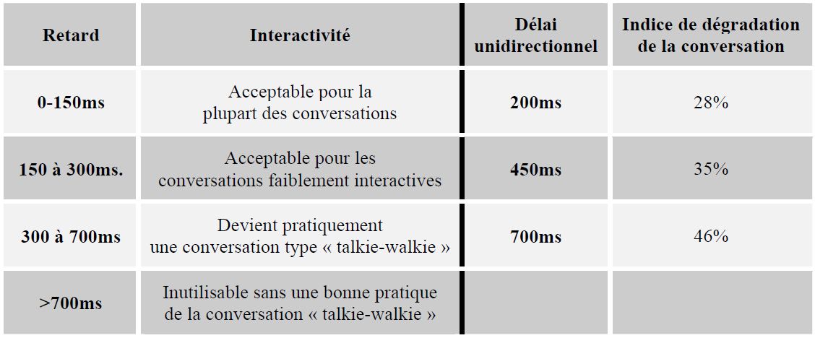
Figure 9: Indice de dégradation de la conversation en fonction de la latence sur le réseau IP (source: ITU-T)
Practically, the effects of a time drift between transmitting and receiving clock are most of the time inaudible to ear. However, strategies are implemented in order to guarantee the quality of service of VoIP applications. Some of them do not need time synchronisation whereas others need a time synchronisation of the IP network nodes. The latter enable the latency estimation on the IP network in order to adapt the length of the memory buffer used at the reception and thus limit the loss of data.
The arrival of VoIP implies the replacement of SNOET/SDH equipment for Ethernet equipment in order to establish IP connections but also a change in the means of frequency synchronisation. SyncE technology has been adopted in order to supply a frequency traceability for VoIP. In addition, the introduction of Ethernet standard and IP protocol enables the use of other means of synchronisation like NTP or PTP. Each of these synchronisation technologies still need the use of GNSS as a complement of the already involved atomic clocks.

Mobile Telecommunication Network
Digital cellular networks are run by mobile network operators and provide vocal and data services to the users. Digital cellular technology constantly evolves in relation to the increase of the demand in data transmission speed.
In France, there are two categories of mobile network operators:
- The public operator: Orange
- Private operators: SFR/Altice, Bouygues Telecom and Free
However, those major operators are not the only one to operate telecommunication infrastructures on French territory. Virtual operator can use « in roaming » the network from one of the operators. The choice of the host operator can change depending on commercial agreements between the involved companies.
Mobile communication networks have constantly evolved since the early 2000. The first GSM networks evolved to GPRS and Edge standards, which were optimized to transferring data (MMS, Internet access, etc…) needing higher rate than telephony (voice). UMTS system allowed data transfer with variables rates enabling, in particular, an access to the internet. LTE (Long Term Evolution) networks, commercially called 4G, represent a major evolution compared to GMS and UMTS networks. LTE and LTE Advanced are optimised for data transfer with fixed rates and guarantees for television, telephony, videophone, video playing applications or with variable rates for applications such as the internet, interactive games, mapping (geolocation).
Every telecommunication network need both frequency and phase (time) synchronisation. Regarding UMTS and LTE, ETSI and 3GPP have published documents specifying the requirements in frequency and phase synchronisation for radio interface in order to ensure a secure transfer between the base stations of the network.
The table below provides the maximum acceptable frequency errors, time difference and errors of date/hour given by ETSI/3GPP documents. For each generation of application, the reference of the related 3GPP document is provided.
Table 14: Timing and synchronisation requirements for Mobile telecommunication
Reference | Applications | Type of Base Station | Maximum Frequency Error (ppm) | Maximum Time Difference (µs) | Maximum Date/Hour Error (µs)
TS 45.010 | GSM/EDGE | Extended base station | ±0,05 | None | None
3GPP2 C.S0002-E  3GPP2 C.S0010-C | CDMA/CDMA 2000 | Extended base station | ±0,05 |  | 1
TR 25.866 | UMTS (3G)/W-CDMA | Extended base station | ±0,05 |  | 2,5
TS 36.133  TS 36.922 | LTE (4G) - TDD | Extended base station (<3km radius) | ±0,05 | ±3 | None
 |  | Extended base station (<3km radius) |  | ±10
 |  | Base station of the area of residence (> 500m radius) |  | ± 1,33 +  Propagation time
 |  | Base station of the area of residence (< 500m radius) |  | ±3
Based on proprietary technology |  | Small Cells |  | ±1,5
TS 36.104 | LTE (4G) – FDD | Extended base station | ±0,05 | None
 |  | Extended base station | ±0,1
 |  | Extended base station | ±0,25
Under discussion at 3GPP | LTE - Advanced | Extended base station | ±0,016 / ±0,05 | ± 1.5 / ± 5 | -
Frequency synchronisation of radio interface allows to minimise disturbances and secure transfers between base stations. On TDD mode, phase (time) synchronisation optimises the use of bandwidth and improve the capacity of the network. In the case of GSM, stable oscillators and the primary E1 signal of Public Switched Telephone Network were used by GSM base stations which needed only a frequency synchronisation. This primary E1 signal continued to be use by 3G base stations until the introduction of a packet network with 3G and 4G. With the introduction of IP protocol by 4G, new synchronisation protocol like NTP, PTP and syncE are now used by base stations. These synchronisation protocols require the installation of PRCs that use GNSS as a time source and/or atomic clocks.

Internet
The internet network is a worldwide network consisting of the interconnection of a multitude of small or big networks all using IP (Internet Protocol) and belonging to Internet service providers. While using the same protocol, these networks can use heterogenous physical transport layers.
Some sections of the Internet network (Internet backbone in particular) use optic links often relying on wavelength multiplexing technologies (CWDM and DWDM). Currently, the optic network is of a worldwide scale and carry data of highly varied nature (voice, video, texts, files).
Backbone networks form the core of the Internet network and serve to link on long distances metropolitan area networks. The main function of these network is the massive transport of information. Initially based on synchronous technologies like SONET/SDH, the growing demand in bandwidth has led to the introduction of wavelength multiplexing techniques (DWDM).
Metropolitan area networks (MAN) lie between long-distance and access networks. A MAN network covers less distance than a long-distance network. In addition, the architecture of long-distance networks remains stable while MAN must adapt to the introduction of new services and types of traffic. Depending on the needs, MAN networks use different protocols and have various need in bandwidth. Like long-distance network, MAN networks were traditionally based on SONET/SDH technology. Now they have adopted Ethernet standard and IP protocol.
Access networks are the closest to the user and at the end of MAN. These networks use different protocols and different infrastructures. Users are many and range from great companies to residential use. In these networks the use of IP technology predominates.
In the case of SONET/SDH, some clocks, positioned at each end of the backbone, use GNSS for synchronisation functions. However, DWDM technology does not seem to depend on a time source to work.
While time does not play an important role in the Ethernet standard IEEE 802.3, Time Sensitive Networks (TSN) have been defined by the work group IEE 802.1. These networks are necessary for applications such as real time audio/video streaming. Hence, time sensitive MAN networks can use GNSS in order to synchronise a primary clock providing a central time source to the network switches as well as to the peripherals.

Satellite Telecommunication
Satellite communications or SATCOM enable to transmit different types of information like radio, television, data and voice all around the world. The infrastructure of SATCOM operator network is generally composed of satellites and ground resources.
Communication satellites can be of several types (geostationary or non-geostationary) and hence evolve on different orbits. Their coverage can be global, regional or local. SATCOM can be used in multiple fields of application, some of which are essential for the good functioning of a nation:
- Maritime;
- Aviation;
- TV broadcast;
- Mobile telecommunication;
- SCADA;
- Government services.
Satellite means of communication are available to users through ground stations or mobile gateways.
The needs in synchronisation of satellite means of telecommunication vary according to:
- The type of signal (voice, data, video, analog or digital);
- Transmission techniques used by the satellite (frequency multiplexing, time multiplexing, modulation);
- Multiple acces techniques used by the satellite (FDMA, TDMA, CDMA, SDMA, RDMA);
- Standards and protocols used by the satellite (Digital Video Broadcasting, TCP/IP, ATM).
Satellite using TDMA need a time synchronisation whereas those using FDMA need a frequency synchronisation (tuning).
Master clocks can be embedded in satellites for synchronisation purposes. These master clocks are used to control local oscillators in transmission and reception channels.
In commercial satellites, master clocks are generally controlled from the ground in order to remain in tolerance levels defined in time and frequency
More sophisticated systems can be implemented for government satellites. For instance, the master clocks of the oscillators can be locked on a ground reference.
The use of GNSS receivers is widespread in satellite control stations and in telecommunication gateways.
GNSS information is used by the:
- Synchronisation function of the links in TDMA for satellite and terrestrial links
- Time distribution services based on NTP for the satellite surveillance and/or control (TT&C function)
GNSS receivers are generally coupled with local oscillators (atomic). However, it should be noted that SATCOM industry is becoming more confident in adopting synchronisation solutions based on GNSS information.

Radio and TV Broadcasts Services

Radio Broadcast
French radio landscape is very diverse. More than 1,000 private and public operators broadcast in all French territory.
In France, radio can be classified in four categories:
- Private FM radios;
- Public FM radios;
- Temporary radios;
- Radios broadcast by other networks.
There are near 4,700 usable frequencies on the FM band, which range from 87.5 MHz to 108 MHz, which represents around 900 radios.
Only the synchronous FM radio (highway information 107.7 MHz), broadcast all along French highways, seems to need a time synchronisation. FM transmitter localised along highways are synchronised in order to avoid jamming in overlapping areas. This synchronisation is possible thanks to the installation of radio antennas along a same linear axis and the use of synchronous iso-frequency radio broadcasting technology. Not all FM radio antennas can use this radio broadcasting technology as a result of their geographic location in relation to each other.
It is possible to use clocks which are radio controlled by wireless time distribution services or by the use of GNSS.

TV Broadcast
There are three core businesses related to the TV broadcast activity. They can be carried out by the same company or outsourced to business partners:
- Service editors, which produce, direct or propose content to be broadcast;
- The broadcaster, which provide programs to the public, notably over the airwaves, by satellite, by cable or through a cable network;
- The network operator which handles technical operations related to transmitting and broadcasting programs to the public.
TV broadcasting industry need to synchronise the transmission of different types of data: video, audio, metadata. Synchronisation signals like “Black and burst” (or TLS) for video, DARS for the audio or timecodes (ST12) for the time of the day (used by automated systems handling the broadcast of television programs), are implemented in order to synchronise analogue television.
Cameras from television studios also need to operate synchronously. All the video signals must be controlled by a reference frequency and be adjusted in phase. The servers from studios and control rooms have to be synchronised in time in order to allow applications such as the addition of special effects, live or replay as well as slow motion.
With the digitisation and the introduction of IP protocol, the synchronisation is still necessary for TV broadcasting:
- Cameras still need to be synchronised with each other;
- Digital TV use synchronisation in order to broadcast on one frequency;
- Video streaming use synchronisation in order to maintain the synchronicity between audio, video and subtitles.
TV broadcasters should slowly turn to PTP solutions but not at every level. In addition, the introduction of PTP remains slow due to the heavy investments already made for transition to UHD (Ultra High Definition). Although old synchronisation standards are less efficient, they are still supported by new equipment. Furthermore, some equipment that can generate Black and burst signals, DARS and timecode can now operate in PTP slave mode.
Synchronisation signals necessary to the simultaneous transmission of several types of data are centrally generated by a master clock. Master clocks can be linked to a GNSS time source. These synchronisation signals operate in one frequency range adapted to media (audio and video) and are easily transmitted to television equipment.

Private Mobile Radiocommunications (PMR)
Several Private Mobile Radio (PMR) technologies are available on the market. They are based on the three following standards:
- TETRA (ETSI standard)
- TETRAPOL (public specification)
- P25 (TIA standard)

TETRA
Terrestrial Trunked Radio (TETRA) is a digital trunked mobile radio standard developed by the European Telecommunications Standards Institute (ETSI). This standard is the result of works involving different manufacturers, users, operators and other experts supported by the European Commission and ETSI. The first version of the standard was published in 1995.
The functioning of PRM radio equipment is based on standards such as MPT 1327, TETRA, APCO 25 and DMR, designed for a specific use by specific organisations.
TETRA standard has been developed to specifically meet the needs of several categories of users like emergency services such as the police, firefighters, medical intervention units. The result is a system equipped with a scalable architecture ranging from a local coverage of a single site to an extended national coverage.
A minimum level or precision in timing and frequency synchronisation is necessary to enable handover between TETRA base stations. TETRA standard has been redefined to achieve higher data rates. Named TETRA Enhanced Data Service (TEDS), this standard was finalised by ETSI in 2005.
At the industry level, mobile manufacturers and the other actors from PMR networks implemented partnerships for the development of PMR solutions based on LTE (4G) technology. Indeed, LTE seems to be a technology likely to fit all or parts of the requirements related to PMR. The development of PMR solution based on LTE (4G) technology leads to more strict frequency and time synchronisation requirements for a PMR network.
PMR network use GNSS time for the synchronisation of time intervals of TDMA or FDMA systems and also for handovers between base stations. Indeed, GNSS time serves to ensure the synchronisation of the radio interface in order to enable the handover and the allocation of communication channels. This allows the user to switch from one coverage area to another without any loss of communication.
GNSS time is used to readjust a time and frequency generation system that generally uses quartz clock with characteristics designed to provide the maintenance of the service in case of a loss of GNSS signal during a given period of time. The loss of GNSS time will lead to a gradual deterioration of the service.
In addition, the limitation of PMR technologies in terms of data transmission, combined with the improvements brought by LTE, enable to imagine that a PMR network can be completed in medium-term with LTE technology in order to guarantee higher quality services like video streaming and data transmission. This functionality could remain under the control of PMR suppliers.
The synchronisation is achieved with the help of GNSS T&S receivers installed at each base station. This allows the users to switch from a coverage area (base station) to another one without service interruption.
The loss of GNSS synchronisation will lead a to a gradual deterioration of the service since local oscillators have a holdover capability.

Impact Assessment Main Outcomes
The table hereunder provides a synthesis of the most important impacts assessed by this study for each considered applications belonging to the electronic, audio-visual and information communication sector.
Table 15: Electronic, audio-visual and information communication applications impact assessment main outcomes
Application | Impact main outcomes
Fixed telecommunication network (PSTN/VoIP) | Depending of the GNSS threat, some services of the fixed telecommunication network can be impacted. Urgency call as well as economic actors which rely on it for their businesses would be affected.
Mobile telecommunication network | Depending on the GNSS threat, some services of the mobile telecommunication network can be impacted. Urgency call services would be in particular affected. The alteration or unavailability of a mobile telecommunication network would also have a substantial impact on the economic actors which rely on it for their businesses.
Internet | No major or critical impacts in relation with the GNSS threats have been identified for the internet by this study.
Satellite telecommunication | Depending on the GNSS threat, some satellite communication systems can be affected. A degradation of the satellite telecommunication services would have an impact on the satellite services providers businesses (e.g. TV broadcast, voice call, internet), as well as on systems located in remote or on hardly accessible places.
Radio and TV broadcasts services | Quality of the TV broadcasting services could be impacted by a GNSS threat. In addition, the economic cost for TV actors could be important as a degradation of the TV broadcasting could induce loss of viewers and advertising revenue.
Private Mobile Radiocommunication | It is estimated that some GNSS threats could induce the unavailability of some PMR networks that are used by essential safety and security services (police, health, firemen).

Rail Communications

Overall Description and GNSS Use
In France, the Global System for Mobile communication – Railways (GSM-R) network is a communication protocol based on GSM technology as specified by 3GPP standards. It has been progressively installed on the French railway network since 2010 and currently covers around 16 000 km of the railway tracks with more than 2 600 radio antennas installed. The infrastructure is owned and operated by “SNCF Réseau”, an SNCF subsidiary.
The GSM-R network allows communications between trains and traffic care points and between railway operators on the field via the use of radio links. The following types of data are transmitted: vocal communications, signalisation data, emergency call, maintenance communications and emergency calls.
The GSM-R network is composed of the following systems:
- The Cab-radio which is the communication system embedded on the trains allowing data exchanges and vocal communications for speeds up to 500 km/h;
- The Radio Block Centre (RBC) which is the ground equipment receiving and sending signalling data to the train. An RBC covers a designed geographical area which is composed of many successive GSM-R cells;
- The Base Transceiver Stations (BTS) which are antennas and radio equipment installed near the tracks and ensure radio coverage;
- The Base Station Controller (BSC) which is a communication node between BTS and RBC.

The following figure illustrates the GSM-R network architecture:
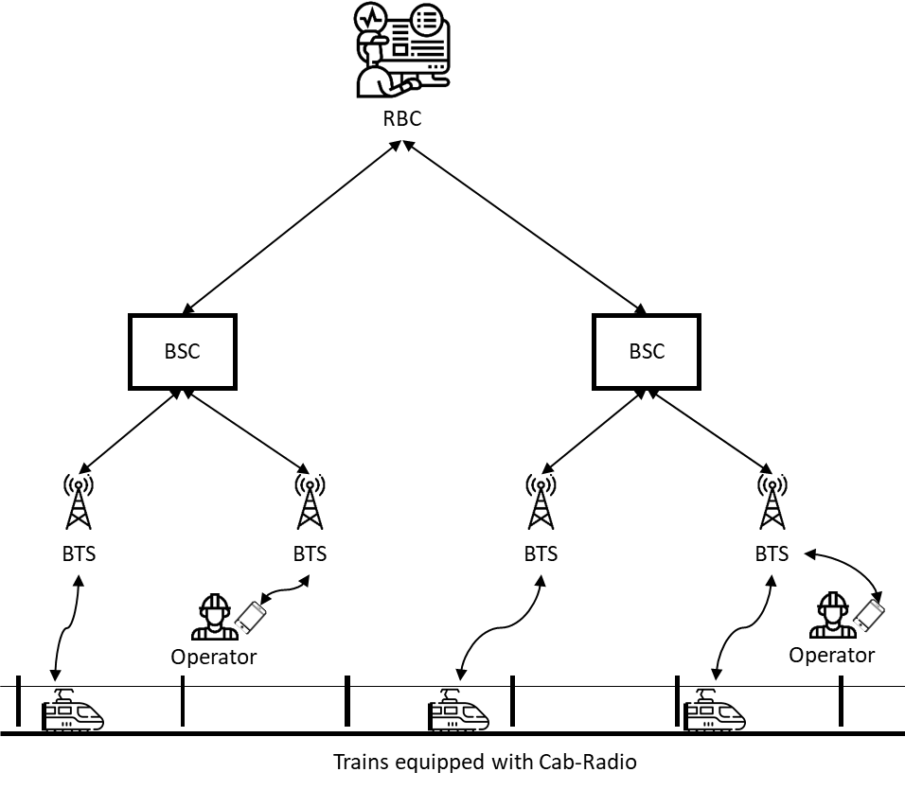
Figure 10: Simplified architecture of the GSM-R network
The synchronisation needs of the GSM-R network are related to the following functions:
- Handover: When a train evolves on the network, the Cab-radio successively communicates with many BTS antennas put along the railway track. The handover is the process used to maintain the connection between the mobile antenna embedded on the train and the GSM-R network when passing from a BTS cell to another.
- The Time Division Multiple Access (TDMA): A temporal multiplexing protocol increasing the data exchange capacity of the GSM-R network. It allows up to eight users to communicate on a same physical communication channel by dividing the channel in eight time slots. Each user broadcasts on its attributed slot. To ensure proper slot allocation, the transceivers need to be synchronized on a same time source.
- The frequency generation: The transceiver frequency stability is needed for proper GSM-R communication and is ensured by the clock stability on which the single source of frequency is generated.
The following table provides synchronization needs of the GSM-R as expressed in the technical specifications of 3GPP TS 45.010 and the system specifications provided by the GSM-R user group (Version 16.0.0):

Table 16: GSM-R synchronisation needs
Time of handover execution for vocal communications | Time of handover for signalling data transfer | Temporal synchronisation for TDMA | Frequency stabilisation
> 350 ms (95%)  > 500 ms (99%) | > 300 ms (95 %)  > 450 ms (99% ) | 30 ,5 µs | > 0.05 ppm

NOTE: The handover time can be reduced to 150 ms using BTS synchronised on a single time source.

As the GSM-R is based on GSM2+ standards, the use of GNSS for time synchronisation is described in section 3.4.5.1.2.

Impact Assessment Main Outcomes
The table hereunder provides a synthesis of the most important impacts assessed by this study for the GSM-R application.

Table 17: GSM-R impact assessment main outcomes
Application | Impact main outcomes
GSM-R | GNSS degradation could lead to important operational issues (e.g. reduction of train speed or stopping of trains) that has a financial impact on railway operators.

Maritime AIS

Overall Description and GNSS Use
The Automatic Identification System (AIS) is a mandatory system for all vessel build after 2002. It is a VHF communication system allowing automatic data exchange between two vessels, between a vessel and the coastal authorities or between a vessel and Aids to Navigation (AtoN). Information exchanged can be static data (e.g. vessels radio identifications or names), flexible data (e.g. vessel load or destination) or dynamic data (e.g. vessel routes or positions, based on GNSS). From an operational point of view, AIS communications aim at:
- Enhancing traffic surveillance thanks to navigation data exchange between vessels, reducing the risk of collision;
- Enhancing traffic gestion in congested area thanks to data communication between the vessels and the coastal stations;
- Performing automatic vessel navigation reports to coastal authorities;
- Securing data exchange between the vessels and the coastal authorities to simplify the control of maritime navigations and cargos;
- Collecting maritime traffic information to analyse traffic maritime evolution, performing risk studies or gathering information on maritime accidents;
- Providing navigation information to vessels thanks to AIS beacons on AtoN such as lighthouse or buoy. Information can be static data (e.g. AtoN position and ID) or dynamic information (e.g. current and meteorological data).
The AIS transceiver communicates on two dedicated VHF channels (161,975 MHz and 162,025 MHz). As the same radio wavelengths have to be shared by multiple transceivers, a Time Division Multiple Access (TDMA) protocol is used to avoid data loss in case of potential interferences with two receivers emitting simultaneously. Hence, the AIS communication channels are divided in 2 250 slots by minutes, each slot being used by a single transceiver in a defined time period.
To ensure proper data exchange, the transceivers need to be synchronized on a same timing source with at least 104 µs accuracy. GNSS are used to provide the reference time. The following figure illustrates the use of GNSS for AIS time synchronisation.

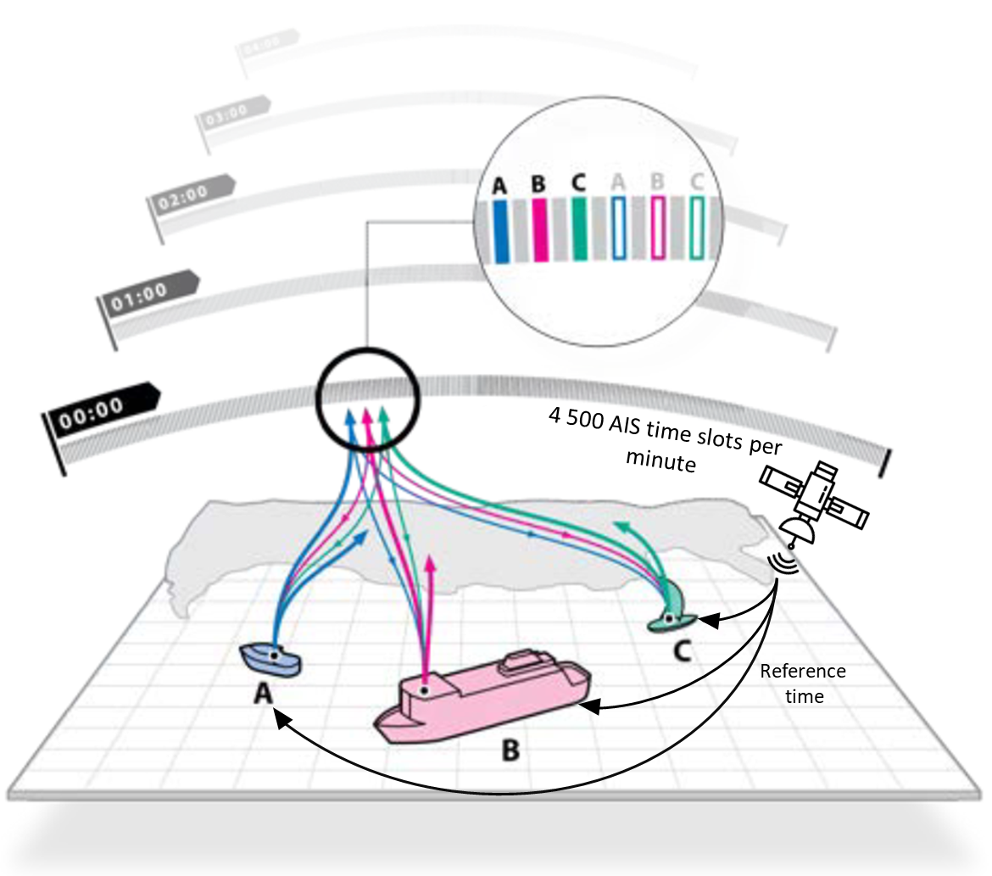
Figure 11: Illustration of GNSS use for AIS time synchronisation
Moreover, it should be mentioned that transceivers need frequency synchronization to ensure a proper communication. The required synchronization is ± 3 ppm.

Impact Assessment Main Outcomes
The table hereunder provides a synthesis of the most important impacts assessed by this study for the AIS application.
Table 18: AIS impact assessment main outcomes
Application | Impact main outcomes
AIS | Degradation of the time synchronisation using GNSS could lead to AIS degradations which increase pilot workload and stress, depriving them of one of their navigation systems. Other systems can however be used such as Vessel Traffic Services (VTS) or on-board radar.  Coastal authorities use backup systems to ensure maritime safety.

Air Traffic Control

Overall Description and GNSS Use
The Air Traffic Control (ATC) is the service in charge of aircraft separation and surveillance. In France, it is ensured by the Direction des Services de la Navigation Aérienne (DSNA).
There are currently three systems used by ATC to get information on air traffic:
- Primary Surveillance Radar (PSR): Detect aircrafts thanks to the reflection of an emitted signal on the targets. The received signal characteristics provide information about the target (e.g. its relative distance and direction to the radar). This technology has numerous limitations such as the influence of the target size and composition on the received signal characteristics, the influence of meteorological conditions on the radar range or the reflexion of the signal on non-vehicle targets. Hence, today, these radars are little used in France. They are mainly used as back up sensors for Secondary Surveillance Radar in order to ensure the compliance with a 3 Nm separation norm in important French airports such as Roissy Charles de Gaulle.
- Secondary Surveillance Radar (SSR): Replacing PSR, they are composed of a ground station and a transponder embedded on the aircrafts. Transponders reply to each ground station interrogation signal by transmitting encoded data allowing to receive, in addition to aircraft distance and azimuth, its identification and altitude.
- Automatic Dependent Surveillance-Broadcast (ADS-B): Autonomous broadcast of aircraft flight data used by other aircrafts, ground vehicles and ATC. Information provided using ADS-B is described in paragraph 3.5.1.1.1.2.
Moreover, the development of multilateration systems is under study in France. Multilateration is a three-dimensional positioning technic based on the use of a network of at least four antennas whose positions on the ground are known. When they receive a same signal, the 3D position of the emitter can be computed by using the Time Difference Of Arrival (TDOA) of the signal in the different receiver.
This document focusses on the radar and the multilateration synchronisation needs.

Radar
Two types of synchronization are required for ATC radars:
- Frequency and phase synchronization via a set of internal oscillators in radar components;
- Radar synchronisation on the same time base (e.g. UTC).
Phase and frequency synchronization must enable a radar to offer the performance defined by Eurocontrol. The time synchronisation of a radar can be ensured using external time source such as GNSS.
A single control centre receives information from several radars in order to cover a large control area. These radars have to provide synchronous information to the control centre in order to accurately place an aircraft plot on the ATC screen, to eliminate potential duplicate radar echo or radar echo too old to be used, to select the best available data provided by the radars in a same area or to merge the data from several radars. Hence, each radar data received by the control centre must be time-stamped on a common time reference: the UTC. Eurocontrol recommends a time synchronisation with an accuracy of +/- 5 ms with respect to UTC. GNSS is used to synchronise all the radars in charge of the air traffic control on the same time base. This single time source facilitates the post processing of the received radar data.

Multilateration
In order to be able to compare the reception times of a same signal by different antennas, these antennas must be synchronised on the same time reference. The synchronisation accuracy has a direct impact on the accuracy of the computed aircraft position. It should be noted that other parameters influence the accuracy of the position computed, such as the geometry of the antenna network or the number of antennas used. The time synchronisation accuracy is even more important in case of poor network geometry. Time synchronisation requirements are not available, however EUROCAE defines some positioning requirements.
In order to ensure the antenna network time synchronisation, several solutions can be considered, based or not on the use of GNSS. They are summarised in the figure below:

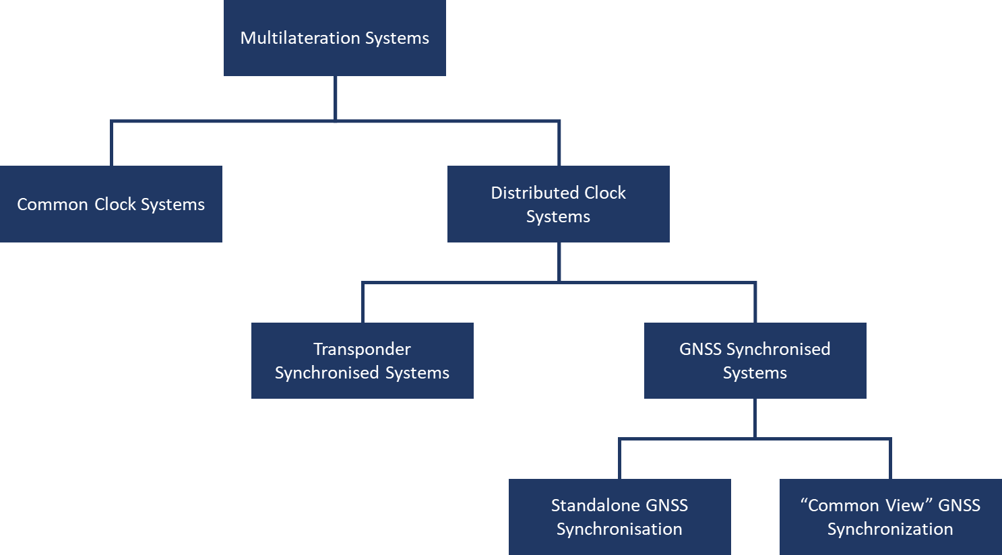
Figure 12: Topologies of synchronisation methods for multilateration systems

In the case of synchronised systems with a common clock, the time-stamping function is centralised in the central data processing unit and provided by a single time source not necessarily synchronised by GNSS. This technique reduces the cost of the receivers but imposes latency performance constraints on the communication means between the receivers and the processing unit, which makes this architecture difficult to use in large area.
An architecture with a distributed clock could then be preferred in order to ensure the multilateration functions. In case of systems with distributed clocks, each receiver is in charge of time-stamping the signals it receives, which reduces the performance requirements on the exchanges between the receivers and the data processing unit. However, each antenna must have a local clock, and a synchronisation process so that these clocks operate on a common time base.
Two synchronisation options are then available for a system with distributed clocks:
- Synchronisation via transponder: a transponder establishes a radio link with all the receivers of the multilateration system in order to provide them with the same time reference (not necessarily generated by the use of GNSS). To cover large areas, it is possible to use several synchronisation transponders, each of which is used as a time reference by the receivers within sight. All the receivers synchronised by the same transponder (and therefore the same clock) form a cluster. To bridge the clock differences between two clusters, at least one receiver must receive time corrections from two transponders. This information is then sent to the data processing centre, which can then correct the time difference between the two clusters.
- Synchronisation via GNSS: GNSS can also be used as a common UTC time reference for each receiver. Synchronisation via GNSS information allows the different receivers of the multilateration system to be synchronised with an accuracy of 10 to 20 ns.
An architecture using synchronisation via a GNSS time source is overall easier to implement and less restrictive than an architecture with a common clock or with transponders.
The following figure illustrates the use of GNSS for time synchronisation:

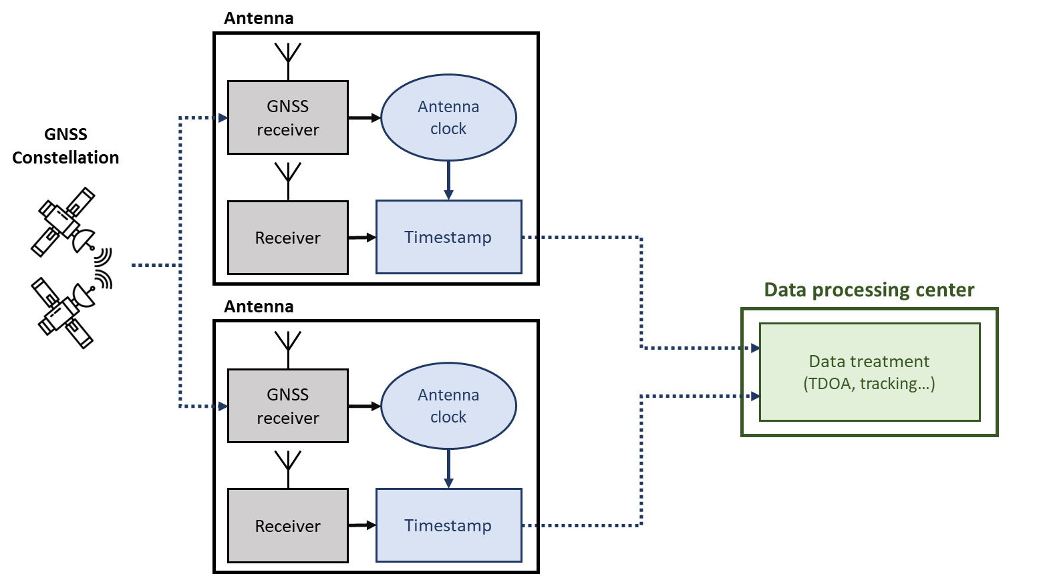
Figure 13: Architecture of a distributed clock multilateration system via autonomous GNSS
In order to increase synchronisation accuracy, relative synchronisation between receivers can be achieved using the “common-view” time transmission method (see Annex 1). This method consists of overcoming common sources of error in satellite signals by comparing data from a same satellite and received by two receivers at different locations.
The use of the common view method is illustrated below.
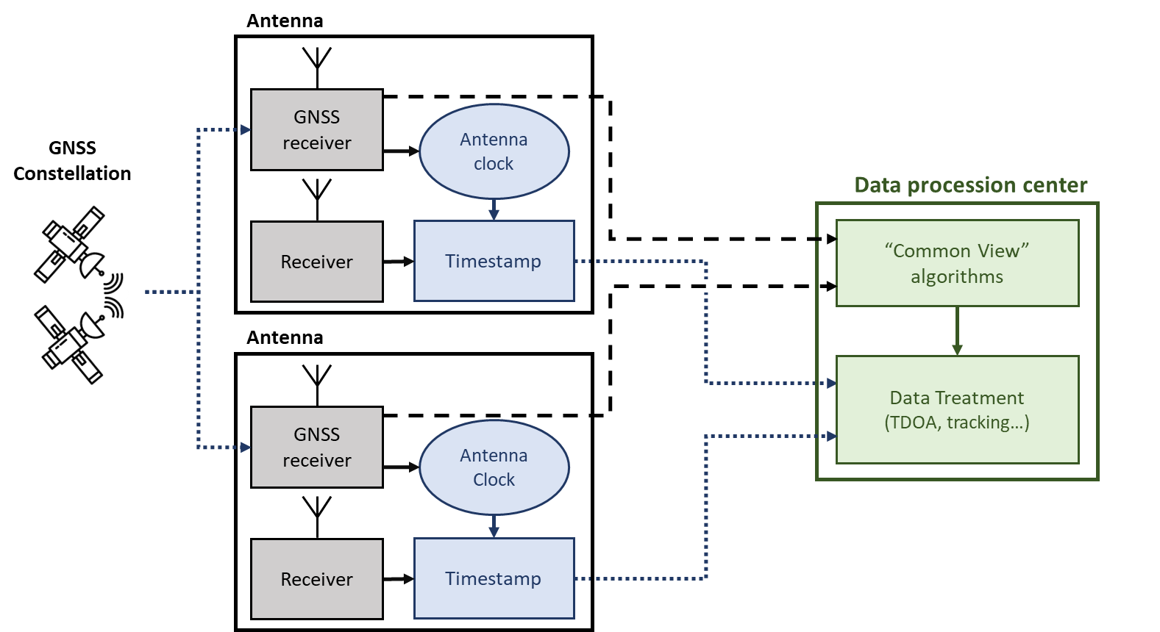
Figure 14: Architecture of a distributed clock multilateration system via the GNSS “Common View” algorithm

Impact Assessment Main Outcomes
The table hereunder provides a synthesis of the most important impacts assessed by this study for each considered applications belonging to the Air Traffic Control.

Table 19: Air Traffic Control applications impact assessment main outcomes
Application | Impact main outcomes
Radar data fusion | Degradation of the time synchronisation using GNSS could degrade air traffic control performances which could have an impact on aircraft safety. To ensure an acceptable level of safety, specific operational procedures are applied (e.g. increase aircraft separation).
Multilateration | No multilateration system is currently used to ensure air traffic control on French territory. The impact assessment should have to be be carried out once these systems will be in operation.

Space
The impact analysis of a loss of GNSS for the space sector is carried out on the basis of the results from a technical note written collectively by the CNES within the scope of this study.

Overall Description and Use
Founded in 1961 the Centre National d’Etudes Spatiales (CNES) is the French government agency in charge of defining and implementing French space policy in Europe.
CNES designs and executes space programmes with its partners from the scientific community and the industry. CNES is also closely involved in many international cooperation programmes.
The main interest of GNSS equipment for the provision of time/synchronisation information to satellite applications is that the satellite applications data are produced with respect to a unique common reference time.
Many satellites embed GNSS receivers essentially for intra or inter-platform synchronisation. They are essentially single frequency GPS receiver. Although multi-frequency and multi-constellation GNSS receivers are progressively starting to appear, GPS receivers are currently the vast majority of embedded receivers.
The Temps Fréquence (TF) laboratory of CNES owns a GPS link with the Observatoire de Paris (OP) for time transfer which enables to ensure the permanent link between UTC(CNES) and UTC(OP), the French legal reference. The UTC(CNES) time scale is then distributed through specific connections (RF and optical) all around the CNES CST site and to the CLS.
In the short term (probably 2021), a time link with UTC(OP) using Galileo signal should be implemented. This should reduce the impact of a loss of GPS but should not provide an additional protective barrier against jamming since the frequency bands are almost identical (L1/E1 band).
In the intermediate term, the implementation of a fibre link between UTC(OP) and UTC(CNES) should enable a redundancy fully independent.
Timing and frequency synchronisation is crucial during rocket launch of the space centre of Kourou in Guyana (CSG).
An atomic master clock (Rubidium) locked on GPS with the SYNCHRO 2 system is currently used by the Guyana space centre. The frequency source is generated by the master clock and distributed through the IRIG B standard around the control centre. Current performances of atomic clock enable to meet the requirements for frequency synchronisation of the site. The future SYNCHRO 3 system will enable the use of other available GNSS constellations (Galileo, GLONASS, …) in addition to GPS.

Impact Assessment Main Outcomes
The table hereunder provides a synthesis of the most important impacts assessed by this study for each considered applications belonging to the space sector.

Table 20: Space applications impact assessment main outcomes
Application | Impact main outcomes
Time transfer between UTC(OP) and UTC(CNES) | No important potential impacts in relation with a GNSS threat has been identified as regard the GPS time comparison between UTC(CNES) and UTC(OP). The CNES should be able to continue its operations efficiently.
Satellite synchronisation | A satellite synchronisation loss due to a GNSS threat should potentially have an impact under particular circumstances.
GSC timing and frequency synchronisation | Globally, no important impact has been identified. The GSC is able to continue its operations without the use of GNSS and no impacts are expected on the launch schedule.

Industry

Overall Description and Use
The industry of the future is turning to a set of new technologies integrated in its production methods. Among those technologies, the Internet of Things (IoT) refers to the extension of the internet to physical objects, notably for data exchange.
There are several types of IoT networks with each one of them having its own characteristics in terms of volume of exchangeable data, covered area, price or security of the exchanges. Hence, each type of network can respond to specific user requirements.
Among the great IoT network families there are the following:
- Wide area wireless network (non-3GPP technology): this family consist of long range (up to 40 km) and low energy consumption networks enabling to send small volumes of data (between 300 bits/s and 50 kbits/s). The most known of these networks are Sigfox, LoRaWAN (Long Range Wide Area Network) and, to a lesser extent, Weightless. Currently, those systems are mainly used for IIoT (Industrial Internet of Things) sensors.
- Wide area wireless network (3GPP technology: GSM/4G/5G): this family refers to the evolutions of already existing cellular network. For instance, NB-IoT (Narrowband IoT) use an evolution of existing 4G antennas. Similarly, the future 5G will have to offer functionalities related to IoT in a close future.
The gateways of the LoRaWAN wide area network need to be synchronized temporarily so that class B and C objects can operate. Class B or C receivers have to rely on the use of LoRaWAN gateways synchronised with GNSS.
Like Sigfox network, the application layer of class A LoRaWAN objects can require timing synchronisation. The application servers to which the objects of the LoraWAN network are connected can rely on time servers using GNSS as a time source to send back a timestamp.
Paragraph §3.4.5 details the use of GNSS on cellular network on which some wide area wireless network relying on 3GPP technologies are based on.
In addition to IoT, Time Sensitive Network (TSN) should enable a more reliable and efficient automation as well as a standardisation of the processing of global packets of information within the same industry.
Most project related to TSN define extensions to Virtual Local Aera Network (VLAN) which are defined by the standard IEEE 802.1Q. Those extensions deal particularly with the implementation of networks having a very low transmission latency and a high availability.
The possible applications of TSN include converged network with audio/video streaming and real-time control flow notably used in automotive control installations, transportation, aerospace or industrial manufacturing.
Peripherals of a TSN network can be distinguished into:
- Industrial systems like industrial controllers, sensors and manufacturing robots from a factory;
- Components of the TSN network like switches and Ethernet gateways;
- PTP synchronisation network composed of a master clock, specialised equipment enabling a precise distribution of time to the different clocks of the elements of the TSN network.

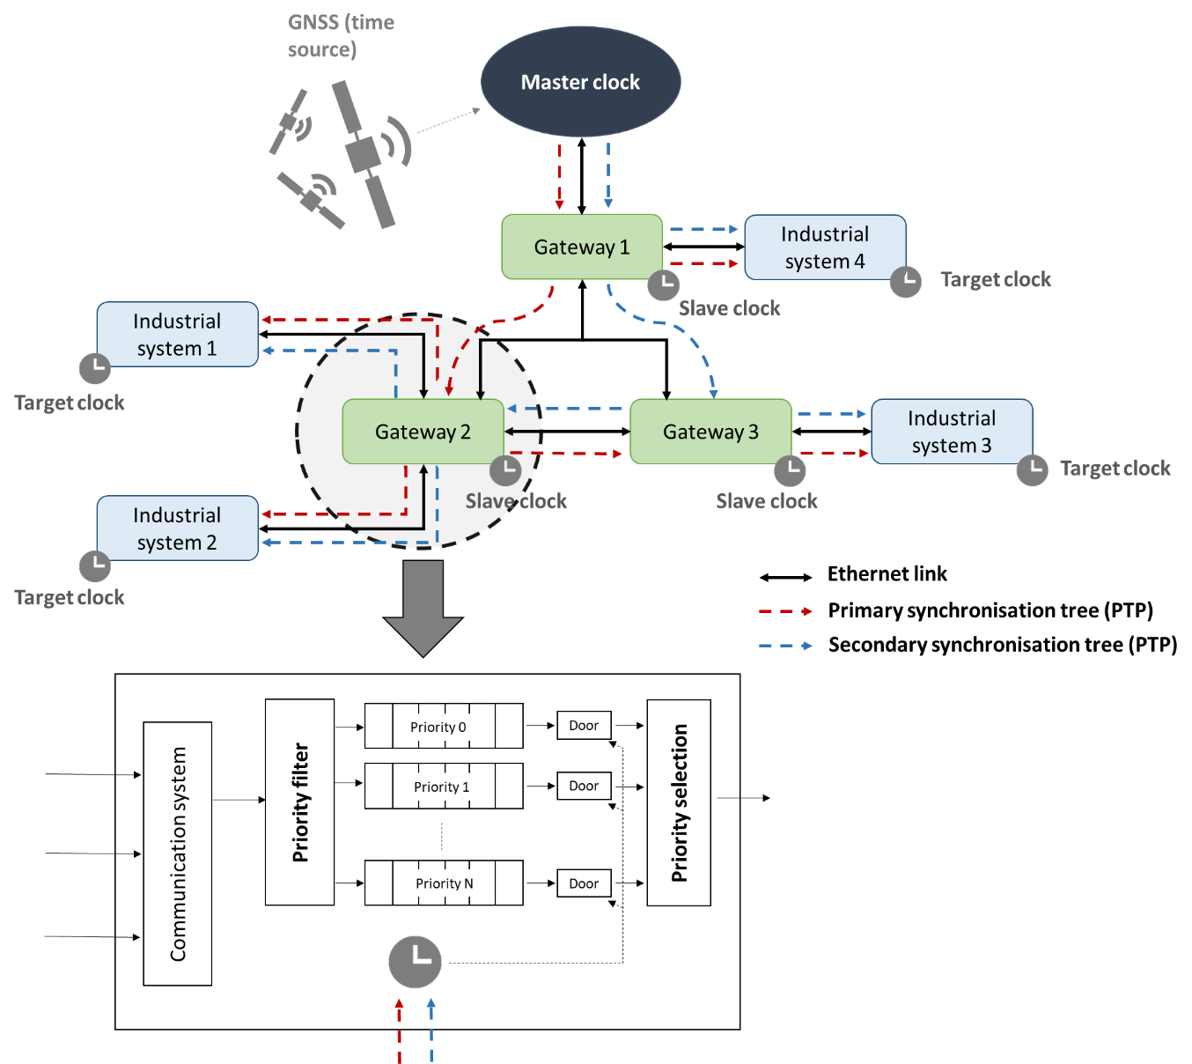
Figure 15: Time Sensitive Network (TSN) GNSS use

Impact Assessment Main Outcomes
The table hereunder provides a synthesis of the most important impacts assessed by this study for each considered applications belonging to the industry sector.
Table 21: Industry applications impact assessment main outcomes
Application | Impact main outcomes
Industrial Internet of Things (IIoT) | Networks such as LoRaWAN, Sigfox or 3GPP can be vulnerable to some GNSS threats with potential impact on the French society at various levels.
Time Sensitive Network (TSN) | The time sensitive networks (TSN) rely on timing and synchronisation and can be vulnerable to some GNSS threats. Such vulnerabilities can potentially have an impact on the French society.

Impact Assessment for Geolocation

Civil Transport

Air Transport

Overall Description and GNSS Use
Air transport designates the activity of passenger or freight transportation by air. Before the crisis experienced by this sector in 2020, air traffic was booming with air passenger transportation doubling on average every 15 years, reaching 4.3 billion passengers worldwide in 2018.
Aircraft localisation is a key element in civil aviation. Needed for the pilots to perform the aircraft navigation, it optimized air transport operations while ensuring a high level of safety. In this section, we will focus on the following applications: aircraft navigation, ADS-B and drone transport.

Aircraft Navigation
The GNSS is currently used to perform the air navigation in all flight phases. First of all, during the taxi phases, the GNSS is used to help pilots to know their precise location in real time on the airport surface. Taking advantage of GNSS, new functions have been developed to reduce pilot workload during taxi phases. For instance, the pilots are notified when their aircraft enters a runway area and may have at their disposal their aircraft position in real time on a virtual airport map. However, Air Traffic Controller (ATC) instructions and ground markings remain the primary source of positioning used by pilots during taxi.
During take-off, cruise and approach, the aircraft move on a flight path defined by a set of waypoints. Air navigation systems have evolved a lot over the past decades: radionavigation has progressively replaced conventional navigation, allowing operations optimisation as aircrafts do not need to fly over radionavigation beacons anymore. Since its first use in civil aviation, GNSS has gradually replaced traditional ground Navigational Aids (NAVAID) such as Automatic Direction Finder (ADF) and VHF Omnidirectional Range (VOR). GNSS is today the main source of positioning during these flight phases. According to the Performance Based Navigation (PBN) manual, area navigation (RNAV) operation standards published by International Civil Aviation Organization (ICAO), GNSS is required to perform some type of operations such as RNP navigations. These operations require a minimum lateral accuracy and a detection ability when this requirement is not met. However, it has to be mentioned that DME/DME/IRS positioning systems can allow some RNP operations if DME infrastructures are available on the aircraft flight path and if the aircraft manufacturer has demonstrated the ability of this airplane to meet RNP requirements with these systems.
During take-off and approach, GNSS is also used to extract aircraft surrounding terrain from a database in order to provide terrain awareness to pilots. The terrain is displayed to the pilots and if a risk of aircraft-terrain collision is detected, alerts are raised to warn the pilots.
Finally, GNSS is the main source of positioning in some approach operations. It provides horizontal guidance to aircrafts for LNAV and LNVAV/VNAV approaches and both vertical and horizontal guidance for LPV approaches. In mainland France and in the overseas departments, GNSS procedures have been deployed on all the runways of IFR controlled aerodromes, which has allowed a rationalisation of ILS equipment on a national scale by the Direction des Services de la Navigation Aérienne (DSNA). Indeed, navigation by satellites allows to perform landing with the same operational performances as the ILS but with lower operational costs. During approach, GNSS is also used to detect potential risks of runway excursions during the landing and warn the pilot.
The following figure summarize the GNSS use by the pilots to perform air navigation:
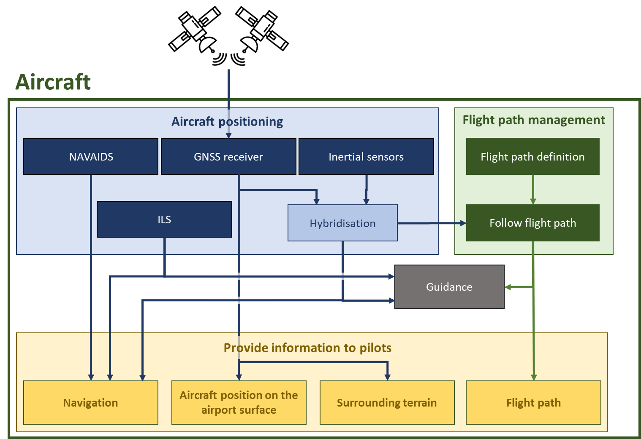
Figure 16: High level architecture of GNSS use in air navigation
The GNSS signal performance requirements are derived from the requirements defined in the Performance-based Navigation (PBN) Manual. Defined by the ICAO, these requirements take into account the potential effects of a GNSS degradation affecting several aircrafts. These requirements are presented in the following table:

Table 22: GNSS positioning requirements for air navigation in civil aviation (source: Annex 10 - Aeronautical Telecommunications - Volume I - Radio Navigational Aids)
Typical operation | Accuracy horizontal  95% | Accuracy vertical  95%
En-route in oceanic area | 2.0 NM  (3.7 km) | N/A
En-route in continental area,  Terminal | 0.4 NM  (0.74 km) | N/A
Initial approach,  Intermediate approach,  Non-precision approach (NPA),  Departure | 220 m  (720 ft) | N/A
Approach operations with vertical guidance (APV-I) | 16.0 m  (52 ft) | 66 ft  (20 m)
Approach operations with vertical guidance (APV-II) | 16.0 m  (52 ft) | 26 ft  (8.0 m)
Category I precision approach | 16.0 m  (52 ft) | 20 ft to 13 ft  (6.0 m to 4.0 m)

ADS-B
The ADS-B is an automatic on-board communication system allowing aircraft-aircraft, aircraft-ATC and aircraft-ground data exchanges. This system allows communication of flights data such as aircraft type, identification, position, heading, speed and trajectory. The ADS-B has the following applications:
- Provide additional information to Air Traffic Controllers (ATC) supplementing the data sensed by the radars;
- Provide enhanced airborne traffic information to pilots by supplementing the data sensed by the Traffic Collision Avoidance System (TCAS) antennas. It should be however mentioned that ADS-B information is not currently used to raise airborne traffic alerts;
- Provide ground traffic information to pilots. New on-board surveillance systems based on ADS-B are under development, such as the SURF-IA (SURFace Indication and Alerting), which aims at protecting aircraft from runway incursions;
- Record and release a large amount of flight data via platforms such as “Flight Radar 24”.
Among this information, aircraft position and ground speed are computed using GNSS. The following figure provide a high-level architecture of the GNSS use by the ADS-B system.
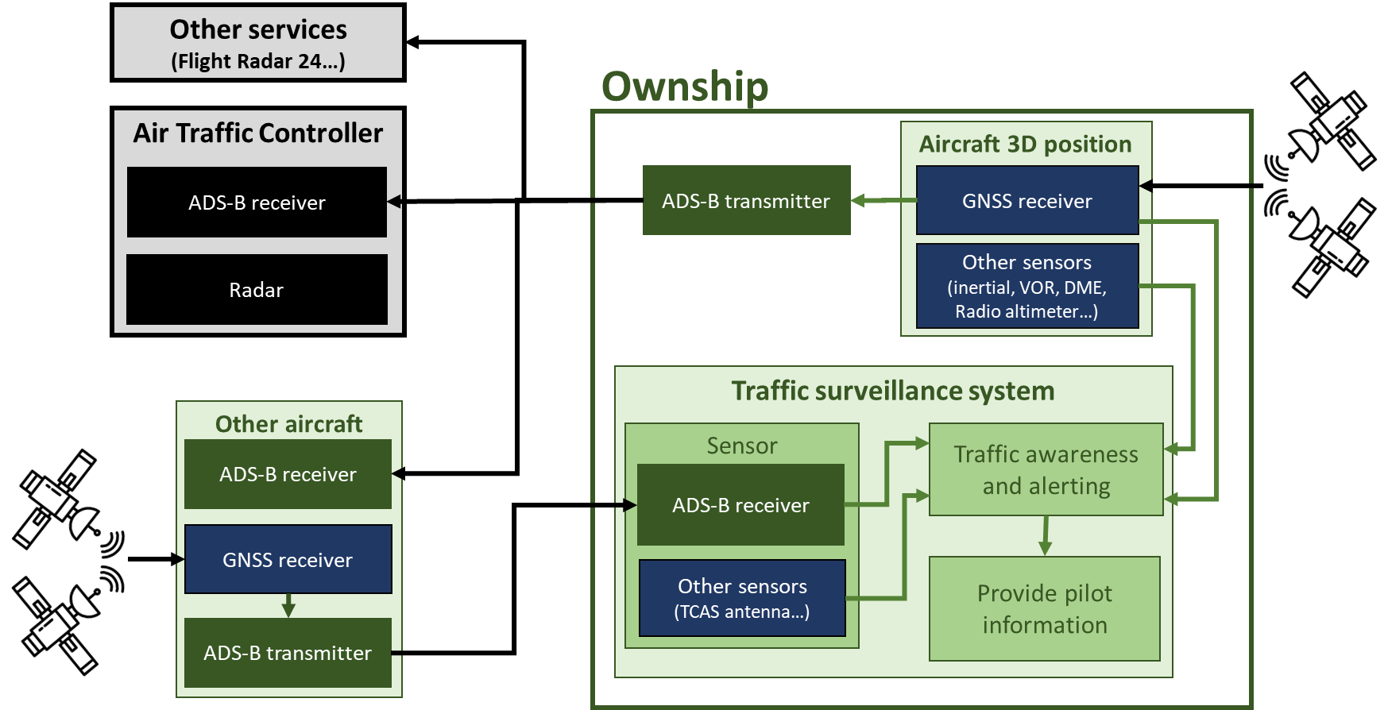
Figure 17: High-level architecture of GNSS use in ADS-B system

The required horizontal accuracy (95%) depends on the airspace in which the aircraft is flying. These requirements are provided in the following table:
Table 23: GNSS requirements for ADS-B
Airspace | Horizontal position accuracy  (95%)
En route | < 911 m
TMA | < 304 m⁵³
On Ground | ≤ 10 m

Transportation Drones
Drone development is currently in strong expansion. Among all its potential uses, freight transportation is one of the most promising application as demonstrated by the development of prototypes by companies specialised in online sales and delivery such as Amazon and UPS. Indeed, drone delivery has multiple benefits such as time and/or cost saving with the possibility to ensure driverless operations.
As drones are remotely piloted or autonomous, localisation is essential to ensure safe drone navigation. Moreover, the drones will have to be localised to ensure the associated traffic control, which is one of the main challenges for the sector development. Many projects have been developed to ensure drone traffic control such as UAS Traffic Management (UTM) in the United States or U-Space in Europe.
Today, GNSS is considered essential to compute drone position used to perform BVLOS (Beyond Visual Line of Sight) or autonomous flights or to ensure drone traffic control. GNSS will certainly be hybridised with other sensors such as an inertial unit to face GNSS limitations especially in constraining environment with few satellites’ visibility for instance. Overall, the development of this sector could go hand in hand with an important use of GNSS. In addition to the drone localisation, it should be noted that drones are protected from their environment by other sensors such as cameras, radars or Lidars which also participate in ensuring the safety of drone flights.
Currently, drone positioning needs are not well defined as there are too many operational scenarios and the regulation is not mature enough. Hence, it is difficult to establish a set of requirements for GNSS use in drone operations. However, European Union Agency for the Space Program (EUSPA) provides a first set of requirements thanks to stakeholder interviews which are resumed in the following table:
Table 24: GNSS requirements for drone operations
Horizontal accuracy | Vertical accuracy | Availability
10 m in rural area  1 m in urban area | 10 m in rural area  1 m in urban area | Between 95% and 99,5 %

Impact Assessment Main Outcomes
The table hereunder provides a synthesis of the most important impacts assessed by this study for each considered applications belonging to the air transport.

Table 25: Air transport applications impact assessment main outcomes
Application | Impact main outcomes
Aircraft navigation | GNSS degradation may have significant operational impacts, as most RNP navigation and some approach procedures (e.g. LPV approaches) cannot be performed without these systems. Moreover, some aircrafts may also be grounded in particular situations.  Some on-board aircraft functions (e.g. aircraft navigation, terrain surveillance or runway overrun protection) can also be disrupted in case of GNSS degradation.
ADS-B | No feared event has been identified regarding ADS-B applications as:  - In France, ADS-B is currently not used for air traffic control  - TCAS is currently the main on-board air traffic surveillance system  - New surveillance systems based on ADS-B, such as SURF-IA, are not yet operational
Transportation drones | As transportation drones are currently not deployed in France, the impact assessment should have to be carried out once these systems will be in operation. GNSS could have an important role in BVLOS and autonomous navigation operations or even in drone traffic control.

Maritime and Waterway Transport

Overall Description and GNSS Use
Maritime transport is the world's most important mode of goods transport. It is mainly used for long distances transportation of raw materials or goods previously packaged. In 2017, around 365 million tonnes of goods transited through French ports. By contrast, people transportation by sea is no longer important since the development of civil aviation, nevertheless it remains widely used for short crossings or cruises.
In 2017, waterway transport represents only 1.9% of goods transportation in France and this value is even lower for people transportation.
Positioning has many applications in maritime and waterway transportation such as:
- Maritime navigation;
- Maritime traffic monitoring through the use of systems such as the Automatic Identification System (AIS): a ship-to-ship or ship-to-coastal authorities VHF radio communication system;
- Fleet and goods management;
- Search and rescue of people in distress;
- Fishing vessels monitoring to ensure that time spent in foreign international waters and in protected areas complies with applicable regulations;
- Support of various port activities such as transit monitoring, mooring or loading and unloading of goods;
- Development of autonomous vessel operations;
- Support of marine engineering activities, a sector which brings together all the technical engineering disciplines relating to beaches, estuaries, ports as well as to fixed structures built at sea as well as mobile structures operating on water.
This document focuses on the role of GNSS in the following applications: maritime and waterway navigation, AIS, fleet and goods management, dangerous goods transportation, vessel automation and maritime engineering.

Navigation
Navigation refers to all the methods used to determine the vessel position and to follow a predefined route. In IMO A. 915 (22) resolution, five general navigation phases are defined:
- Deep-sea navigation: During this phase, the navigation system aims at ensuring vessel safety and at optimizing maritime routes, taking into account the weather conditions for instance;
- Coastal navigation: the closer a ship gets to the coast, the more likely it is to encounter another ship or the reef. Navigation requirements are therefore more stringent than for deep-sea navigation due to the safety constraints;
- Port or restricted area navigation: because of the proximity of other boats and reefs, the risk of collisions is very high in these areas. The reaction times required in case of avoidance manoeuvres are also very short. Thus, the navigation requirements are very high in this phase;
- Waterway navigation: navigation is critical on rivers because the ship operates in a very limited space. Navigation requirements are usually set by local authorities which do not necessarily adopt IMO recommendations.
Localisation requirements are set by maritime and waterway regulatory bodies which establish standards. Due to the multiplicity of organizations involved in the definition of these standards, positioning requirements are not consistent. However, the IMO A.915 requirements are commonly considered as the one to be applied. They are summarized in the following table:

Table 26: IMO performance requirements
Phase of navigation | Accuracy  (95%)
Ocean | 10 m to 100 m
Coastal | 10 m
Port approach and restricted waters | 10 m
Port | 1 m
Inland waterways | 10 m

In its market study, the EUSPA has shown that these regulatory requirements are not stringent enough to meet all the user needs. Through a survey, the agency has therefore established a set of requirements closer to these user needs as summarized in the following table:

Table 27: Localisation required performances for maritime navigation
Navigation phase | Horizontal accuracy  (95%) | Vertical accuracy  (95%)
Ocean | 100 m | N/A
Coastal | 10 m | N/A
Port approach | 10 m | N/A
Port and restricted waters | 1 m | N/A
Inland waterways | 3 m | N/A

In maritime navigation, GNSS is the main positioning source used. Ships follow a set of waypoints. GNSS is used to compute every second the course to reach the next waypoint. By comparing the updated course with the actual one, the autopilot calculates and applies the trajectory corrections. Moreover, the vessel speed and latitude computed using GNSS are also used to correct gyrocompass speed deviation. Finally, ship position and trajectory information computed using GNSS are used by directional communication antennas to point to the appropriate communication satellite. GNSS degradation doesn’t interrupt the communications, but the satellite tracking is degraded.
The following figure illustrates the use of GNSS in maritime navigation:
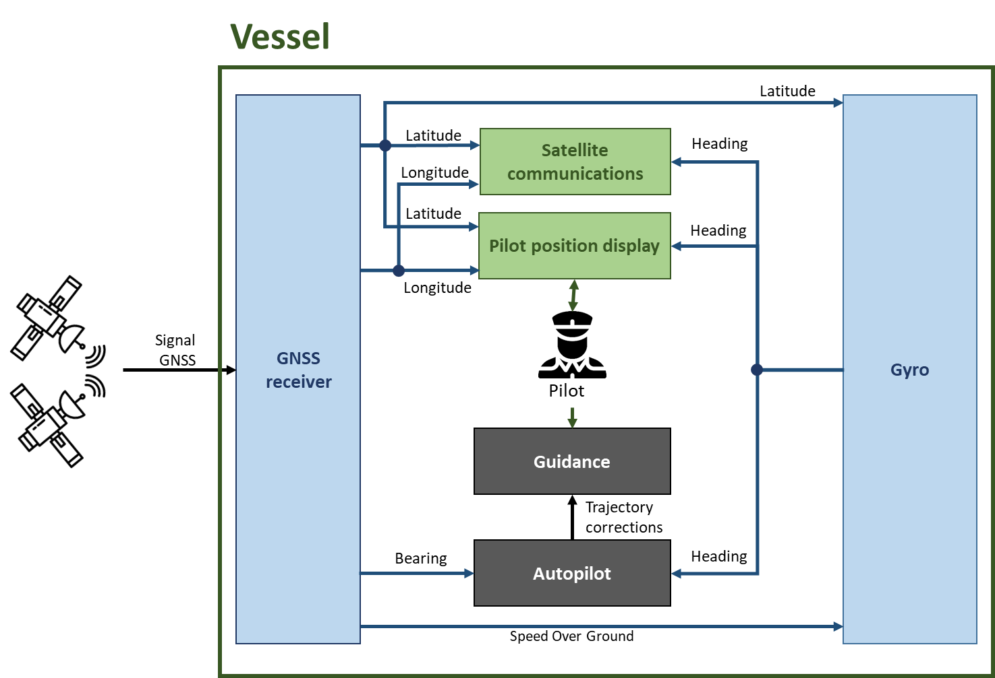
Figure 18: High-level architecture of GNSS use in maritime navigation
In waterway navigation, augmented GNSS systems and radars are used to provide additional navigation information. However, the visual aids remain the primary means of navigation.

AIS
A detailed description of the AIS is provided in the paragraph 3.4.7.1 of this document. As a reminder, the AIS is a VHF communication system allowing automatic navigation data exchange between vessels or between vessels and coastal authorities. Among the information exchanged, the vessel position and information on vessel course are provided thanks to GNSS.
The following table provide AIS positioning requirements according to user needs provided in the EUSPA studies:
Table 28: Localisation required performances for AIS
Navigation phase | Horizontal accuracy  (95%) | Vertical accuracy  (95%)
N/A | 10 m | N/A

Asset Management
To optimise operations, vessels and transported goods management is carried out by the transporters.
Vessel location tracking with GNSS optimizes vessel uses in a fleet. Moreover, it improves maintenance as GNSS can be used to continuously monitor asset movements and performances. Analysis of this information can be used to detect when specific item maintenance is needed or to develop predictive maintenance models to fine-tune maintenance schedules.
The real time goods position management is really important in the context of “just-in-time” transportation environment. It greatly improves transport service, allowing to anticipate times of arrival in handling areas. The freight management can therefore be based on vessel or container position tracking.
Multimodal container position tracking also ensures good tracking throughout their entire journey. To perform this tracking, a GNSS antenna is installed on each container and is connected to a system recording a lot of container transportation information such as openings of the container, temperature and humidity, etc. This information can be used by several entities such as customers or transporters.
Finally, container handling machines use GNSS to localise the container in the stockage area. The container reference is associated with its stocking area in a database. This area identification is obtained thanks to the GNSS antenna installed on the handling machines. It saves time and money by optimising container storage activities.
The following table provides asset management positioning requirements according to user needs provided in the EUSPA studies:
Table 29: Localisation required performances for maritime asset management
Navigation phase | Horizontal accuracy  (95%) | Vertical accuracy  (95%)
Ocean / Coastal / Inland waterways | 100 m – 1 km | N/A
Port | 1 m | 1 m

Transportation of Dangerous Good
Some transported goods can represent a threat to the environment or to society if they are spilled or stolen. These hazardous materials are defined and classified by the United Nations. In France, the maritime and waterways transport of dangerous goods is regulated by:
- The International Maritime Organisation (IMO) which publishes codes and standards concerning the transport of hazardous materials in packages or in bulk;
- The ADN agreement, a European agreement for inland waterways transportation of dangerous goods;
- The Regulations for the transport and handling of dangerous goods in Maritime Ports (RPM) enforcing the permanent localisation of dangerous goods when stored in ports.
GNSS allows real time and multimodal tracking and monitoring of dangerous good during transportation. This information is used to optimize risk management during the journey as it allows optimisation of logistics and implementation of emergency services in case of accident, reducing therefore potential environmental and societal impacts.
As no specific quantified positioning requirements were identified for this application during this study, it has been assumed that these requirements are the same as those identified for goods transportation management (see previous paragraph).

Autonomous Navigation
Autonomous vessel is currently at the stage of proof of concept. The corresponding studies on this topic are motivated by the potential of autonomous navigation to significantly improve good transportation in long distances. Indeed, it could reduce the costs as no on-board crew is needed, as well as the ecologic impact as vessel operations can be optimised and the usable capacity of a vessel maximised. This report focuses on remotely controlled unmanned ships as this type of vessel has been widely studied during the past years in the frame of many projects such as Maritime Unmanned Navigation through Intelligence in Networks (MUNIN).
GNSS is the main source of localisation for autonomous navigation. It ensures the ship to follow its trajectory while avoiding traffic and dangerous meteorologic area and taking into account operational constraints. The following table provides positioning requirements for autonomous navigation according to user needs gathered by the EUSPA studies:
Table 30: Localisation required performances for autonomous navigation
Navigation phase | Horizontal accuracy  (95%) | Vertical accuracy  (95%)
Ocean | 15m | N/A
Coastal | 5m | N/A

Even if autonomous navigation is currently available for ships moving on a predefined trajectory, some technical gaps need to be fulfilled to enable wide deployment of autonomous vessel operations.
First of all, on-board system robustness needs to be improved as no crew will be available to perform periodic maintenance. Hence, asymmetric redundancy of the positioning systems is crucial and the localisation systems must be able to self-diagnostic the state of the information provided.
Moreover, the integration of many sensors and the development of decision algorithms is an issue, especially for critical functions such as vessels collision avoidance. According to the Convention on the International Regulations for Preventing Collisions at sea (COLREG), surrounding vessel monitoring is under the crew responsibility who has to manage detection and resolution of conflicts between ships. The development of avoidance rules for unmanned ship is then a challenge. Although human judgment is still possible when a ship is remotely piloted, it becomes non-existent for a completely autonomous ship.
Finally, GNSS is also used to allow communication with the remote pilot. Ship position and trajectory information computed using GNSS are used by directional communication antennas to point to the appropriate communication satellite. GNSS degradation doesn’t interrupt the communications, but the satellite tracking is degraded.
The following figure illustrates the use of GNSS in autonomous maritime navigation:

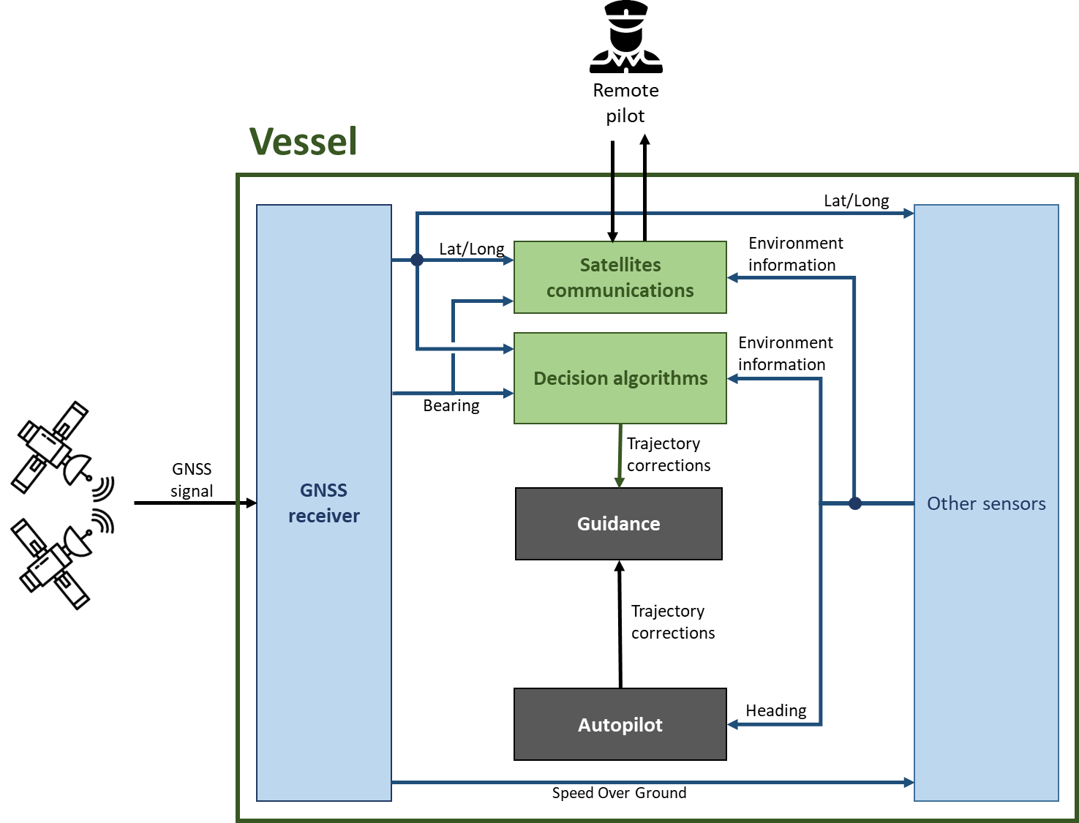
Figure 19: High-level architecture of GNSS use in autonomous maritime navigation

Marine Engineering
Marine engineering gathers all the technical disciplines relative to beach, estuary, port and fixed or mobile on sea constructions. The present study focuses on the Shom (French Service hydrographique et océanographique de la marine) activities which aims at describing maritime physical environment. GNSS use is studied for the following applications: bathymetry, oceanography, marine geophysics and marine geology.

Bathymetry:
The bathymetry refers to sciences and technologies used to measure and estimate the water depth in order to describe seabed topography.
As part of its national hydrographic mission, the Shom regularly conducts a set of bathymetric surveys. These surveys can be carried out using acoustic systems embedded on ships, airborne LIDARs or satellite altimetry. This section of the report focuses on the bathymetric surveys carried out by vessels embedded systems. Indeed, airborne LIDAR measurements are studied in paragraph 3.5.2.1.1.4 and altimetric surveys does not use GNSS as corresponding satellites are localized thanks to laser ranging.
The data collected through bathymetric surveys contributes to many applications such as:
- The French National Hydrographic Program which aims at meeting the hydrographic surveys needs of the maritime community;
- The production of marine cartography to ensure the safe maritime navigation;
- The production of seabed digital models intended for engineering constructions studies such as characterization of offshore sites for marine renewable energies, layout of tunnels or pipelines;
- Coastal development;
- Environmental protection;
- Prevention of natural hazards;
The Shom standard defines the requirements to be applied during the various bathymetry activities. These requirements are derived from the "Publication S-44", an international hydrographic standard published and maintained by the International Hydrographic Organization (IHO). These requirements are presented in the following table:
Table 31: Localisation required for bathymetry survey
 | Critical area  (Minimum under-keel clearance and critical navigation conditions) | Area of special interest  (Navigation condition are less critical than in critical area) | Coastal survey  (Non-critical navigation conditions) | Deep sea survey for general hydrography | Survey during transit
Depth | Up to 40 m | Up to 40 m | Up to 40 m | From 100 m | -
Total Horizontal Uncertainty | 2 m | 5 m +5% of depth | 5 m +5% of depth | 20 m +10% of depth | 20 m +10% of depth
Total Vertical Uncertainty | a = 0,25 m  b = 0,0075 | a = 0,5 m  b = 0,013 | a = 0,5 m  b = 0,013 | a = 1,0 m  b = 0,023 | a = 1,0 m  b = 0,023

Initially defined in relation to the sensors position, the surveyed information is attached to a reference terrestrial system, using GNSS. The GNSS information is hybridised with inertial sensors allowing positioning robustness to short GNSS losses and ensuring a certain integrity level of the computed localisation. The GNSS positioning technique is chosen according to the survey accuracy requirements as presented in the Table 31. Indeed, costal surveys are mainly using differential GNSS whereas offshore surveys use only primary GNSS systems. For very high accuracy survey, Precise Point Positioning (PPP) can be used.
Moreover, tidal corrections are needed to compute the sensor vertical position with the required accuracy for depths lower than 200 meters. There are no specific requirements on the uncertainty of the tidal corrections. However, the survey cumulated uncertainty, taking into account the tidal correction uncertainty, must be compliant with the required vertical positioning accuracy presented in Table 31. Tide corrections can be computed using:
- Tide gauges;
- Digital tide models mainly used for offshore surveys where tide gauges cannot be installed;
- Kinetic tide method, which consists in measuring the vessel altitude relative to the ellipsoid by implementing a vertical measurement system with a centimetric accuracy such as GNSS.
Kinetic tide methods allow to eliminate the measurement uncertainties associated with the use of a tide gauge and the dynamic movement of the boat during the measurements. The kinetic tide method requires a system providing GNSS corrections in order to obtain a centimetre-level vertical positioning accuracy. The GNSS corrections can be used in real time, if the service continuity can be guaranteed, or in post-processing. In addition to the GNSS information, the short variations in the ellipsoidal height of the vessel as well as its roll and pitch must be corrected by other on-board sensors. The vertical position accuracy provided by the GNSS must meet the survey requirements in Table 31. For instance, in critical area with 10 m depth, the maximum vertical uncertainty is 26 cm taking into account both the uncertainties of GNSS and the bathometer. To meet this requirement, the vertical uncertainty of GNSS positioning must not exceed 5 to 10 cm. The following figure illustrates the use of GNSS in kinetic tides:
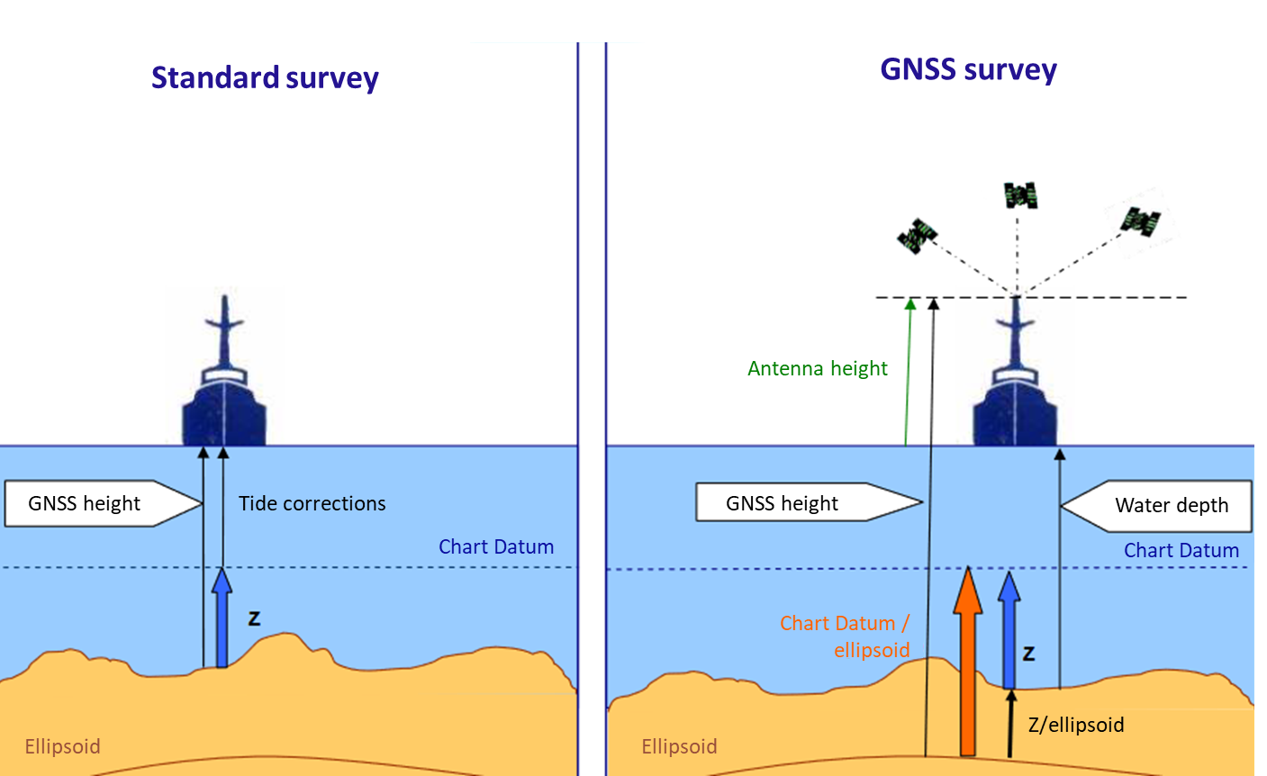
Figure 20: Illustration of GNSS use in kinetic tide
The position integrity should be checked frequently during the survey. For this, acquisitions at the fixed point (or “target”) as close as possible to the work zone are carried out. It aims at comparing the real position of the fixed point with the position computed by the positioning system. Moreover, it is strongly recommended to record the GNSS raw data in order to be able to perform data post-processing aiming at significantly reducing the horizontal and vertical uncertainties.
NOTE: GNSS is also used to timestamp data measured in relation to the UTC and to synchronize the equipment used. At least a 200 Hz frequency synchronization is required

Oceanography:
Physical oceanography aims at studying ocean water physical properties. In this field of activity, the Shom produces oceanographic models thanks to massive data acquisition. In this report, we will focus on two types of sensors using GNSS information: tide gauges and current meters.
A tide gauge is a sensor for measuring sea level. There are many different types of tide gauges but the most commonly used today are:
- The radar tide gauges which are used along the coast to measure the sea level relative to the earth's crust thanks to the reflection of a radar wave emitted towards the water surface. The hight of tide is thus determined with centimetre accuracy;
- The pressure tide gauges which are used offshore to measure the sea level relative to the seabed by measuring the pressure in a column of water.
Tide gauges are also essential for meteorological vigilance applications such as preventing rapid and severe flooding on the coastline and ports.
The current meter is a sensor that measures strength and direction of currents. There are two different types of current meters: fixed current meters and mobile current meters (which are attached to ships). Information provided by these sensors is used to feed oceanographic models. The data acquired must be positioned with a ten metres accuracy to enable the characterisation of the water bodies movements.
GNSS is used by radar tide gauges and mobile current meters.
Radar tide gauge uses GNSS to compute its vertical position with respect to the ellipsoid which can be impacted by geophysical phenomena such as Earth tide. Therefore, this measurement is essential to guarantee the centimetric accuracy of the measurement of the height of the water relative to the earth's crust. It should be noted that the vertical movements of the tide gauges are slow and GNSS measurements are therefore made over several days.
NOTE: The GNSS information is also used to calibrate the tide gauge's internal clock to timestamp the various measurements made.
Figure 21: Illustration of GNSS use by radar tide gauges
As regards mobile current meters, GNSS information is used to provide horizontal position of the measurements with a ten metres accuracy.
Today, the measurement of water depth via floating buoys whose height is computed via GNSS is being studied and could become in the coming years a new GNSS application in the field of oceanography.

Marine geophysics:
Marine geophysics refers to the study of the physical characteristics of the Earth. In this field, the Shom is in charge of characterising the Earth's gravity field and the Earth's magnetic field by studying gravity variations in the maritime environment. These measurements can be carried out at low resolution by satellite or at high resolution by aircraft or ship.
Geophysical surveys are similar to hydrographic surveys, except regarding the sensors used to obtain the surveyed data. Hence, GNSS is used to localise the measurement in a terrestrial reference system. As these surveys are mainly realized in deep sea environment, a ten-metre horizontal accuracy is required. Moreover, as for bathymetric surveys, GNSS can also be used to provide vertical positioning. The required accuracy depends on the survey objectives as presented in Table 31.
The Shom also produces separation models between the different maritime vertical references. These models are used to simplify coordinates system changes for measured data. The vertical references considered are presented in the following figure:

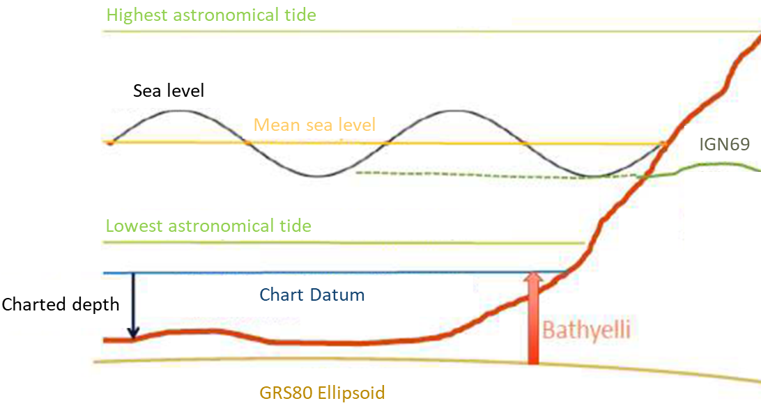
Figure 22: Maritime vertical references (source: Shom)
As part of this activity, the Shom computes the Chart Datum in the International Terrestrial Reference System (ITRS). To do this, the mean sea level is determined in this reference system. Three techniques are used:
- At the coast, the mean sea level is measured using tide gauge (see above);
- Offshore, the mean sea level is measured using space altimetry. This technique is not considered in this report as it does not use GNSS;
- Between these two areas, the mean level is calculated using GNSS measurements at sea. These measurements are essential to compensate for the low accuracy of spatial altimetry measurements near the coast.
Surveys are thus carried out by boat using differential GNSS (PPK) allowing to obtain a centimetric accuracy (25 cm). The acquired data are then processed and possibly corrected with the boat altitude data and reduced by tide and weather effects.
Finally, the GNSS is also used to measure earth crust deformations due to the tide. The impact of the loss of GNSS for this type of application is discussed in the section dedicated to the geographic information (section 3.5.2.1).

Marine geology:
Marine geology is the study of the nature and morphology of the seabed. In this field, the activities carried out by the Shom mainly consist of determining the typology of the seabed by studying the characteristics of the sediments from both a qualitative (sediment texture) and quantitative (granulometry) point of view. The Shom archives the marine sedimentary data acquired in a database, allowing the creation of sedimentary maps. This information complements the data on the morphology of the seabed obtained from hydrographic surveys.
To perform the seabed typology, the sediment samples are positioned using GNSS information. The position must be provided with metric accuracy.

Impact Assessment Main Outcomes
The table hereunder provides a synthesis of the most important impacts assessed by this study for each considered applications belonging to the maritime and waterway transport.

Table 32: Maritime and waterway transport applications impact assessment main outcomes
Application | Impact main outcomes
Navigation | GNSS degradation may have an impact on maritime navigation optimisation and on maritime safety. Other navigation systems can be used in this case but it may increase pilot workload and stress, especially if the navigation conditions are difficult.
AIS | GNSS degradation could lead in some instances to the interruption of AIS data exchanges or the exchange of false vessels positions. This will increase pilot workload and stress, depriving them of one of their navigation systems. Other systems can however be used such as Vessel Traffic Services (VTS) or on-board radar.  Coastal authorities use backup systems to ensure maritime safety.
Asset management  & | Management of assets and dangerous goods is affected in case of GNSS degradation, especially during port operations.
Transportation of dangerous goods
Autonomous navigation | As autonomous navigation is currently at the stage of proof of concept in France, the impact assessment will have to be carried out once these systems will be in operation.
Marine engineering | GNSS degradation impacts the positioning of the survey data. In this case, surveys may need to be postponed or remade.  If undetected, erroneous hydrographic surveys could impact maritime navigation safety.

Road Transport

Overall Description and GNSS Use
In France, the road is the most used transportation mean. In 2017, it represented 87% of national people transportation and 86% of goods transportation. Positioning has a major role in road transportation and have multiple uses. The following paragraphs focuses on the following applications: automobile navigation, tachograph, autonomous vehicles, asset management, transport of dangerous goods, pay-as-you-drive and carsharing.

Automobile Navigation
Automobile navigation systems are portable or on-board devices used to provide vehicle location and help for navigation. These systems are based on GNSS that provides the following information to users:
- Vehicle position on a three-dimensional navigation map;
- Computation of the most optimized route taking into account navigation constraints such as traffic congestion, travel time or fuel consumption…;
- Vehicle speed and comparison with the legal maximum speed in the area.
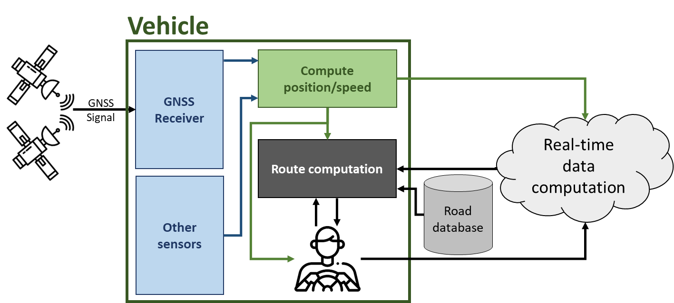
Figure 23: High level architecture of automobile navigation application

Tachograph
Mandatory since 1969, the tachograph is a system used to monitor the use of transportation vehicles of more than 3.5 tonnes as well as the vehicles for public transportation with a carriage capacity of more than eight persons. It allows to register the data relative to the vehicle movement and timing stops in order to control and respect the driving and resting periods of the driver as defined by the law.
Today, digital tachographs are replacing analogic tachographs, automatizing most of the registering information. Since 2019, European regulation 165/2014 imposes the tachograph 1C installation on new vehicles. In addition to odometer (the traditional sensor used to get speed and distance information) this new tachograph introduces the use of GNSS to get more precise and less falsifiable data. The GNSS is used to record vehicle position at the beginning and the end of the service and every 3 hours. GNSS is however considered as a secondary source of information.

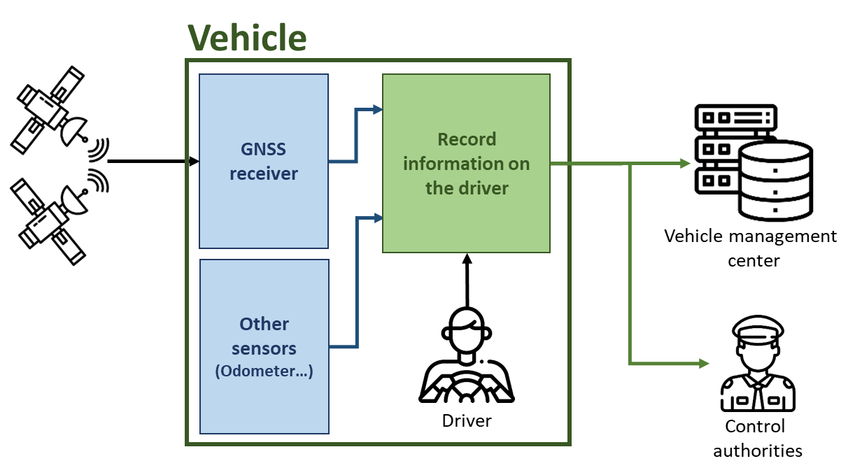
Figure 24: High level architecture of the digital tachograph application

Autonomous Vehicles
During the last years, intelligent and autonomous vehicles have been widely developed, especially in the field of road transportation. For instance, the RATP or Régie Autonome des Transports Parisiens, a state-owned public transport operator and maintainer, has experienced the deployment of autonomous shuttles on a 6 km circuit in a pedestrian area of the “Bois de Vincennes” in the Parisian suburb. The development of these new vehicles makes it possible to improve traffic flow and safety while reducing energy consumption.
For these applications, GNSS is used to compute the absolute position of the autonomous vehicle. It is used to compute the vehicle trajectory and provide navigation information. The use of GNSS-RTK allows to strongly improve the accuracy of the GNSS information, from 2/3m to centimetric accuracy. Other position sensors, such as odometer, gyrometer or inertial unit, are fused with GNSS to provide more robust information. Moreover, these sensors improve vehicle position availability in case of GNSS loss of signal: the last absolute position is derived thanks to relative position computed by these sensors. In addition, other sensors, such as LIDAR, radar or cameras, are used to complete the position computation by identifying road markings and signs. Moreover, they are used to protect the vehicle from its environment by detecting road borders, other vehicles and obstacles.
Information provided by these sensors are completed by mapping information. This mapping can be integrated into the vehicle and/or previously downloaded. There are two complementary types of cartography:
- High-Definition Spatial Mapping, containing information on the road geometry (longitudinal and lateral), road signs or localised visual landmarks;
- Dynamic Cartography, containing information on traffic, weather, working areas, accidents or area with a high density of pedestrians or animals. This information compensates for the range of the other sensors which is limited to a hundred meters. It is particularly useful when the vehicle is moving at high speed or when events affecting road safety must be anticipated.
GNSS is also used to ensure autonomous vehicle's communications with other vehicles or infrastructure, called V2X communications. The vehicle sends information on its trajectory and received information aims at enhancing data provided by car's sensors, such as cameras, radars or lidars. It is useful in complex manoeuvres such as overtaking or insertion, but also route optimisation. In the United States and Europe, automatic short-range communication messages have been standardised. Lots of applications have been developed such as traffic management or vehicle speed adaptation when approaching a traffic light. The positioning accuracy requirements depend on the application considered. For instance, a ten metres accuracy is needed for traffic management, while traffic lights applications need a ten centimetres accuracy. The following figure summarises the GNSS use in autonomous vehicles:

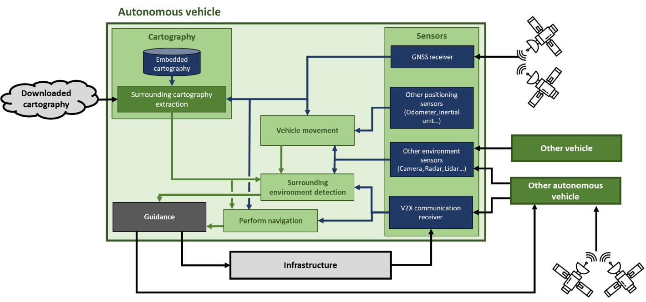
Figure 25: Illustration of GNSS use by autonomous vehicles

Asset Management
The description of this application is similar to the one provided in paragraph 3.5.1.2.1.3.
It should be noted that in the field of road transport, the transport of goods is carried out with a particularly tight flow and that a particular attention is given to the various disturbances affecting the traffic such as traffic jams or accidents. This information is used to update the journey times of the various drivers in real time.

Transportation of Dangerous Goods
The description of this application is similar to the one provided in paragraph 3.5.1.2.1.4.
It should be noted that the transport of dangerous goods is regulated by the Accord for Dangerous goods by Road agreement.

Pay-As-You-Drive
By recording vehicle position, speed and time of use, insurance companies can study each vehicle use in order to adapt service and tariffication to each customer needs. GNSS is mainly used to provide the number of kilometres travelled, the travel duration or the route taken. It has to be noted that other parameters can be analysed to determine user driving behaviour such as the analyse of sudden braking or strong accelerations.
The following figure provides a high-level description of the GNSS use in the Pay-As-You-Drive application.
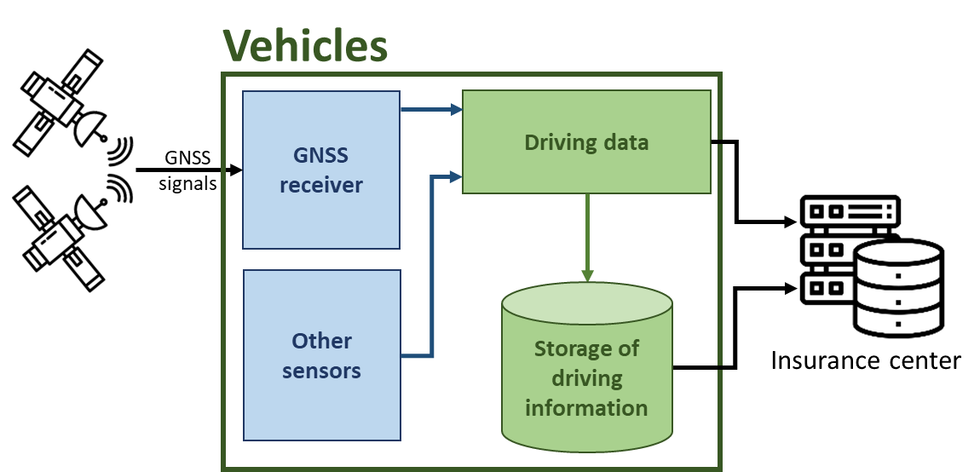
Figure 26: High level architecture of the use of GNSS in Pay-As-You-Drive application

Carsharing
Carsharing is defined by the pooling of a fleet of vehicles for the benefit of subscribed users. Different types of vehicles can be provided (such as cars, scooters, bicycles or electric scooters) for relatively short durations (usually less than an hour). With pollution issues and the increasing costs of personal vehicles, the development of carsharing grows a lot especially in large cities.
GNSS is essential for some car-sharing services, especially when the vehicles are available on the street without any predefined location. Vehicle location allows car-sharing companies to:
- Manage the vehicle distribution within the area in which the service is provided;
- Localise vehicles that require maintenance operations (e.g. scheduled maintenance operations, repair following an accident, electric battery charging, etc.).
At user level, vehicle location improves the service by providing them with information such as the position of the nearest available vehicles.

Impact Assessment Main Outcomes
The table hereunder provides a synthesis of the most important impacts assessed by this study for each considered applications belonging to the road transport.

Table 33: Road transport applications impact assessment main outcomes
Application | Impact main outcomes
Automobile navigation | Navigation systems are impacted in case of GNSS information degradation. This would result in non-optimised navigation or in the multiplication of navigation errors. In these conditions just-in-time freight carriers will be in particular impacted, degrading the level of service provided.
Tachograph | Due to the non-primary role of GNSS in tachographs, a GNSS failure does not lead to feared events for this application.
Autonomous vehicles | As autonomous vehicles are currently under the experimentation stage in France, a complete impact assessment will have to be carried out once these systems will be in operation.  However, it can be already anticipated that GNSS degradation may impact autonomous navigation, resulting in navigation errors or vehicle immobilisation for the duration of the failure. Although navigation errors could impact road safety, it can be considered that the autonomous car will protected from its environment by on-board sensors independent of GNSS such as LIDARs or cameras.
Asset management | If the GNSS failure affects the freight (dangerous or not) and fleet management functions, then carriers will find themselves unable to anticipate delays and therefore to adapt the transportation chain accordingly.
Transportation of dangerous goods
Pay-as-you-drive | Pay-as-you-drive insurance services are dependent on the integrity and accuracy of the GNSS location information to determine the rate to be paid by an insured. A degradation of the GNSS information can impact the insurance service, resulting in mispricing (if the erroneous GNSS information is undetected) or preventing the implementation of the service (if the degradation of the GNSS information is detected).
Carsharing | Car-sharing services can be degraded due to a failure of GNSS position information as it is essential for a user to find available vehicles, especially if stations are not used. The more vehicles are impacted, the more the service is degraded. For the operators, an inaccurate or lost location of vehicles can lead to a degradation of the service because certain tasks (such as the optimisation of the maintenance or of the distribution of vehicles in the area covered by the service) are degraded.

Rail Transport

Overall Description and Use
In France, railway is mainly used for passenger transportation and, to a lesser extent, for freight transportation. Hence, in France, rail transport accounted in 2017 for 60% of national passenger transport and 9.6% of national freight transport.
With the digitalisation of the rail transport services and the increase in traffic on the network, real-time train positioning is becoming increasingly important. GNSS is currently used in non-safety critical applications in order to optimise the use of the network, to provide assistance to drivers or to enable train fleet management. However, due to technical limitations such as positioning errors due to the railway environment, GNSS is not used in safety-critical applications, as integrity and reliability requirements are not met. Nevertheless, some research projects aiming at integrating GNSS into safety-critical applications are multiplying, mainly motivated by the low cost of commissioning and operating this information source.
Among all the possible uses of the GNSS, this section focusses on the following applications: signalling, trackside worker protection, asset management and transportation of dangerous goods.

Signalling
Railway signalling systems are used to ensure train separation on the network, to avoid the running of trains in the wrong direction and to avoid derailments due to excessive speeds.
Today, faced with the multiplicity of signalling systems in Europe, the European Union Agency for Railways (ERA) is pushing for the homogenisation of signalling systems on the continent via the development of the European Rail Traffic Management System (ERTMS). In France, all lines under construction are legally required to be equipped with this system. ERTMS represents the new signalling norm and it pushes for the integration of GNSS information.
There are three different levels of ERTMS functionality.
In ERTMS level 1, the position of the train is computed by ground systems such as track circuits or axle counters. This information is sent to the interlocking in order to know whether the blocks are occupied or not. Ground-train information is then transmitted via beacons placed on the ground: the Eurobalises. This information is intended to give the movement authority to the on-board train control system, the ETCS (European Train Control System). The frequency of ground-train information exchange can be increased by multiplying the number of beacons used. The ERTMS level 1 data exchange is presented in Figure 27. The trackside positioning systems send the train position information to the interlocking which manages the safety conditions for running on the different blocks. Thus, the interlocking manages the signalling on the tracks by controlling the various signal housing. The train then receives the signalling information via the Eurobalise and the signalling panel.
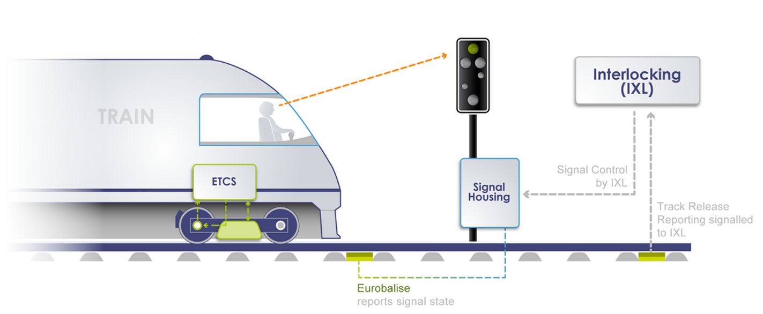
Figure 27: ERTMS level 1 (source: THALES)
Unlike ERTMS level 1, in ERTMS level 2 the ground-train data exchange is continuously performed using GSM-R communication means. Hence, the train continuously communicates its position to the control centre, the Radio Bloc Centre (RBC), which in turn gives its movement orders. Thus, as soon as a trackside system detects that a train is leaving a block, this information is immediately transmitted to the following train which improves the fluidity of the network. The Eurobalises are used to readjust the train's on-board odometry. The ERTMS level 2 data exchange is presented in the following figure.

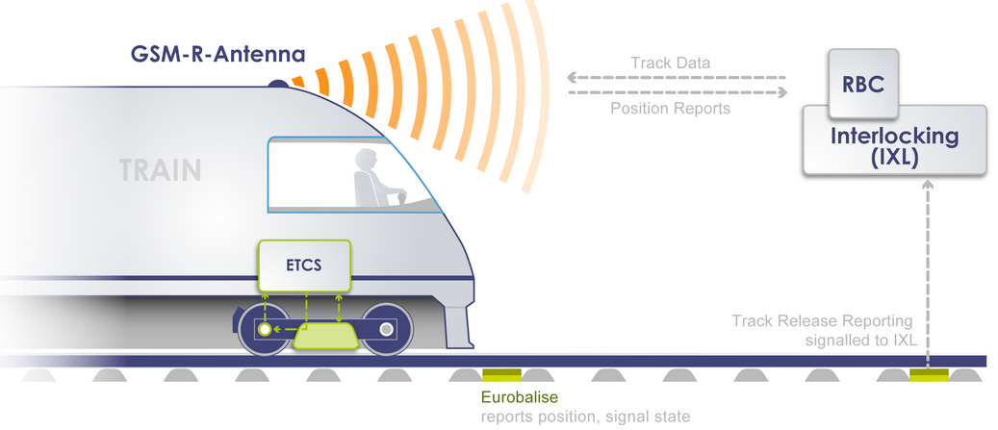
Figure 28: ERTMS level 2 (source: THALES)
Studies are performed to introduce GNSS in ERTMS level 2 systems. Hence, GNSS could be used to calibrate the odometer, acting as a virtual beacon. To do so, the position computed using GNSS will be compared in real time with a set of coordinates stored in a database, defining the positions of the virtual beacons. If the GNSS position of the train is similar to that of a virtual beacon, then the virtual beacon is considered the last relevant beacon for the train and is used to calibrate the odometer. Thus, the use of GNSS will allow to supplement and/or replace the physical Eurobalises, reducing the costs associated with the installation and maintenance of physical beacons. The following figure illustrates the virtual beacon principle.
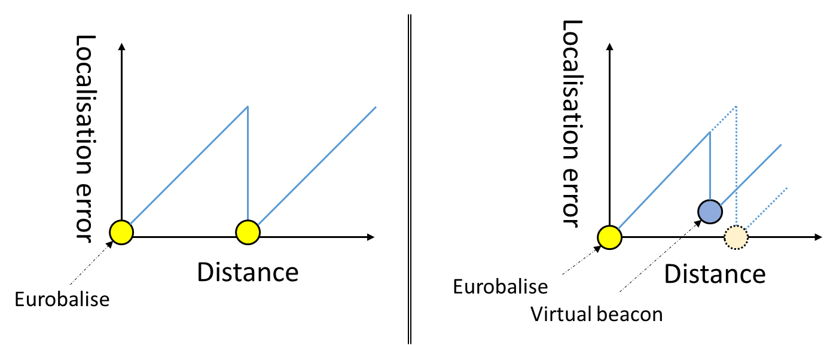
Figure 29: Virtual beacon concept
The figure below provides a simplified architecture of a possible use of GNSS in ERTMS level 2:
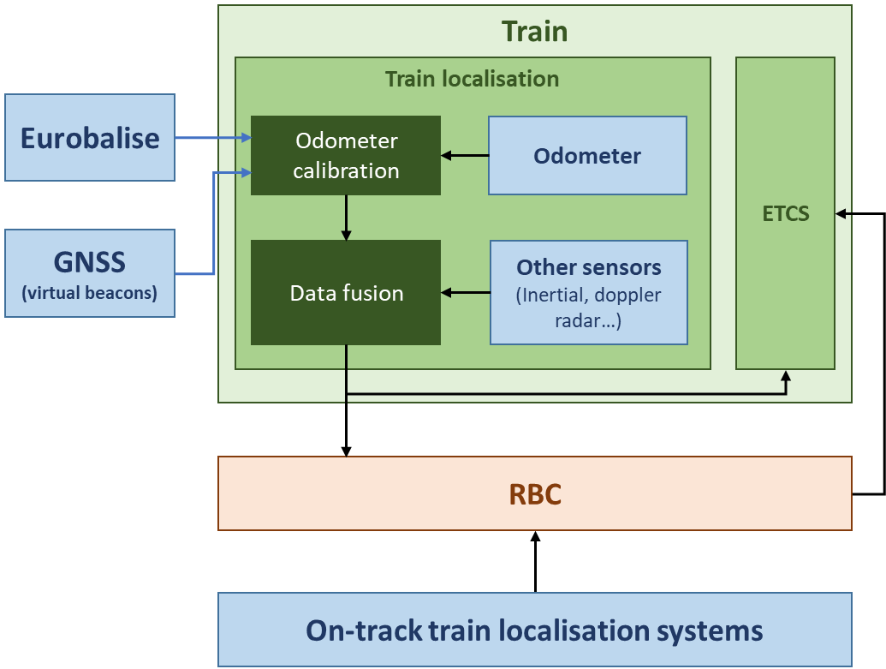
Figure 30: High level architecture of GNSS use in ERTMS level 2

The ERTMS level 3 is currently being studied. As in ERTMS level 2, trackside/on-board communications will be continuously performed using the GSM-R network and the Eurobalises will be used to calibrate the on-board odometer. The specificity of ERTMS level 3 is that the integrity of the train localisation is ensured by on-board positioning systems instead of trackside systems as in ERTMS level 1 and 2. The RBC will therefore use the position provided by the trains to manage their separations. Such difference allows the introduction of a new signalling concept, the moving blocks, which greatly increases the capacity of the network, especially in mixed traffic situations where different types of trains use the same tracks. In ERTMS level 3, GNSS is expected to be used as a source of position data. It will be used to monitor the integrity of the computed position using GNSS augmentation systems. The ERTMS level 3 data exchange is presented in the following figure.
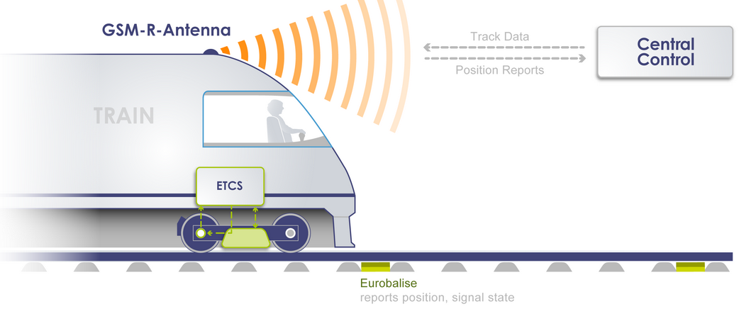
Figure 31: ERTMS level 3 (source: THALES)

The figure below provides a simplified architecture of a possible use of GNSS in ERTMS level 3:

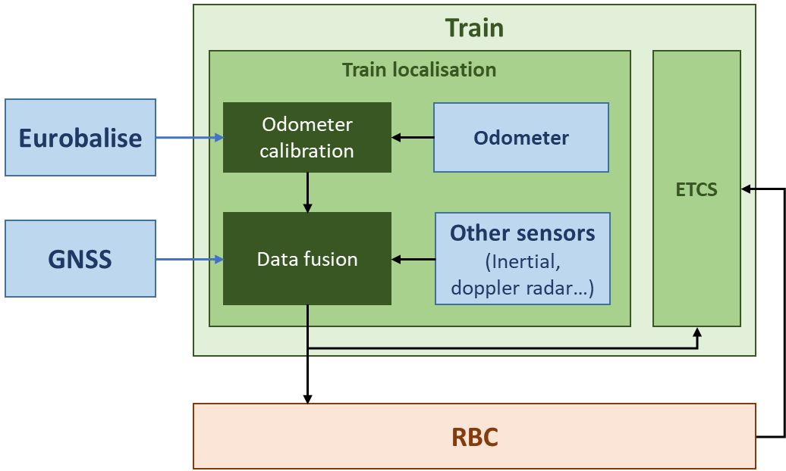
Figure 32: High level architecture of GNSS use in ERTMS level 3

Trackside Worker Protection
Workers in charge of track maintenance and their equipment have to be protected from trains running on the network. Thus, when entering a maintenance area, drivers are notified and speed restrictions are applied. In the same way, workers must be warned of the arrival of a train near their working area. Today there are only manual or semi-automatic protection procedures to manage the position of workers, equipment and trains. For example, announcers are used to inform operators of the arrival of a train.
Some solutions currently deployed in France to ensure trackside worker protection use GNSS as an optional non-safety critical function. For instance, GNSS is used to monitor the distance between the different trackside devices alerting the workers of the arrival of a train.
In the future, GNSS use could be extended. For instance, GNSS could be used to monitor the position of individual operators and maintenance equipment and, by comparing it with the position of trains on the network, generate potential warnings.

Asset Management
The description of this application is similar to the one provided in sub-section 3.5.1.2.1.3.
However, it has to be mentioned that “just-in-time” transportation induces specific constraints on railway freight transportation. The late arrival of a train at the depot will delay its unloading and have impacts on the entire transport and distribution chain. It should be noted that the position of the transported goods can be monitored directly via the position of the container, allowing the continuous monitoring of the same container during multimodal transportation, or via the position of the train or the different wagons.
In addition, tracking the position of trains enables the optimisation of network capacity and better adaptability of traffic in case of unforeseen events.
Finally, accurate monitoring of train position and speed allows for optimised maintenance operations, also reducing the number of technical incidents. Operating and maintenance costs are thus reduced.
GNSS is now widely used as a positioning source for these applications.

Transportation of Dangerous Goods
The description of this application is similar to the one provided in sub-section 3.5.1.2.1.4.
However, the transport of dangerous goods by rail is regulated by the Regulation concerning the International Carriage of Dangerous Goods by Rail, the so-called RID Regulation. It should be noted that in the rail sector, particular attention is paid to possible delays in the delivery of goods rather than to their nature.

Impact Assessment Main Outcomes
The table hereunder provides a synthesis of the most important impacts assessed by this study for each considered applications belonging to the rail transport.

Table 34: Rail transport applications impact assessment main outcomes
Application | Impact main outcomes
Signalling | GNSS information is currently not used in French signalling applications. However, future deployment and implementation of GNSS systems in the frame of ERTMS development could lead to the identification of significant impacts linked to the potential alteration of the corresponding information which may have to be assessed.
Trackside worker protection | Currently the GNSS is an optional functionality in trackside worker protection systems so no feared event has been identified in the context of this study.
Asset management | A GNSS failure can degrade the means of monitoring the position of trains and goods. This results in a degradation of the management of these assets and a poor optimisation of the use of the network, implying a degradation of the transportation services.

Civilian State Activities

Geographic Information

Overall Description and GNSS Use
Location or positioning refers to the action of determining the position of an object or person in relation to an environment. The environment considered can be local (i.e. a locality, a remarkable artificial or natural point) or global (the Earth and its immediate environment). The spatialization process is based on these landmarks or on a cartographic representation. The progressive development of the Earth sciences and particularly geodesy (study of the shape and dimensions of the Earth and its gravity field) has made it possible to create a geometric representation of the territory (scientific cartography), thus facilitating positioning and navigation by sea, land and air using geographical coordinates expressed in reference marks.
Geographic information is structured, geolocated and georeferenced information. The processes of geolocation and georeferencing of data mostly involve the direct or indirect use of GNSS.
The continuous increase in the quantity and diversification of sources leads to the implementation of new methods of acquisition (collaborative), processing (automatic learning and artificial intelligence), qualification and dissemination (digital platforms) of geolocated data and services. As a factor of innovation, geographic information is fully integrated into the digital challenges impacting public authorities, businesses and civil society.
Among all the applications related to this field, only those related to the civilian state activities are studied in this document, namely geodetic infrastructure, monitoring and surveillance of geophysical phenomena, monitoring and surveillance of positioning systems and crisis mapping.
The main application features are detailed in the table below:
Table 35: Application characteristics (source: IGN)
Applications | Application coverage | Expected accuracy | Data sampling | Products
Geodetic infrastructure | National (mainland France and overseas territories) | mm | Hourly, daily | Weekly, daily, hourly
Monitoring and surveillance of geophysical phenomena | National (mainland France and overseas territories), local | mm | Hourly, daily | Weekly, daily
Monitoring and surveillance of positioning systems | Worldwide, National (mainland France and overseas territories), local | mm | Hourly, daily, real-time (1s) | Weekly, daily, high-speed (15 min)
Crisis mapping | Local | m | Hourly, daily, real-time (1s) | Real / non-real time
With the exception of crisis mapping, the applications identified in the table above use exclusively delayed positioning data, the geolocation information resulting from the post-processing of previously recorded GNSS information.
For the surveillance and monitoring of geophysical phenomena, real time is however a perspective for future applications such as a real time warning system for dangerous geophysical phenomena.

Geodetic Infrastructure
In France, networks of permanent GNSS ground stations, dedicated to differential measurements, have been deployed and operated as geodetic infrastructure to support positioning, as a complement to the infrastructure deployed by GNSS operators. They allow the execution of geographic and geolocation activities using GNSS. The main objective of these networks is to provide access to a national geographic reference, thus contributing to the interoperability of the geolocation data resulting from these activities.
The French permanent GNSS network (RGP or Réseau GNSS Permanent) is a mean of accessing the RGF93 geodetic reference frame, applicable in mainland France, or the geodetic reference frame applicable to the overseas departments.
The coherence of the national reference systems with the European (ETRS89) and international (ITRS) systems is ensured by the imbrication of the RGP network with the European network (EPN) and the international network (IGS). Thus, it should be noted that the RGP is integrated into networks with international application coverage.
The RGP is a national federation of permanent GNSS installations and a disseminator of openly licensed data, products and metadata. It provides access to differential processing, guaranteeing centimetric precision positioning in non-real time, in mainland France and the overseas departments.
The RGP stations are geolocated via a static positioning method which provides high accuracy positioning of a supposedly fixed point thanks to a long observation time of the GNSS signals (from a few tens of minutes to a few days). When a new station is installed, three weeks of observations are necessary to calculate its position, which will then be updated regularly.
The following table provide the characteristics of static positioning method:
Table 36: Static positioning characteristics (Source: EUSPA, IGN)
 | Station network | Real time capacity | Initialisation time | Horizontal accuracy
Static positioning | Worldwide, national, local | No | 2h to 3 weeks | ~ 5mm

The permanent stations of the RGP network allow the application of differential static and kinematic positioning methods in non-real time: GNSS errors in the user’s position measurement are partly removed by comparing the observations of the user’s receiver with those of the reference stations close to the user. Thus, a user recording GNSS signal observations on his GNSS receiver can then localise himself in the applicable reference system by downloading GNSS observations, from the nearest RGP stations, and accurate IGS orbits.
A large proportion of the stations integrated into the RGP are owned by operators providing commercial RTK (Real Time Kinematic) services on national (Teria, Sat-Info) or regional (Coop&Tech, Actisat, Lél@) areas. The integration of these stations into the RGP ensures that the clients of these services have access to the national coordinate reference system. These correction services, which can be provided in real time, are used in many fields that use GNSS information and its corrections to obtain very precise positioning (e.g. autonomous vehicles in agriculture or in the construction sector). It should be noted that these services are not public, as the IGN only contributes to the supervision of the stations of these networks. These applications are therefore not studied in this document.
There are many permanent network applications. For instance, the Regina project (GNSS Network for the IGS and Navigation), which is the result of a partnership between CNES and IGN, is a multi-GNSS and real-time network with a worldwide coverage (see Figure 33). It contributes to the integration of the European Galileo system within the international geodetic infrastructure (IGS) and to the development of new positioning and navigation techniques such as the PPP.
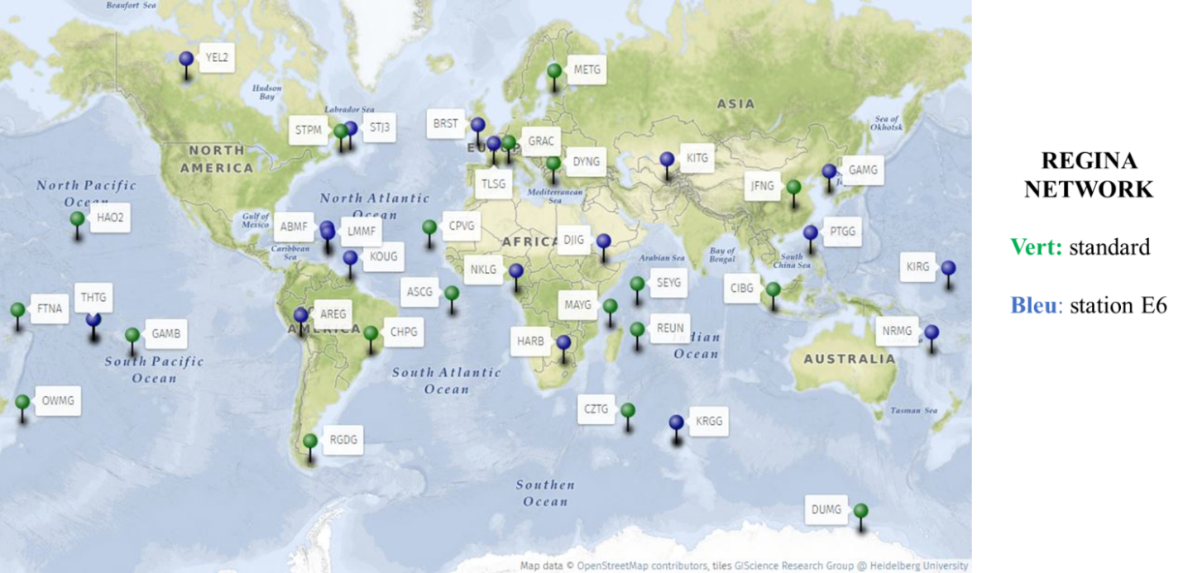
Figure 33: REGINA network and E6 Galileo acquisition capacity (source CNES)
The RGP also has applications in meteorology, where the processing of the data recorded by the stations makes it possible to calculate the integrated water vapour content in the atmosphere (see section 3.5.2.2).

Monitoring and Surveillance of Geophysical Phenomena
In addition to their contribution to geodetic infrastructures, the GNSS station networks are also used as geophysical systems providing warning, monitoring, follow-up and measurement of geophysical deformations. The following national research infrastructures are based on these networks:
- RENAG (Réseau national GNSS des laboratoires de recherche français), a national GNSS network of French research laboratories, set up for scientific research and Earth observation in internal and external geophysics and geodesy;
- SONEL (Système d’Observation du Niveau des Eaux Littorales), a scientific infrastructure for sea level observation.

The permanent GNSS networks have notably contributed to the identification and modelling of the effects of oceanic overload on coastal areas. This phenomenon, caused by the displacement of water masses during tides, generates a periodic deformation of the earth’s crust which is propagated to land areas. The displacements observed are of the order of a few millimetres to a few centimetres on the vertical component.
In the field of volcanology too, the use of these networks, in correlation with other techniques, makes it possible to acquire knowledge of local deformations and to monitor them. These techniques are implemented by the “Institut de Physique du Globe de Paris” (IPGP) for example at the Piton de la Fournaise volcanic observatory (Reunion Island) which integrates a dedicated GNSS network into its permanent instrumentation.
The regular analysis of the permanent network products allows to alert on anomalies (displacements or fast deformations) observed on one or several stations. Thus, the analysis of the daily calculation of the coordinates of the RGP stations has allowed the identification in 2018 of rapid displacements of stations located in Mayotte, revealing a global displacement of the island and important deformations as illustrated in the following figure.

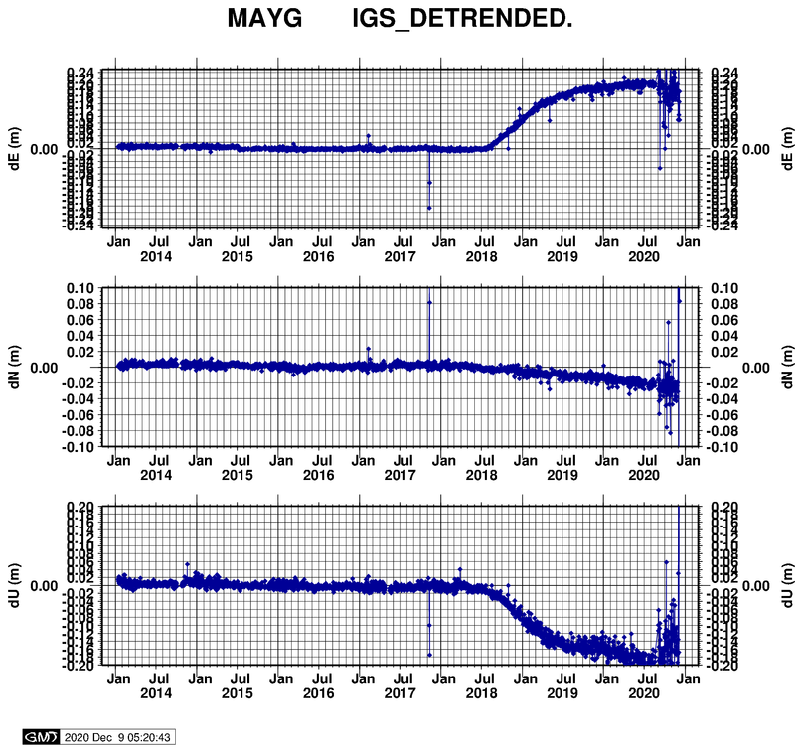
Figure 34: MAYG station coordinates evolution over time (source: IGN)
Following this alert, the analysis carried out by REVOSIMA (Réseau Volcanologique et Sismologique de Mayotte, grouping together several scientific organisations such as CNRS, IPGP, IFREMER, BRGM) as well as multidisciplinary observation campaigns, including the setting up of a specific GNSS network, enabled the identification and characterisation of a particularly intense telluric crisis as illustrated in the following figure.
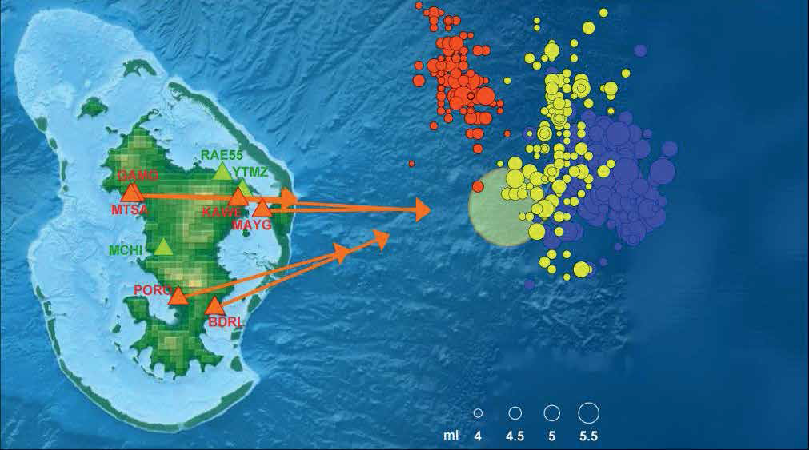
Figure 35: Observation of the Mayotte island deformations – Estimation of these deformation origins (source: REVOSIMA)

Monitoring and Surveillance of Positioning Systems
At the satellite positioning systems level, the continuous collection of GNSS raw data in the frame of the geodetic infrastructure operations is also used for the following applications:
- The detection of any local or global anomalies that have an impact on one of the GNSS components (ground or space segment, signal, receiver) through quality controls or routine processing carried out on this data;
- The test conduction on new constellations, new services and new GNSS signals, essential for the definition or the evolution of data exchange standards (Rinex standard, RTCM standard);
- The monitoring and the characterization of local or global events that have impacted one of the GNSS components (ground or space segment, signal, receiver).
The REGINA network allows access to GNSS service signals (see figure below) during the test phases or its initial service (i.e. not yet fully operational).
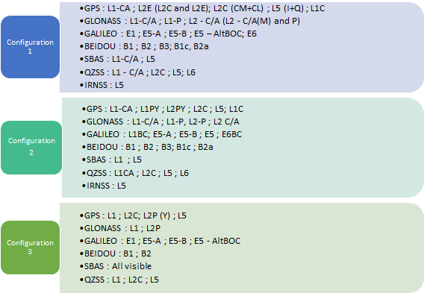
Figure 36: REGINA configurations for constellation and signal acquisition (source: CNES-2020)
GRC-MS is the European Union Member State contributions to the Galileo Reference Centre. It supports the EUSPA in the regular monitoring of the Galileo system performances. Relying on a worldwide network of around 70 stations, the GRC-MS produces quality indicators in different domains (orbits and clocks, ionospheric products, open navigation service, open time service, interoperability with other GNSS). The REGINA network is currently integrated into the GRC-MS network.
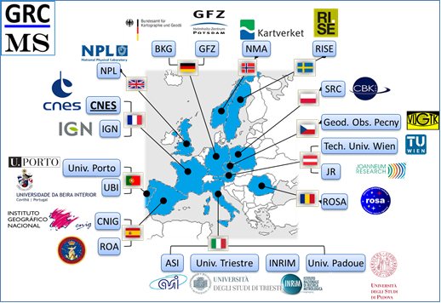
Figure 37: GRC-MS, members of the consortium (source CNES)
At the national scale, the ANFR (the French national frequency agency) is in charge of investigating interference phenomena that have been reported. The RGP infrastructure helps to analyse and locate the phenomenon source. This analysis is currently carried out after the phenomenon has been reported to the ANFR. However, the use of this network as an early (less than an hour delay) or even a real time warning system is jointly considered by the IGN and the ANFR.

Crisis Mapping
Georeferenced images, among the Earth observation devices, have repeatedly demonstrated their usefulness in the management of natural and industrial disasters or humanitarian crises. Indeed, digital mapping services can provide valuable information to the various actors in each stage of a crisis management:
- Before the crisis: This is a prevention phase, involving the identification of risks and the study of their potential impacts as well as the means to be implemented to prevent them. Mapping can be used as a study tool that makes it possible to anticipate and reduce the impact of a future crisis. The acquisition of the corresponding mapping data thus makes it possible to feed the prevention or simulation models in the face of crises.
- During the crisis: This is a phase in which the various decision-making tools make it possible to minimise the consequences of the crisis by optimising the various operations set up to manage it. Updated mapping data provide valuable information to support the intervention of the rescue teams or to locate and estimate the damage.
- After the crisis: This is a phase of return to normality during which the priority areas to be rebuilt are defined, as well as the potential changes in land use planning in order to limit the impact of future crises. Feedback from the past crisis is also used to improve the various crisis prevention models. Mapping-based studies help to identify key areas of the territory in order to prioritise reconstruction activities. An update of the mapping of the disaster area is then carried out in order to update the crisis preparedness models.
Mapping is mainly carried out using aerial or satellite means. Aerial mapping allows the acquisition of data with a very high resolution, which is particularly well suited to civil mapping missions. Satellite mapping, on the other hand, allows large areas to be mapped in a short period of time, offering the possibility of regular data acquisition.
In France, the IGN is in charge of numerous mapping missions. Every three years, the institute updates the aerial photographic coverage of the whole country. The orthophoto coverage obtained has a resolution of a few tens of centimetres. In addition to image acquisition, airborne LIDAR surveys (Lidar HD project) are used to construct a digital 3D model of the terrain and surfaces. This aerial mapping is supplemented by satellite imagery, which allows for more frequent updating of the national mapping, which is essential for certain activities such as the monitoring of coastlines vulnerable to storms and floods, the monitoring of land artificialisation or the evaluation of the resilience of a territory after a natural disaster. Since the beginning of the 2010s, the Pleiades satellites and then the SPOT 6 and 7 satellites have enriched the image offer for France, providing a ground resolution of approximately 50 to 150 cm.
In addition to this permanent mapping, the IGN can be requisitioned in the event of a natural disaster to take emergency photographs of the disaster zone. The data acquisition phase must be carried out as close as possible to the peak of the crisis in order to get data as precise as possible. For instance, in case of flood, data acquisition has to be performed within 12 hours after the crisis peak in order to ecametriced the flooded areas precisely, thus guaranteeing a better accuracy of the hydrological forecasting models on the one hand, and allowing the realisation of the potential flooding area mapping on the other hand.
It should be noted that emergency mapping in the event of a crisis is not necessarily useful in areas where very accurate and reliable models have already been put in place. These models then provide sufficient information to assist in risk prevention or crisis management.
Localisation plays an important role in cartography as it allows the precise positioning of the various geographical information on a map. A typical positioning method is to determine the position and orientation of the sensors during the survey. The position of the sensors can be obtained by different means:
- For satellite imagery, the position of a satellite in its orbit is determined by the on-board instrumentation and monitored via various measurements made by the control stations. The georeferencing of the data is mainly based on a recalibration of ground support points.
- For aerial photography, GNSS information, hybridised with inertial information, is widely used to geolocate the various sensors with metric (or even ecametric) accuracy. This geopositioning of the acquired data allows the different images obtained to be pre-positioned which optimises massive correlation algorithms from ground support points. It allows a significant time saving in post-processing activities (i.e. 48 hours of post-processing if the GNSS is used for pre-positioning against more than a week otherwise).
In addition to the geolocation of the acquired data, the GNSS positioning information is used in aerial photography for:
- The triggering of the data acquisition process by the camera, which must start when its absolute position, calculated using GNSS information, is within a data acquisition launch area defined during the mission preparation. The position accuracy needs to be lower than 10 m.
- The LIDAR calibration during the data acquisition requiring a metric position accuracy.
- The air navigation (refer to paragraph 3.5.1.1.1.1).
Each sensor used for aerial photography mapping has its own positioning system and the GNSS antenna used for these sensors is different from the one used to perform air navigation.
The following figure illustrates the use of GNSS for aerial mapping:
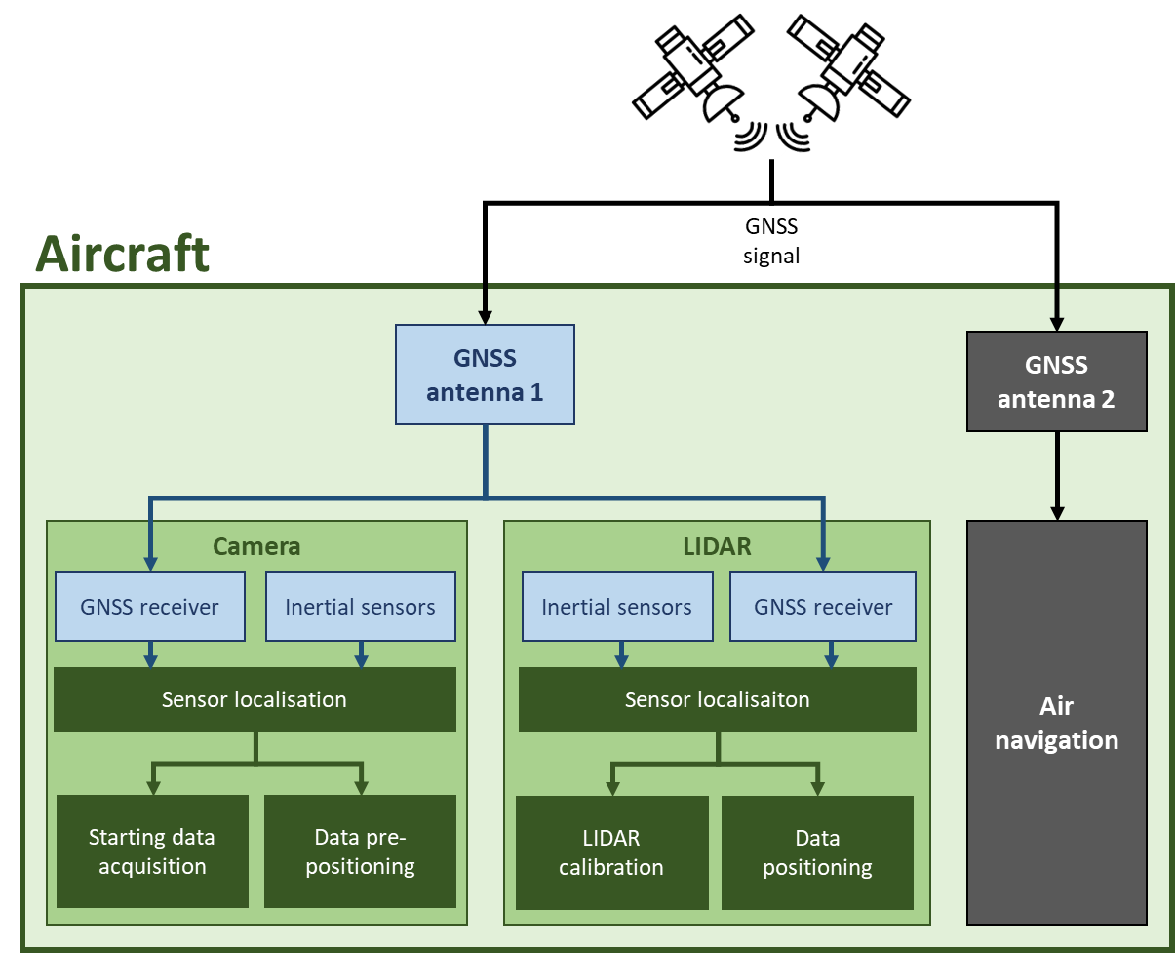
Figure 38: Illustration of the GNSS use for aerial mapping

Impact Assessment Main Outcomes
The table hereunder provides a synthesis of the most important impacts assessed by this study for each considered applications belonging to the geographic information sector.
Table 37 : Geographic information applications impact assessment main outcomes
Application | Impact main outcomes
Monitoring and surveillance of geophysical phenomena | The monitoring and surveillance of geophysical phenomena is not very sensitive to GNSS positioning degradation. Indeed, the GNSS-based measurements and studies of these phenomena are carried out over long periods of time (i.e. at least several days for the measurements and several months to several years for studies).  To a lesser extent, it is worth mentioning that some of these studies use many different types of sensors to perform geophysical measurements, thus reducing the sector’s dependence on GNSS.
Monitoring and surveillance of positioning systems | As the RGP is a national network of observation stations, it is robust to most GNSS degradations. Hence, no impacts have been identified in the context of this study.
Crisis mapping | Aerial surveys can be impacted by degraded GNSS positioning, which can have a financial impact on the entity in charge of carrying out these surveys.  If the GNSS degradation impacts a crisis area, it leads to a degradation of mapping data acquisition capacities, which may reduce the efficiency of the operations conducted by the entities in charge of the crisis management.

Meteorology

Overall Description and GNSS Use
In addition to the information provided in section 3.4.4.1.2, it should be noted that GNSS is also used in meteorological measurements to georeferenced data acquired before being integrated into numerical models of the atmosphere.
Hence, GNSS is used to automatise some fixed stations positioning (e.g. lidar aerosol stations), allowing to save time considering manual positioning.
For mobile meteorological stations, the need to provide data positioning is even more important. Mobile sensors that use GNSS to be positioned are: radiosonde, aircraft on-board systems, meteorological stations embedded on vessels and buoy.
Radiosondes are used to provide meteorological information in precise layers of the atmosphere of a defined area. These data complete the one provided by satellites. There are currently 5 radiosonde stations in metropolitan France, 10 in overseas departments and 4 on vessels between France and Antilles. GNSS receiver is the only sensor used to compute the radiosonde altitude. The required altitude accuracy depends on the atmosphere layer altitude: in the lower layers 0.5 hPa (around 4 m) accuracy is required. In addition, the wind speed and direction are computed by studying the Doppler effect on the carrier of the received GNSS signal. The wind speed must be measured with an accuracy of 2 m/s.
In addition to radiosondes, air traffic is used to get additional meteorological measurements. Indeed, the Aircraft Meteorological Data Relay (AMDAR) system, launched in 1995 by the World Meteorological Organization (WMO), transmits meteorological data sensed by aircraft onboard sensors to ground meteorological stations via the use of standard aeronautical communication systems. The data provided by AMDAR helps to characterise the vertical profiles of the atmosphere with high resolution by providing information on wind speed and direction, temperature and possibly even humidity (only 9 Lufthansa aircrafts are equipped with humidity sensors in Europe) or turbulence (turbulence data is not currently available in Europe). As these data are measured by the aircraft in flight, they need to be georeferenced. The AMDAR reference manual defines the following accuracy requirements for data positioning:
Table 38: AMDAR data positioning requirements
Altitude | Latitude | Longitude
100 ft | 5 Nm | 5 Nm

To position the AMDAR data, aircraft on-board positioning systems are used. Thus, GNSS information, hybridised with inertial measurements, is used to determine the latitude and longitude of the sensed meteorological data. Vertical positioning is based on the pressure altitude and therefore does not depend on GNSS information.
In addition to these observations, maritime measurement methods are used to collect precise meteorological data at sea. This data is valuable for general weather forecasting and marine forecasting in particular.
Automatic shipboard stations measure basic atmospheric parameters (i.e. pressure, temperature, humidity, wind) and surface water temperature. This data is sent every hour by satellite to the Météo-France centre in Toulouse. To be fed into numerical weather forecasting models, the measurements must be localised using GNSS.
Meteorological buoys are equipped with meteorological sensors to provide additional meteorological information on the ocean such as atmospheric pressure, wind speed and direction, air and sea temperature, air humidity and wave period, height and direction. To define localisation needs, a distinction must be made between moored and drifting buoys. Moored buoys use GNSS to measure the water level and characterise the true wind. In addition to these meteorological measurements, it monitors buoy positioning and raise alerts in case of buoy drifting which can be dangerous for marine safety. The drifting buoys are localised using GNSS to monitor their position and thus localise the measurements performed. The study of the successive positions of these buoys is used to characterise the surface current in delayed time (if the values are wrong, the calculated currents will be wrong). This data is used to validate the analysis and forecasting models of ocean circulation based on satellite observations. It has to be noted that other sensors such as accelerometers can complete GNSS sensors to get more accurate data.
Finally, Météo-France studies the various propagation properties of the GNSS signal in the atmosphere to gather meteorological information that feed the atmospheric models. From GNSS SiS propagation characteristics sensed by RGP stations (refer to sub-section 3.5.2.1.1.1), ground stations compute the signal Zenith Total Delay (ZTD) which is used to get the water vapour content of the atmosphere layers crossed by the signal. Hence, 450 daily measurements are performed across the French territory providing information on atmosphere water content which complement data observed by radiosondes.

Impact Assessment Main Outcomes
The table hereunder provides a synthesis of the most important impacts assessed by this study for each considered applications belonging to the meteorology sector.
Table 39: Meteorology applications impact assessment main outcomes
Application | Impact main outcomes
Meteorology | A large-scale and long-lasting GNSS positioning degradation reduces the number of usable meteorological observations, which may have an impact on small-scale weather forecast models. However, this deterioration in the quality of weather forecasts should not have a direct impact on Météo-France revenues but rather on the socio-economic benefits of reliable weather forecasting.

Space

Overall Description and Use
This paragraph supplements the information of paragraph 3.4.9 of this document.

Satellites
The role of operators is to maintain satellites on station and avoid potential collision thanks to a set of manoeuvres. Hence, they need to know with precision the position of their satellites in order to easily manoeuvre. For that purpose, they use ground measures (angle, distance, radial velocity). However, this positioning method show some drawbacks: high uncertainty, expensive equipment, the need of a good visibility for the satellites.
GNSS receivers can be embedded on satellites mainly to improve the availability and the accuracy of the positioning information which make the manoeuvres of the operator easier. Currently, many satellites carry GNSS receiver for positioning purposes. They are mainly single frequency GPS receivers. In the near future, satellites (notably those like nanosat) might use GNSS as the only location information.

Launchers
For each launch, CNES has a responsibility for ensuring the safety of people and assets. This function requires, under all circumstances, the location of the launchers in order to neutralise them if they were to become dangerous.
The principle of safeguard is to continuously locate a launcher regardless of its trajectory, and to perform a risk diagnosis at all time in order to guarantee that no fallouts lead to a catastrophic risk to people and assets. Continuous location of the launcher can also be used for navigation in addition to safeguard. GNSS can be used by the launchers for both functions.
Launcher location is mainly provided by a series of ground radar. The location by GNSS signals is also used with different approach depending on the launcher. For instance, GNSS is not used yet for the safeguard of ARIANE 5 but its utilisation is already planned.
GNSS can be used of the navigation mission of the launcher. Soyuz launcher in Guiana integrates a GPS/GLONASS receiver whose signals are only used for navigation. Safeguard only uses radar data to localise the launcher on Safeguard and Intervention Mission (SIM).

Impact Assessment Main Outcomes
The table hereunder provides a synthesis of the most important impacts assessed by this study for each considered applications belonging to the space sector.

Table 40: Space applications impact assessment main outcomes
Application | Impact main outcomes
Satellites | GNSS threats can lead under certain conditions to the damage or loss of some of the satellites mission. GNSS satellites dependency could be increased in the coming years, especially with the rising adoption of nanosats.
Launchers | GNSS threats could have an impact on the satellite in-orbit injection precision without meaning the loss of the launched satellite.

Conclusion
This study allowed highlighting the major role of GNSS in several Critical Infrastructure sectors of the civil society. It also identifies and the characterises the impacts that an alteration or an unavailability of GNSS information could have on various French society sectors. However, the public status of this report, necessary for its wide distribution, has led to remove some details and information included in its national classified version. The outcomes of the activities dedicated to the identification and characterisation of the vulnerabilities, feared events as well as the corresponding detailed levels of impacts are not reported in the present document.
At a general level, it appeared throughout the study that GNSS is not used in a similar way by all the actors of the same domain. Indeed, if some actors have implemented countermeasures in order to effectively control the impact of a threat to GNSS and alert competent entities to end the corresponding alteration (ex: alert the National Frequency Agency in case of suspicion of GNSS interference or jamming), others might not have implemented such measures. In the absence of interviews or bibliographic sources demonstrating a wide adoption of countermeasures against threats to GNSS, the evaluation of the impact was carried out with the assumption that no countermeasures are implemented. This hypothesis allows to raise awareness of GNSS users to the potential vulnerabilities related to the use of GNSS so that each operator can evaluate the necessity to implement a process that will increase the robustness and the resilience of its systems, with an adapted response in the case of an event occurred. It also allows to make this study a starting point for more detailed studies likely to be carried out by the concerned operators.

Timing and Synchronisation Standards

One-way Synchronisation Method Using GNSS
In a one-way time transfer system, a GNSS constellation transmits a standard time reference to a GNSS receiver which then adjusts its local clock to the standard time reference. This method is the simplest but least accurate and varies with the GNSS constellation in view.
The following figure illustrates the one-way synchronisation method using GNSS.
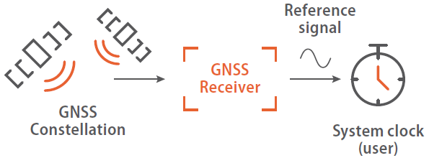
Figure 39: One-way synchronisation method using GNSS

Network Time Protocol (NTP)
The Network Time Protocol (NTP) is one of the oldest and most widely used and accepted standards for maintaining time across a network. It has the advantage of being relatively easy to implement, even if it only offers millisecond accuracy.
This protocol is based on a client-server model as defined by the IETF RFC 5905 which is now in its fourth version.
A basic NTP network is composed of NTP time servers and user equipment (e.g. workstations, routers, application servers) to be synchronised in time. NTP networks are usually structured into stratums in order to prevent potential traffic congestion or disruption. Each time a server is assigned to a stratum level, it corresponds to its distance from an accurate time source. Only Stratum I servers have a direct access to a standard time source such as GNSS or an atomic clock (stratum 0).
An example of NTP architecture is provided in the following figure.
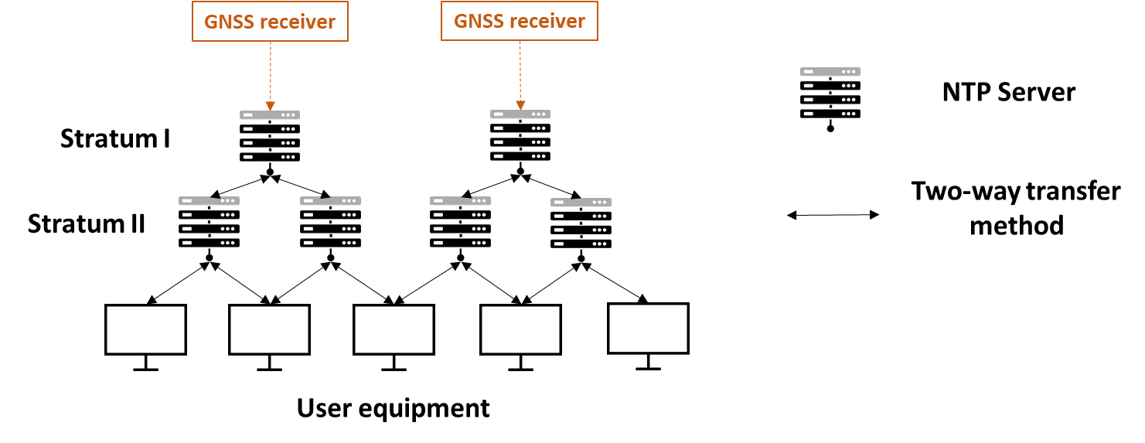
Figure 40: Example of an NTP synchronisation architecture

Precision Time Protocol (PTP)
The Precision Time Protocol (PTP) is defined by the IEEE 1588 standards. Like NTP, it aims to synchronise several elements communicating though a packet network. PTP is often more expensive to implement than NTP as it relies on the use of specialised hardware, but it is much more accurate.
The PTP enables the accurate time-transfer between two clocks by the transmission of messages containing the accurate timestamps of the time at which the packet is sent. The repeated transmission of PTP messages allows the derivation of frequency.
The following figure illustrate a PTP architecture.
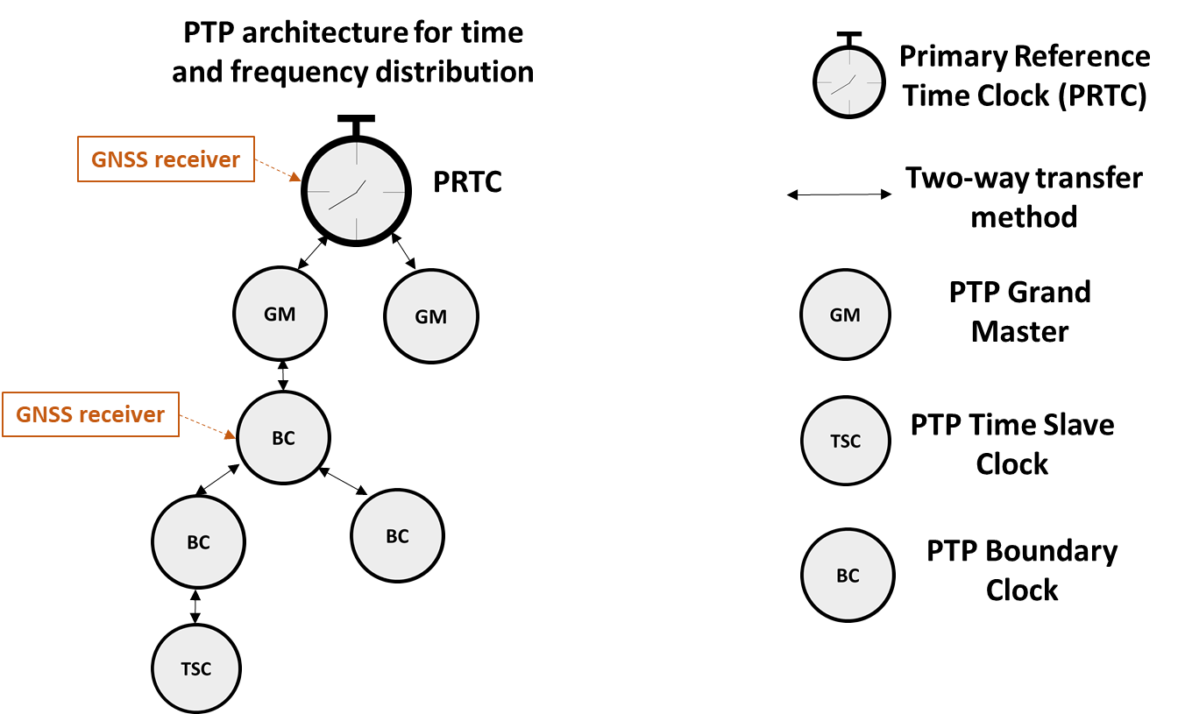
Figure 41: PTP architecture
The Primary Reference Clock (PRTC) is locked on a GNSS time source and acts as the primary time source for PTP Grand Master (GM). The standardisation of PRTC clocks was born in 2012 to support the increasing use of Ethernet physical links. Two types of PRTCs were initially defined: PRTC A and PRTC B. Each of these PRTCs is based on the use of GNSS as a time source. Since 2016, increased needs for performance and better protection against GNSS failures led to the creation of a new standard called ePRTC. This new type of primary reference clock is still based on GNSS but also on the use of an atomic clock providing a frequency reference. The respective roles of the different clocks in a PTP network are as follows:
- The Grand Master Clock (GM) is a master clock responsible for providing the time stamp to the Boundary Clocks.
- The Boundary Clock (BC) is a clock node, which is used to bridge the network segments to be synchronised. A BC can itself become a master clock if it is connected to a time source.
- The Time Slave Clocks (TSCs) are ordinary clocks connected to BCs that remain in slave mode and cannot become master clocks of the PTP network.

SyncE
SyncE is a dedicated technology used to provide frequency synchronization on an Ethernet network. This technology relies on the Ethernet physical layer to provide frequency synchronisation. SyncE was created to support the adoption of Ethernet in the modernisation of mobile phone networks. Indeed, since Ethernet is by nature an asynchronous technology, SyncE provides the required synchronisation between network nodes to ensure that services such as voice/video transmission can work as expected.
An example of a SyncE architecture is provided in the following figure.

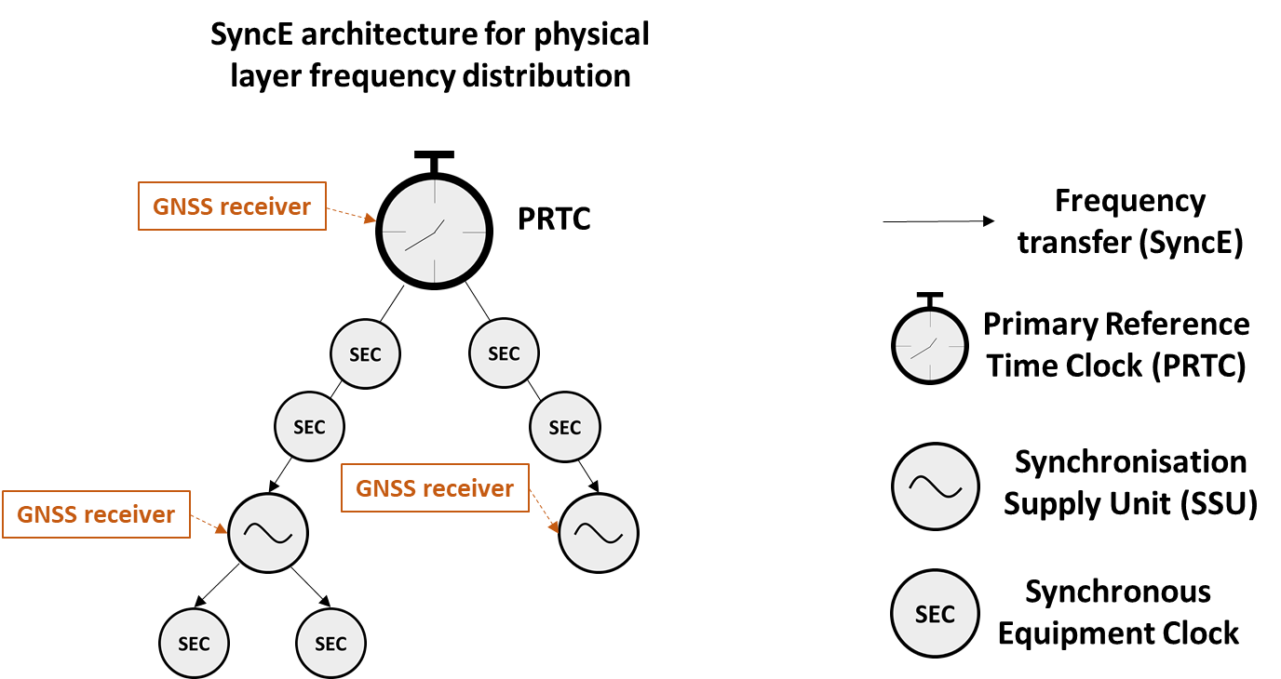
Figure 42: SyncE architecture
Like PTP, the SyncE standard is based on a hierarchy of specialised clock hardware and the use of a Primary Reference Time Clock (PRTC) at the top of this hierarchy. Synchronisation Supply Units (SSUs) are connected to the PRTCs to regenerate the time signal emitted by the PRTC. To enable this regeneration, the SSUs are connected to a time source such as GNSS. Synchronous Equipment Clock (SEC) can be connected to PRTCs or SSUs in order to synchronise nodes of the network.

White Rabbit (WR)
White Rabbit (WR) is the name of a collaborative project aiming at developing an open-source Ethernet based network for general purpose data transfer and sub-nanosecond accuracy time distribution. It takes advantage of the latest developments for improving timing over Ethernet, such as SyncE and PTP standards, and offers even more accurate synchronisation over Ethernet, with less latency and more reliability.
Instead of using a traditional two-way PTP scheme which cancels fibre transmission delays but generates synchronisation traffic overheads, the WR project uses continuous measurement of the phase (similar to SyncE) of the bounced back clocks with respect to the transmitting clocks in each of the switches.
An illustration of a WR dissemination architecture is provided in the following figure.
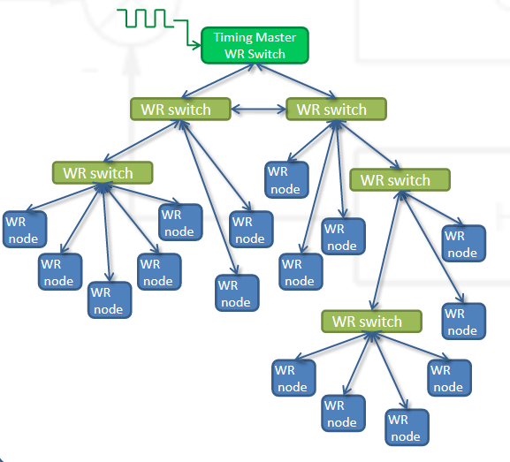
Figure 43: Architecture White Rabbit (WR)
The central component of the WR system structure is the WR switch. As for the T&S standards (i.e. NTP/PTP, SyncE), a hierarchical timing distribution architecture is used. The first WR switch in the hierarchy receives its ‘clock’ from an external source (e.g. GNSS) and transmits time information to other WR switches lower in the hierarchy which then transmit the time information to the WR network nodes to be synchronised.
The first WR element to be developed was the ‘white rabbit switch’, financed by the government of Spain and CERN, and produced by Seven Solutions. Since then, companies such as OPNT and CreoTECH have also developed their own WR commercial solution.

Inter Range Instrumentation Group (IRIG)
The IRIG standard stemmed from a US military project to define a set of time codes for the transmission of time stamps. This standard has been updated several times since its creation. Unlike NTP, PTP or SyncE, IRIG transmits timing information using coaxial cables rather than Ethernet.
IRIG time codes are divided into 6 subgroups called A, B, D, E, G and H. Each subgroup corresponds among other parameters to the number of synchronisation pulses per second as well as the modulation used and the frame format.
Of these subgroups, IRIG-B is the most frequently used by IRIG code generators. These IRIG code generators rely mainly on the use of GNSS to provide an UTC time source.

Long Distance Time Transfer Using GNSS: “GNSS Common-View” and “GNSS All in View”
Common view
The "GNSS common view" method was developed in the 1980s and provides a simple way to compare two clocks located in different places. While the principle of this method is relatively simple, it requires the use of specialised equipment in rooms where the temperature and humidity must be controlled. In addition, the two clocks to be synchronised must be linked by a communication mean. Despite these constraints, this technique remains the cheapest available with costs per GNSS station of around €20k.
This technique can only be used when the same GNSS satellite is visible to the receivers of both clocks to be compared.
The operating principle of this technique is presented in Figure 44. Based on the GNSS satellite signal received, the difference between the GNSS time of the satellite and the time of the clock A on the ground is calculated. The propagation time is subtracted in order to obtain only the difference between the time of the clock A on the ground and the time of the GNSS satellite. The same operation is performed simultaneously for clock B. The means of communication between clock A and B is used to deduce the difference between the two clocks.
This technique corrects some of the measurement errors compared to a one-way technique.
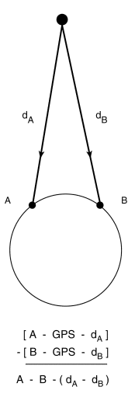
Figure 44: GNSS Common-View method (source: NIST)
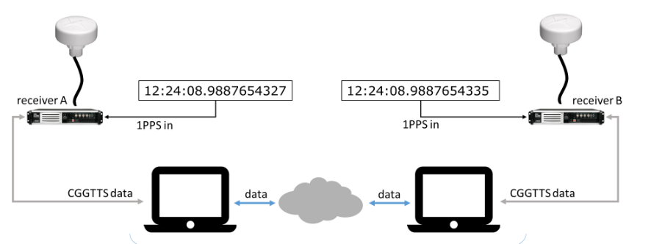
Figure 45: Typical installation in measurement laboratories (source: Ublox ITSF 2019)

All-in-View,
Unlike the Common-View method, the All-in-View method does not require the same GNSS satellite to be in view and relies on IGS products to measure the differences between the local clock of a GNSS station and a common global time scale called IGS Time. Unlike the Common-View method, the All-in-View method does not correct errors in satellite clocks and GNSS satellite ephemeris, making it less efficient in case of nearby laboratories (<5000 km). However, in Common-View, the satellite clocks noises and their ephemeris are not totally eliminated for distances greater than 5000 km, which can make the Common-View method inapplicable in favour of the All-in-View method.

Two-Way Satellite Time and Frequency Transfer (TWSTFT)
The Two-Way Satellite Time and Frequency Transfer (TWSTFT) is a time transfer method using geo-stationary communication satellites. This method is mainly used by metrology laboratories to compare distant atomic clocks without using an intermediary clock.
The TWSTFT technique requires an earth station costing about 200 k€ plus the rental of a repeater satellite on an intermittent basis. Indeed, the continuous rental of a satellite would be far too expensive for metrology laboratories. Unlike the common view method, TWSTFT allows a comparison of UTC(k) in a few minutes, whereas a GNSS-based time transfer requires some time for filtering the measurement noise.
For TWSTFT, LNE-SYRTE operates two earth stations: OP01 and OP02. These stations are equipped with SATRE modems that allow real-time exchange of Ku-band atomic clock signals via a geostationary telecommunications satellite.
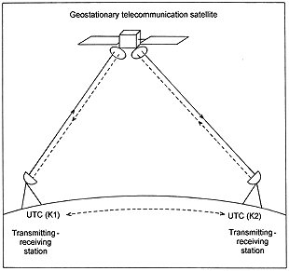
Figure 46: TWSTFT illustration (Source: BIPM)

Transmission Using Fibre Optic
Numerous European initiatives have been carried out in order to set up physical links via fibre optics. These initiatives bring together not only metrology laboratories but also private players such as telecommunications operators and industrialists.
Among the existing or under development fibre optic dissemination networks, the following ones can be mentioned for instance:
- REFIMEVE+: This network allows the transmission of a metrological frequency generated by the SYRTE (Paris Observatory) to 17 French laboratories. An evolution of this equipment is in progress to allow the transfer a time reference (T-REFIMEVE project). REFIMEVE+ is a first step to build a network at European level.
- GEANT2: It is a first extension of the REFIMEVE+ network planned for Germany with the support of the DFN (German academic network).
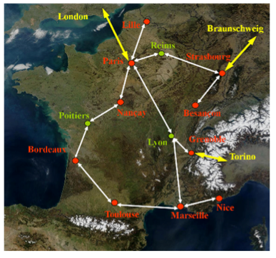
Figure 47: Map of the REFIMEVE network in France
European projects such as OFTEN and CLONETS also aim to extend and improve fibre optic connections between European atomic clocks:
- The CLONETS project aims to provide a state of the art of fibre optic dissemination technologies and propose a roadmap for the development of frequency transfer services.
- The OFTEN project aims to build an optical interconnection network between European clocks based on the results of the CLONETS project.

Abbreviations and Acronyms
0-9
3GPP 3rd Generation Partnership Project
A
ADF Automatic Direction Finder
ADMS Advanced Distribution Management System
ADR Accord for Dangerous goods by Road
ADS-B Automatic Dependent Surveillance-Broadcast
ADSL Asymmetric Digital Subscriber Line
AIS Automatic Identification System
AMDAR Aircraft Meteorogical Data Relay
ANFR French national frequency agency (French: Agence Nationale des Fréquences)
ANSSI French National Agency for the Security of Information Systems (French: Agence Nationale de la Sécurité des Systèmes d'Information)
ARCEP France's Electronic Communications, Postal and Print media distribution Regulatory Authority (French: Autorité de Régulation des Communications Electroniques et des Postes)
ATC Air Traffic Control
ATM Asynchronous Transfer Mode
AtoN Aid to Navigation
B
BDT BeiDou Time
BIPM International Bureau of Weights and Measures (French: Bureau International des Poids et Mesures)
BRGM Bureau of Geological and Mining Research (French: Bureau des Recherches Géologiques et Minières)
BSC Base Station Controller
BTS Base Transceiver Station
BVLOS Beyond Visual Line Of Sight
C
C4ADS Center for Advanced Defense Studies
CA Carrier Aggregation
CAM Cooperative Awareness Messages
CAS Commercial Authentication Service
CDMA Code Division Multiple Access
CEN European Committee for Standardization (French: Comité Européen de Normalisation)
CENELEC European Committee for Electrotechnical Standardization (French: Comité Européen de Normalisation ELECtrotechnique)
CGCS2000 China Geodetic Coordinate System 2000
CLUG Certifiable Localisation Unit with GNSS in the railway environment
CME Coronal Mass Ejections
CNES National Centre for Space Studies (French: Centre National d’Etudes Spatiales)
CNRS French National Centre for Scientific Research (French: Centre national de la recherche scientifique)
COLREGs Convention on the International Regulations for Preventing Collisions at Sea
CoMP Coordinated Multi-Point
CSG Guiana Space Centre (French: Centre Spatial Guyanais)
CSMA/CA Carrier Sense Multiple Access with Collision Avoidance
CSTDMA Carrier Sense Time Division Multiple Access
CT2 Cordless Telephone generation 2
CWDM Coarse Wavelength Division Multiplexing
D
DAB Digital Audio Broadcasting
DARS Digital Audio Reference Signal
DECT Digital Enhanced Cordless Telecommunications
DENM Decentralized Environmental Notification Messages
DER Distributed Energy Resources
DFR Digital Fault Recorder
DME Distance Measuring Equipment
DoS Denial of Services
DWDM Dense Wavelength Division Multiplexing
E
EBIOS Expression of Needs and Identification of Security Objectives (French: Expression des Besoins et Identification des Objectifs de Sécurité)
EGNSS-R European GNSS Navigation Safety Service for Rail
eICIC enhanced Inter-Cell Interference Coordination
eMBMS Evolved Multimedia Broadcast Multicast Services
EMC ElectroMagnetic Compatibility
EMI ElectroMagnetic Interference
EMS Energy Management System
ERA European union agency for RAilways
ERTMS European Rail Traffic Management System
ETCS European Train Control System
ETRS89 European Terrestrial Reference System
ETSI European Telecommunications Standards Institute
F
FACTS Flexible Alternating Current Transmission System
FDD Frequency-Division Duplexing
FDMA Frequency Division Multiple Access
FM Frequency Modulation
FMS Flight Management Système
FttH Fiber to the Home
FRMCS Future Rail Mobile Communications System
G
GEO Geostationary Earth Orbit
GLONASS Global Orbiting Navigation Service System
GLONASST GLONASS Time
GNSS Global Navigation Satellite System
GOVSATCOM GOVernmental SATellite COMmunications
GPRS General Packet Radio Service
GPS Global Positioning System
GSM Global System for Mobile communications
GSM-R Global System for Mobile communication – Railways
GST Galileo System Time
GTRF Galileo Terrestrial Reference Frame
H
HAS High Accuracy Service
HNSE Horizontal Navigation System Error
HTTPS HyperText Transfer Protocol over TLS
I
IALA International Association of the marine aids to navigation and Lighthouse Authorities
ICE Intercontinental Exchange
IEC International Electrotechnical Commission
IEEE Institute of Electrical and Electronics Engineers
IFREMER French Research Institute for Exploitation of the Sea (French: Institut Français de Recherche pour l'Exploitation de la Mer)
IGS International GPS Service
IGSO Inclined GeoSynchronous Orbit
IHM Interface Homme Machine
ILS Instrument Landing System
ION Institute of Navigation
IIoT Industrial Internet of Things
IoT Internet of Things
IP Internet Protocol
IPGP Paris Institute of Earth Physics (French: Institut de Physique du Globe de Paris)
IRIG Inter-Range Instrumentation Group
IRS Inertial Reference System
IRU Inertial Reference Unit
IRU International Road and transport Union
IS-XX Interim Standard-XX
ITRS International Terrestrial Reference System
L
LEO Low Earth Orbit
LNAV Lateral NAVigation
LNE National Laboratory of Metrology and Testing (French: Laboratoire National de métrologie et d’Essais)
LOFAR LOw Frequency ARray
LPV Localizer Performance with Vertical guidance
LRNS Long Range Navigation Systems
LTE Long Term Evolution
M
MAN Metropolitain Area Network
MASS Maritime Autonomous Surface Ship
MEO Medium Earth Orbit
MiFID Market in Financial Instrument Directive
MiFIR Market in Financial Instrument Regulation
MILSAT MILitary SATellite
MMS Multimedia Messaging Service
MTTr Mean Time To Repair or Mean Time To Recover
MUNIN Maritime Unmanned Navigation through Intelligence in Networks
N
N/A Non-Applicable
NASA National Aeronautics and Space Administration
NAVAIDS Navigational Aids
NAVWAR NAVigation WARfare
NB-IoT NarrowBand Internet of Things
NenuFAR New extension in Nançay upgrading LOFAR
NPL National Physical Laboratory
NPSS Narrowband Primary Synchronisation Signals
NSSS Narrowband Secondary Synchronisation Signals
NTP Network Time Protocol
NYSE New York Stock Exchange
O
OCXO Oven Controlled X-tal(Crystal) Oscillator
OP Paris Observatory (French: Observatoire de Paris)
OS-NMA Open Service Navigation Message Authentication
OTDOA Observed Time Difference Of Arrival
P
P25 Project 25
PAS Publicly Available Specification
PBN Performance Based Navigation
PCL Pilot Controlled Lighting
PDH Plesiochronous Digital Hierarchy
PHS Personal Handy-phone System
PLC Programmable Logic Controller
PMR Professional Mobile Radio
PMU Phasor Measurement Unit
Positioning, Navigation, Timing
PPK Post Processed Kinematic
PPP Precise Point Positionning
PPS Pulse Per Second
PRC Primary Reference Clock
PRP Parallel Redundancy Protocol
PRTC Primary Reference Time ClockPRS Public Regulated Service
PTP Precision Time Protocol
PVT Position, Velocity and Time
PZ90 Parametry Zemli 1990
R
RAN Radio Access network
RATP Autonomous Parisian Transportation Administration (French: Régie Autonome des Transports Parisiens)
RBC Radio Block Center
RDMA Remote Direct Memory Access
RDS Radio Data System
REGINA GNSS Network for IGS and Navigation (French: Réseau GNSS pour l’IGS et la Navigation)
RENAG GNSS National Network (French: REseau NAtional GNSS)
REVOSIMA Volcanological and seismological network of mayotte (French: REseau VOlcanologique et SIsmologique de MAyotte)
RFI Radio Frequency Interferences
RGF93 French geodetic network (French: Réseau Géodésique Français 1993)
RGP French permanent GNSS network (French: Réseau GNSS Permanent)
RID Regulation concerning the International Carriage of Dangerous Goods by Rail
RNAV Area navigation
RNP Required navigation performance
RTCM Radio Technical Commission for Maritime services
RTE Electricity Transmission Network (French: Réseau de Transport d’Electricité)
RTK Real Time Kinematic
RTU Remote Terminal Unit
S
SATCOM SATellite COMmunications
SBAS Satellite-Based Augmentation System
SCADA Supervisory Control And Data Acquisition
SDH Synchronous Digital Hierarchy
SDMA Space Division Multiple Access
SEC Secondary Equipment Clock
SEL Single Event Latch-up
SEU Single Event Upset
SHOM Naval Hydrographic and Oceanographic Service (French: Service Hydrographique et Océanographique de la Marine)
SGAM Smart Grid Architecture Model
SGG Smart Gas Grid
SIL Security Integrity Level
SIP Session Initiation Protocol
SiS Signal in Space
SNCF French National Railway Company (French: Société Nationale des Chemins de fer Français)
SNTP Simple Network Time Protocol
SOLAS Safety Of Life At Sea
SONEL Coastal water level monitoring system (French: Système d’Observation du Niveau des Eaux Littorales)
SONET Synchronous Optical NETwork
SSR Secondary Surveillance RADAR
SSU Synchronisation Supply Units
STARS Satellite Technology for Advanced Railway Signalling
SURF-IA SURFace Indication and Alerting
SYRTE Time-space reference system (French: SYstème de Références Temps-Espace)
T
T&S Timing & Synchronisation
TAI International Atomic Time (French: Temps Atomique International)
TCXO Temperature Compensated X (Crystal) Oscillator
TC RT Technical Committee Rail Telecommunications
TDD Time Division Multiplex
TDMA Time Division Multiple Access
TEDS TETRA Enhanced Data Service
TETRA Terrestrial Trunked Radio
THF Trading Haute Fréquence
TIA Telecommunications Industry Association
TLS Transport Security Layer
TMA Terminal Manoeuvring Area
TNT Télévision Numérique Terrestre
TSN Time Sensitive Network
TT&C Telemetry, Tracking & Control
TWSTFT Two-way satellite time and frequency transfer
U
UE European Union
UHD Ultra High Definition
UIT/ITU Union Internationale des Télecommunications / International Telecommunication Union
UTC Coordinated Universal Time (French: Temps Universel Coordonné)
UTM Unmanned aircraft systems Traffic Management
UMTS Universal Mobile Telecommunications System
UWB Ultra WideBand
V
VHF Very High Frequency
VLAN Virtual Local Area Network
VNAV Vertical NAVigation
VoIP Voice Over Internet Protocol
VOR VHF Omnidirectional Range
W
WAM Wide Area Multilateration
WAMPACS Wide Area Monitoring Protection and Control System
WCDMA Wideband Code Division Multiple Access
WGS 84 World Geodetic System 1984
WIOD World Input–Output Database
WLAN Wireless Local Area Network
WPAN Wireless Personal Area Network
WR White Rabbit
X
XO X (Crystal) Oscillator

Change Records

Version | Date | Description | Auteurs
Initial | 10/11/2021 | Initial version for review | Aurélien FOURNET, FDC  César EL-BEZ, FDC  Franck MANGIN, FDC

Report on Road User Needs and Requirements, EUPSA, 01/07/2019
https://www.euspa.europa.eu/sites/default/files/uploads/technology_report_2020.pdf
https://www.gps.gov/systems/gps/performance/accuracy/
https://www.researchgate.net/publication/228936470_GNSS_Status_and_perspective#pf3
https://www.gsc-europa.eu/sites/default/files/sites/all/files/Galileo-OS-SDD_v1.1.pdf
https://directory.eoportal.org/web/eoportal/satellite-missions/content/-/article/cnss
https://gssc.esa.int/navipedia/index.php/Galileo_Performances#cite_note-Galileo_OS_SDD-1
http://www.csno-tarc.cn/en/system/introduction
Failure Modes and Models for Integrated GPS/INS Systems, Umar Iqbal Bhatti and Washington Yotto Ochieng, Imperial College London
https://www.spaceweatherlive.com/fr/aide/que-sont-les-eruptions-solaires.html
Etude TIMING IA - CE – 2019
Etude TIMING IA - CE – 2019
Projet ARCHIPROD d’EDF
https://www.instavox.fr/blog/adp-edf-frequence-reseau-radio-lte-prive/
SGCG/M490/G_Smart Grid Set of Standards 24Version 3.1, CEN/CENELEC, ETSI
https://www.hitachiabb-powergrids.com/offering/product-and-system/substation-automation--protection---control/products/remote-terminal-units
https://www.elspec-ltd.com/metering-protection/g5-phasor-measurement-unit/
Méthodes de localisation et de détection de défauts d’arcs électriques séries dans un réseau électrique alternatif basse tension, THESE, Edwin Milton CALDERON MENDOZA, 20 décembre 2018
https://patentscope.wipo.int/search/fr/detail.jsf?docId=WO2019097312
http://www.services.eaufrance.fr/docs/synthese/rapports/Rapport_Sispea_2017_VF.pdf
https://www.lacroix-sofrel.fr/offre/postes-locaux/s4w/
https://www.barrages-cfbr.eu/-Metropole-.html
https://www.barrages-cfbr.eu/-Outre-Mer-.html
https://pdfs.semanticscholar.org/39f9/50a920652d139ce16d435ce3471bdf0918c2.pdf?_ga=2.191658659.821366707.1597153289-539465516.1593531637
https://www.barrages-cfbr.eu/IMG/pdf/colloque2018_maintenance.pdf
ITU-R TF.460-6
https://lne-syrte.obspm.fr/
https://www.bipm.org/fr/about-us/
Manuel TRANSFERT ET DIFFUSION PAR SATELLITE DE SIGNAUX HORAIRES ET DE FRÉQUENCE, Bureau des radiocommunications, ITU, Edition de 2010
http://www.meteofrance.fr/nous-connaitre/decouvrir-la-meteorologie/notre-histoire#
EGOS Technical Document no. 88 reviewed (draft), MINIMUM SPECIFICATIONS AND GUIDELINES FOR THE OPERATION OF EGOS DRIFTING BUOYS, European Group on Ocean Stations, 2002
Source : Entretien Météo France
https://www.arcep.fr/
Propagation time: propagation delay between the base station of the area of residence and the network of the selected cell as a source of synchronisation.
Global Mobile satellite communication theory, Volume I, Second edition, Stojce Dimov Ilcev
https://uic.org/IMG/pdf/srs-16.0.0_uic_951-0.0.2_final.pdf
https://uic.org/IMG/pdf/srs-16.0.0_uic_951-0.0.2_final.pdf
https://www.era.europa.eu/sites/default/files/filesystem/ertms/ccs_tsi_annex_a_-_mandatory_specifications/set_of_specifications_2_etcs_b3_mr1_gsm-r_b1/index012_-_subset-039_v310.pdf
https://eduscol.education.fr/sti/sites/eduscol.education.fr.sti/files/ressources/pedagogiques/12390/12390-ressource-gsm-r.pdf
https://www.itu.int/dms_pubrec/itu-r/rec/m/R-REC-M.1371-0-199811-S!!PDF-E.pdf
http://www.allaboutais.com/jdownloads/Access%20schemes%20technical%20downloads/ais_tdma_access_schemes.pdf
https://www.eurocontrol.int/sites/default/files/publication/files/surveillance-standard-document-for-radar-surveillance-in-en-route-airspace-and-major-terminal-areas199703.pdf
ICAO Annex 5
Eurocontrol standard document for radar surveillance in en-route airspace and major terminal areas, SUR.ET1.ST01.1000-STD-01-01, V1.0, Mars 1997
https://www.bruitparif.fr/pages/Thematiques/700%20Bruit%20du%20trafic%20a%C3%A9rien/600%20Les%20politiques%20de%20gestion%20du%20bruit%20du%20trafic%20a%C3%A9rien/630%20La%20surveillance%20du%20bruit%20du%20trafic%20a%C3%A9rien%20r%C3%A9alis%C3%A9e%20par%20A%C3%A9roports%20de%20Paris/2002-08-01%20-%20Monitorage%20bruit%20et%20trajectoires%20d%27avions%20-%20DGAC%20STNA.pdf
https://www.icao.int/NACC/Documents/Meetings/2011/ADSBMLT/Day01-07-THALES-Ludmilla.pdf
https://www.eurocontrol.int/sites/default/files/2019-05/surveilllance-report-wide-area-multilateration-200508.pdf
https://www.eurocontrol.int/sites/default/files/2019-05/surveilllance-report-wide-area-multilateration-200508.pdf
Note technique « impact d’une perte GNSS au CNES pour l’enquête FIRST-TF », DSO/RF/STR- 2021.0000600, 25 Mai 2021, Edition 1, Révision 0, Non sensible
https://www.ebds.eu/fiche_produit/kona-mega-gps-1ant-tektelic-gateway-lorawan-868mhz-gps-ip67
IEEE 1588 v2 (Precision Time Protocol = PTP)
Positionning system using two Distance Measuring Equipment (DME) and a on-board Inertial Reference Unit (IRU)
http://citeseerx.ist.psu.edu/viewdoc/download?doi=10.1.1.129.6059&rep=rep1&type=pdf
https://www.icao.int/APAC/Documents/edocs/APX.%20O%20-%20Revised%20AIGD%20Edition%2013%20-%20draft%20v2a%20-%20ENRI%2010.3.pdf
Report on Aviation User Needs and Requirements, EUSPA
https://www.statistiques.developpement-durable.gouv.fr/sites/default/files/2019-04/datalab-52-chiffres-cles-du-transport-avril2019.pdf
Report on Maritime and Inland Waterways User Needs and Requirements, EUSPA
Report on Maritime and Inland Waterways User Needs and Requirements, EUSPA
Report on Maritime and Inland Waterways User Needs and Requirements, EUSPA
Report on Maritime and Inland Waterways User Needs and Requirements, EUSPA
The numerical value of the maximum vertical uncertainty is given by: $\sqrt{a^{2}+(b.P)²}$ with P the depth
https://www.statistiques.developpement-durable.gouv.fr/sites/default/files/2019-04/datalab-52-chiffres-cles-du-transport-avril2019.pdf
Annex 1C of the European Regulation 165/2014
https://unece.org/about-adr
https://www.statistiques.developpement-durable.gouv.fr/sites/default/files/2019-04/datalab-52-chiffres-cles-du-transport-avril2019.pdf
Dans une zone définie, système de détection de train basé sur un circuit électrique.
https://www.thalesgroup.com/fr/european-train-control-system-etcs
https://www.thalesgroup.com/fr/european-train-control-system-etcs
https://www.witpress.com/Secure/ejournals/papers/TDI010328f.pdf
https://www.thalesgroup.com/fr/european-train-control-system-etcs
https://otif.org/en/?page_id=1105
http://rgp.ign.fr/PRODUITS/solutions.php
http://rgp.ign.fr/
http://reseau-orpheon.fr/les-domaines-application-orpheon/guidage-dengins-et-dragage/gestion-des-pistes-de-ski-et-zones-montagneuses/
https://regina.cnes.fr/
http://www.ppp-wizard.net/
http://renag.resif.fr/presentation/
https://www.sonel.org/?lang=fr
http://www.ipgp.fr/fr/ovpf/reseaux-dobservation-de-lovpf
http://mayotte.gnss.fr/
Support for the Galileo Reference Centre attribué à consortium européen conduit par le CNES, auquel l’IGN participe
https://library.wmo.int/doc_num.php?explnum_id=9026
https://ohwr.org/project/white-rabbit/wikis/WRpresentations
https://www.meinbergglobal.com/english/info/irig.htm
Time and frequency measurements using the Global Positioning System, Lombardi M., Nelson L., Novick A. and Zhang V., The international journal of metrology, July 2001
GPS All in View time transfer for TAI computation, Petit G. and Jiang Z., Metrologia, No. 45, p35-45, 2008
Precise Point Positioning for TAI computation, Petit G. and Jiang Z., International Journal of Navigation and Observation, volume 2008, Article ID 562878
http://www.refimeve.fr/index.php/fr/presentation/description-du-projet.html

